

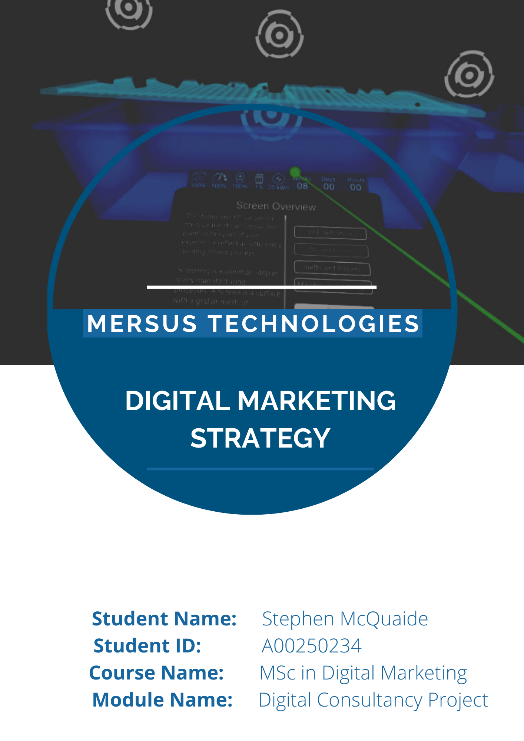

Contents
1. Introduction 1
2. Situational Analysis 2
2.1. Website Analysis 2
2.2. Search Engine 4
2.3. Social Media Analysis (Insights and Engagement) 5
2.4. Customer Personas 12
3. Objectives 16
4. Strategy 17
4.1. STP 17
4.2. Marketing Mix 19
4.3. Unique Selling Points 21
4.4. Branding/IMC Strategy 23
4.5. SEO Strategy 26
4.6. Social Media Strategy 28
4.7. Content Strategy 29
5. Tactics 30
6. Actions 33
6.1. Content Plan 33
6.2. Timeline 37
7. Controls 41
8. Conclusion 44
9. Bibliography 44
10. Appendix 45

Introduction
This report goes over Mersus Technologies’ current digital situation, technical overview of their website and social media platforms as well as a digital marketing strategy based on this information. This is written and planned around the SOSTAC model, encompassing six different headings for each category. The situation analysis summarises the important elements of the previous full report including the state of the Avatar Academy website, technical performance of that site and the performance of the social media platforms utilised by the company. With those in mind, three objectives are created through the SMART framework. From there, the strategy section analyses the information from the situation analysis in order to tie back into the objectives. Factors to be analysed include the STP model, 7Ps, Unique Selling Points of the brand, the branding and IMC strategy, and strategies for content, social media and SEO. Tactics breaks down the digital tools that should be utilised towards the target audience and how that can be done. Actions goes over the timeline of events and the schedule created to implement the chosen tactics, done through tables alongside a Gannt Chart. Lastly, Control asks how the performance can be monitored including creating goals and implementing KPIs.

Mersus Technologies is an Athlone-based company primarily identified as a virtual reality platform that aims to replicate real world experiences. It is categorised in the Immersive Technology industry. Mersus Technologies was co-founded by Dermot Condron and Geoffrey Allen back in 2013. Prior to that, there was a previous partnership called Makin Media Mobile, who had built a strong reputation in digital media and video animation, even managing to achieve a place in the Enterprise Ireland Hot 100, a ranking of the top 100 business start-ups in Ireland for a given year. In 2016, the company started experimenting with real-time technology to reduce the cost of animation rendering sequences. This would create the shift to immersive training technology, where Mersus would eventually become the market leader in Ireland. In 2018, the company would create one unified platform to future-proof and set the stage for new virtual environments from then on. This is called the Avatar Academy, a virtual reality training program aiming to replicate authentic experiences through simulations. It is also able to receive data based on user experience through these training courses and develop a significant understanding of that user.

Situational Analysis

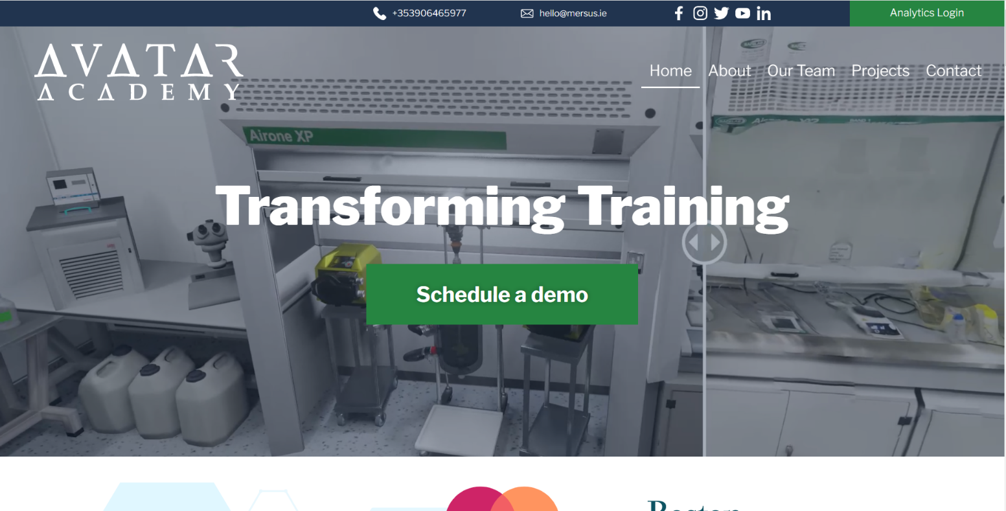
Website Analysis
Figure 1 - The home page of the Avatar Academy website
- The Avatar Academy website will be analysed (avataracademy.io)
- On the XML Sitemap Index page, there are 5 sitemaps listed on the Avatar Academy website and a total of 13 URLs overall.
- 9 of those URLs were on ‘page-sitemap.xml’. This sitemap categorises every page and sub-page located on the website. Two pages have 5 images, the About page has 10 images, four pages have 11 images, the Teams page has 25 images and lastly, the Home page has 31 images.
- This rounds up to a total of 120 images on this sitemap. That is more than the number of images in the database, but that is likely due to images being reused in more than one page.
- This indicates that the pages of the website are being updated on a regular basis, which is especially the case since the website only launched back in September.

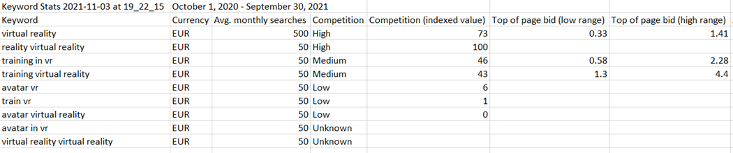
Figure 2 - Keywords generated through Google Ads keyword planner after inserting the domain, 'avataracademy.io'
- The Avatar Academy website doesn’t appear in the top 100 for any of the keywords shown
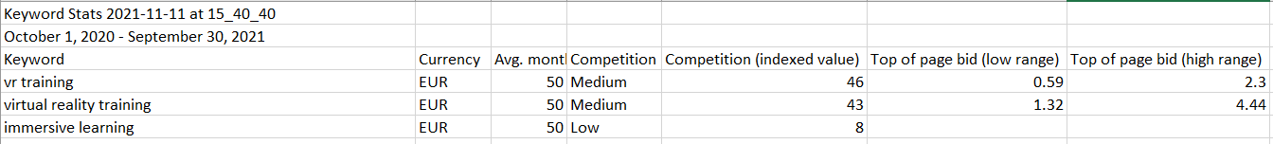
- No page on the website has any focus keyword nor SEO optimisation tailored to the keywords that appear on the spreadsheet, meaning that a score cannot be calculated for how SEO-friendly a post/page is based on a given word.
Figure 3 – Performance of the three keywords provided by the company overall, generated through Google Ads
- The three focus keywords provided by the company are as follows:
  - ‘vr training’
  - ‘virtual reality training’
  - ‘immersive learning’
- 50 searches are made on average per month with medium to low competition.

Keyword performance done through Ubersuggest keyword planner
 | Search volume | SEO difficulty | Paid difficulty | CPC
‘vr training’ | 20 | 47 | 26 | €1.34
‘virtual reality training | 480 | 61 | 54 | €30.66
‘immersive learning’ | 720 | 58 | 18 | €12.05

- In total, the website runs on Wordpress version 5.8.1, using the Astra theme contains 1 post and 9 pages within the domain.
- There are currently 12 plugins active on the site including Asset Cleanup, Startup Templates, Smart Slider 3, GDPR Cookie Compliance, Elementor plugins, Smush, WPForms, WPvivid Backup Plugin and YoastSEO
- 110 media items were found within the website.

- The SEO title for the homepage titled ‘Avatar Academy – Virtual Reality Training’ is “%%title%%
- There is no slug nor meta description in any of the pages, meaning meta tag and descriptions are automatically generated based on what’s written on the page.
- The Meta description being empty means that it automatically generates text from the respective page instead of containing it’s own individual description to set it apart.
- The home page of the Avatar Academy fulfils criteria for a good SEO score like word count and normal inbound and outbound links, while suffering from the lack of slug, meta description and missing alt attributes for images.

- According to the Search Console, the Avatar Academy page is mobile friendly.
- Mobile page loading time was 3.8 seconds. This is poor as sites with a good to decent speed load up in about 1 to 2.5 seconds.
- One way the site benefits from mobile is users having the ability to utilise their touchscreen to scroll through each client rather than messing up the layout of the site.

Search Engine
- 14 crawled pages
- 86% site health
- 3 errors, 14 warnings, 33 notices
- Errors include 4xx status code and duplicate title tags
- Warnings include 11 pages with no meta descriptions, low text/ HTML ratio, no h1 heading, low word count, and HTTPS page leading to HTTP page
- Notices include external links with nofollow attributes, more than one h1 tag, and a page with only one incoming internal link
- Site is mostly healthy. It helps that the website is brand new. Since there is not too many pages on the site to begin with, it means lesser risk of failure compared to other, much larger websites.
- Low interest was found for the three chosen keywords on Google Trends

Social Media Analysis (Insights and Engagement)
Facebook
- 832 people liking the page and 858 followers.
- The most recent post was created over half a year ago on March 8^{th.}
- Content includes showcasing artwork and animations created by staff, virtual training statistics, nominations for awards relevant to the company and highlights of virtual reality work done for other clients.

  - Follower gender: 51.1% women
48.9% men

  - Age demographic: 1st: 45-54
2nd: 35-44
3rd : 25-34

  - Top Countries: 1st: Ireland (83.9%)
2nd: United States (4%) 3rd : United Kingdom (3.1%) 4th: Myanmar (1.8%)

  - Top Cities: 1st: Athlone (16.5%)
2nd: Galway (15.5%) 3rd : Dublin (3.6%) 4th: Roscommon (2.6%) 5th: Mullingar (2.2%)

March 1st 2020 – November 1st 2021
  - Highest reach for one post: 2,000+
  - Overall reach during this period: 3,168
Facebook Post 1 (Pinned post)
- One of the most popular posts in 2020 has a total of 2,680 organic impressions and 1,959 organic reaches. 123 engagements were made.
- There is a big drop-off after 15 seconds. Within 20 seconds, there is a huge drop in retention by 54.3%, meaning most users lost interest in that time frame

Facebook Post 2 (Most recent post)
- 211 organic impressions and 192 organic reaches.
- 28 engagements were made.
- 12 users reacted to it, no shares nor comments.

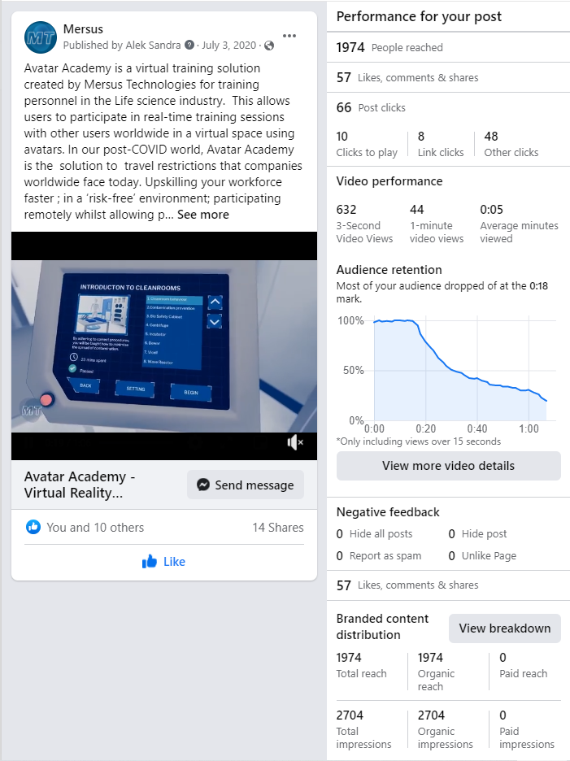
- During October 20th 2021 to November 16th 2021 period, Page views and post reach decreased by 25% compared to the previous period
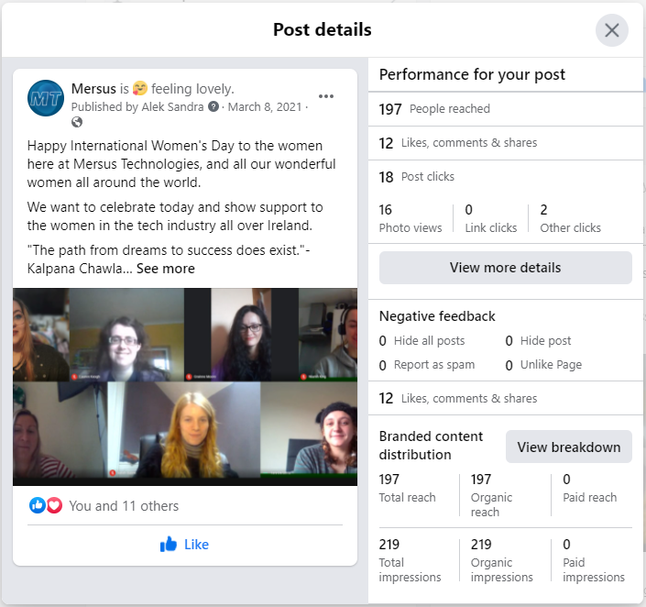

Figure 4 - The pinned Facebook post (Left) and the most recent Facebook post (Right)

Instagram
- 494 followers.
- The most recent post was created over half a year ago on July 31st 2020.
- Content includes artwork done by various staff, 3D modelling, VR and AR concepts, behind the scenes videos and samples of the portfolio seen on the website.

  - Follower gender: 37.5% women
62.5% men

  - Age demographic: 1st: 35-44
2nd: 25-34
3rd : 45-54

  - Top Countries: 1st: Ireland
2nd: United Kingdom 3rd : United States 4th: India

  - Top Cities: 1st: Dublin
2nd: Athlone 3rd : Galway 4th: Limerick 5th: Buenos Aires

March 1st 2020 – November 1st 2021
  - Highest reach for one post: 151
  - Overall reach during this period: 258

Previous 12 posts compiled
- Average engagement rate: 3%
- Average likes 11%
- Average comments per 1000 likes: 12%

Facebook/Instagram Potential Audience
  - Audience Size: 3.4 million

  - Follower gender: 57.1% women
42.9% men

  - Age demographic: 1st: 35-44
2nd: 25-34
3rd : 45-54

  - Top Cities: 1st: Dublin (32.15%)
2nd: Cork (4.57%) 3rd : Limerick (3.02%) 4th: Galway (2.78%) 5th: Waterford (1.59%)

Twitter
- 3,616 followers.
- The most recent post was created over half a year ago on February 9th.
- Content includes artwork done by various staff, 3D modelling, VR and AR concepts, behind the scenes videos and samples of the portfolio seen on the website.
October 19th 2021 to November 15th 2021
  - Tweet Impressions: 148
  - Profile visits: 444
  - Mentions: 3

 | September | October | November
Tweet Impressions | 174 | 144 | 67
Profile visits | 6 | 96 | 353
Mentions | 0 | 1 | 2

Twitter Post 1 – Pinned Tweet
  - Impressions: 1,660
  - Media Views: 318
  - Total Engagements: 57

Twitter Post 2 – Most Recent Post
  - Impressions: 15,320
  - Total Engagements: 106

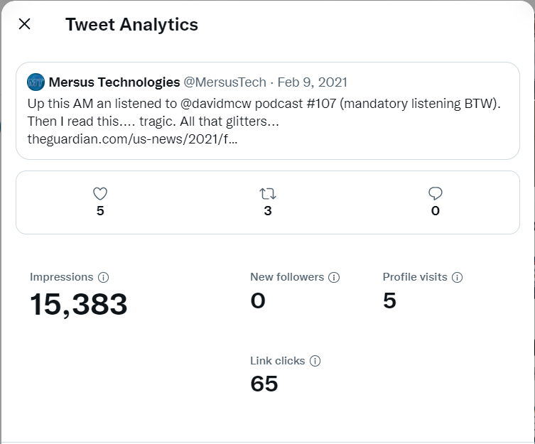
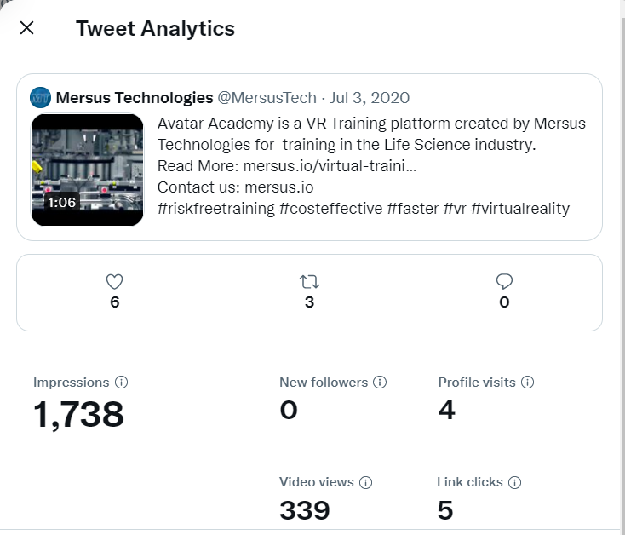
Figure 5 - The pinned Facebook post (Left) and the most recent Facebook post (Right)

LinkedIn
October 14th 2021 to November 13rd 2021
    - Page Views: 252
    - Unique Visitors: 89
    - Custom Button Clicks: 6

- 28 desktop users vs 3 mobile users.

  - Top Locations (visitors): 1st: Westmeath (53.23%)
2nd: Greater NYC Area (4.03%)
3rd : Greater Nashville Area (3.23%)
4th: Limerick (3.23%) 5th: Meath (3.23%)

  - Top Industries (visitors): 1st: Staffing & Recruiting (27.14%)
2nd: Mechanical/Industrial Engineering (9.05%)
3rd : Higher Education (8.04%)
4th: Pharmaceuticals (3.02%)
5th: Building Materials (3.02%)

  - Top Locations (followers): 1st: Westmeath (11.76%)
2nd: London (5.88%)
3rd : Belfast (4.58%)
4th: Greater NYC Area (4.58%)
5th: Meath (2.61%)

  - Top Industries (followers): 1st: IT & Services (11.09%)
2nd: Computer Software (10%)
3rd : Higher Education (7.83%)
4th: Education Management (4.13%)
5th: Marketing/Advertising (3.48%)

Organic content metrics
  - Reactions: 40
  - Comments: 1
  - Shares: 2

- Most days during this period had under 100 impressions. However, days like October 17th, 19th, 25th and November 8th saw peaks in impressions.

- Same case for the followers as all of them arrived through organic means. Most days would see at least one follower, however, October 19th and November 4th peaked at 3 followers a month. In total, this time period saw 22 followers, an 83% increase compared to the prior period.

YouTube
October 14th 2021 to November 13rd 2021
- Views: 782
- Average Watch Time 5 hours 3 minutes
Top Videos
Video Title | Average View Duration | Views
Mersus Dental Virtual Reality - 360° Training showreel | 0:18 (50%) | 670
Mersus Tech Promo Video - Virtual Reality Training | 1:18 (81.2%) | 22
Avatar Academy - Virtual Reality Training Platform | 0:47 (35.1%) | 19
FIT Virtual Academy | 1:35 (36.9%) | 17
The Camfil Experience - Virtual Reality application | 0:24 (15.2%) | 8
Traffic Source type
  - Suggested videos: 74.9%
  - External: 7.3%
  - YouTube search: 5.8%
  - Browsing Features: 5.2%
  - Channel pages: 3.1%
  - Others: 3.7%

External Sources | Average View Duration/Percentage Viewed | Views | Watch Time (Hours)
Google Search | 0:58 (39.8%) | 8 | 0.1
Mersus.io | 0:45 (47.8%) | 6 | 0.1
YouTube | 0:01 (1.7%) | 2 | 0.0
Google | 1:17 (36.9%) | 1 | 0.0
Google Docs | 0:24 (99.7%) | 1 | 0.0
Duckduckgo.com | 0:12 (32.7%) | 1 | 0.0
Linkedin.com | 4:19 (99.8%) | 1 | 0.1
Nibrt.ie | 1:25 (96.8%) | 1 | 0.0
Techireland.org | 0:42 (85.7%) | 1 | 0.0
Avataracademy.io | - | 0 | 0.0

YouTube Search:
  - Dentist 360: 17.8%
  - Dentist vr: 6.7%
  - 360 dentist: 4.4%
  - Vr dentist: 4.4%
  - Avatar training: 2.2%

  - Top Countries: Ireland
Mexico
India

  - Subscribers: Not Subscribed (94.8%)
Subscribed (5.2%)
YouTube Video
  - The most popular video on the YouTube channel has around 17,365 views. 0.38% of viewers liked/disliked the ‘Mersus Dental Virtual Reality’ video with only 1 comment seen.
‘Behind the Scenes of Mersus Technologies’ saw a 0.29% ratio of view to likes/dislikes.
‘Enda vs McGregor’ saw a 0.87% ratio of views to likes/dislikes.

  - For the FIT Virtual Academy video, over 1/3 of viewers lost interest within the first 5-10 seconds
  - At the 30 second mark, viewer retention was at around 40%. By the halfway mark, it was hovering around 33% and by the very end, 25% of viewers finished watching.

- The video with the most watch time was the Dental Virtual Reality at 3.51 hours.

Customer Personas
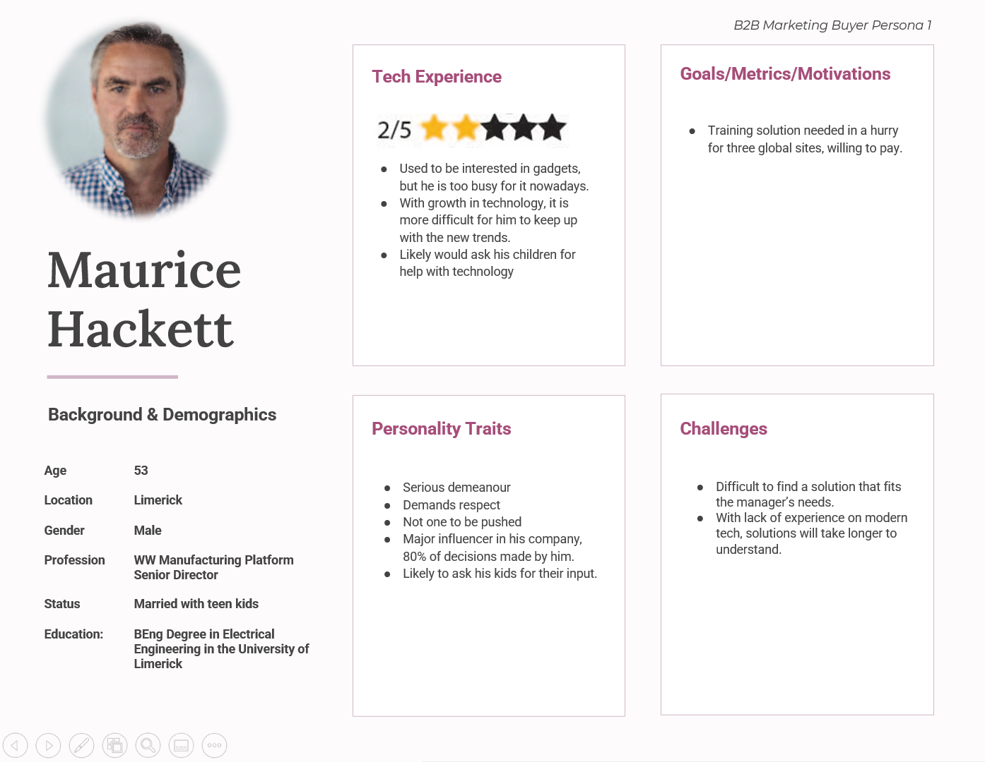

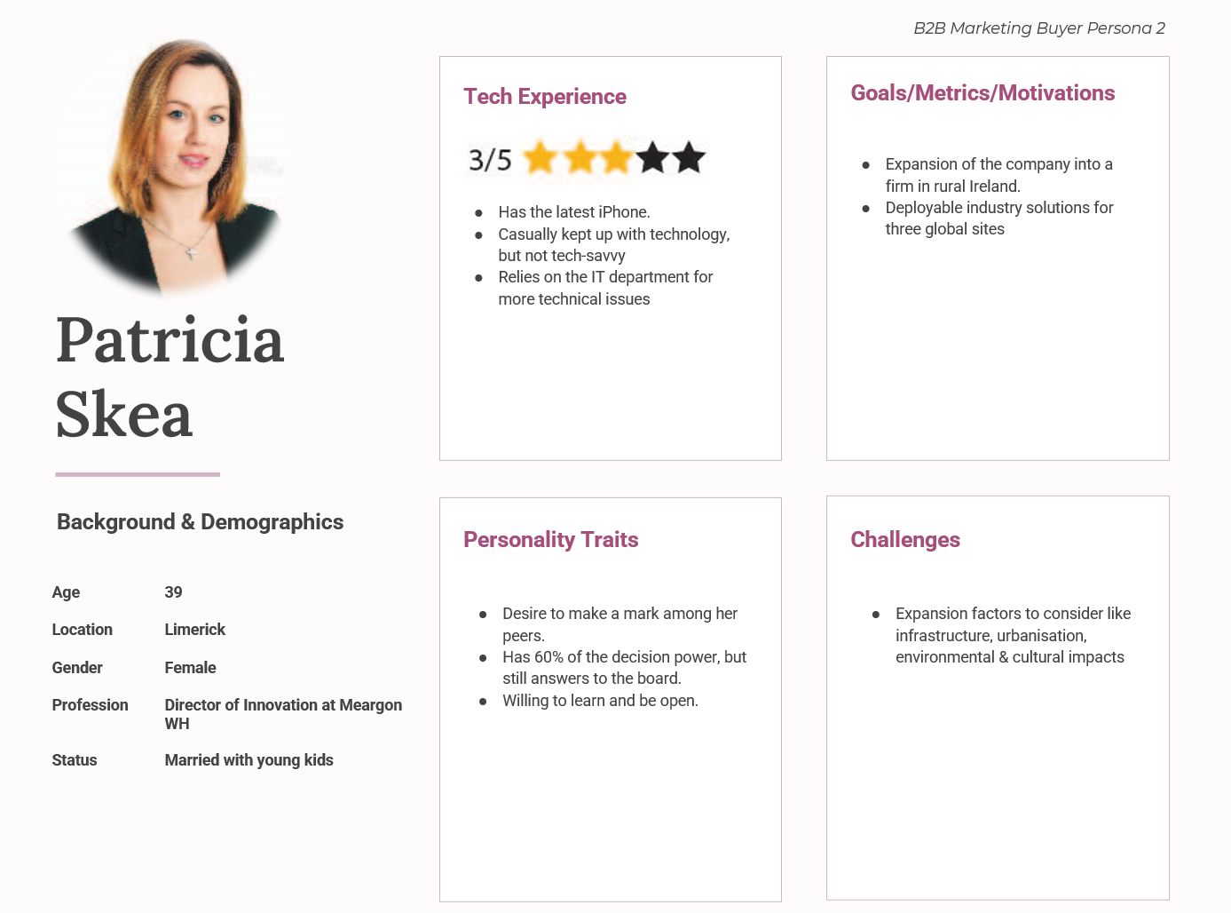

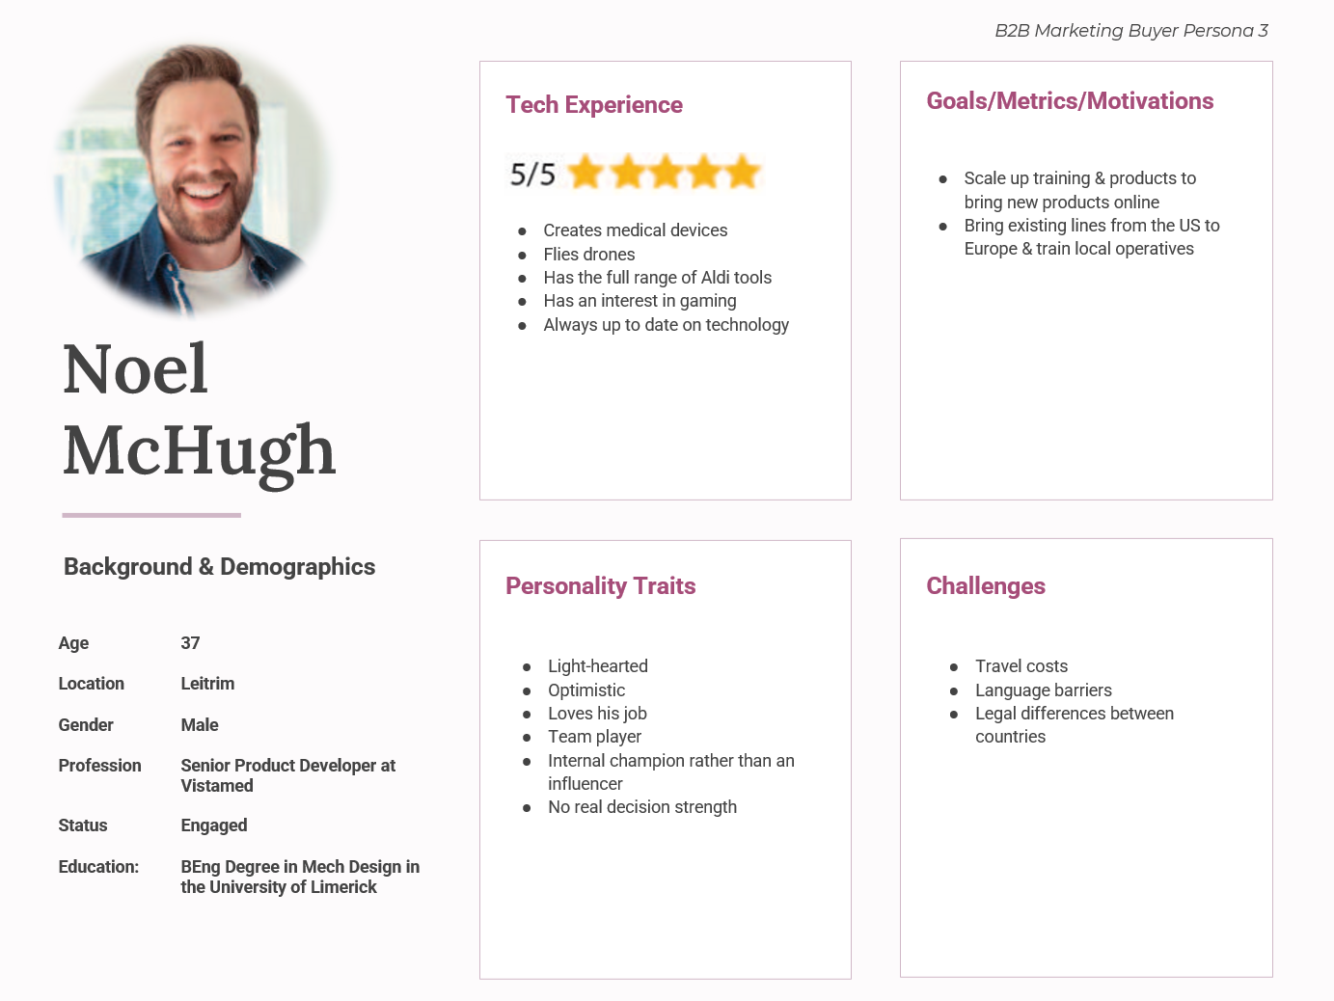

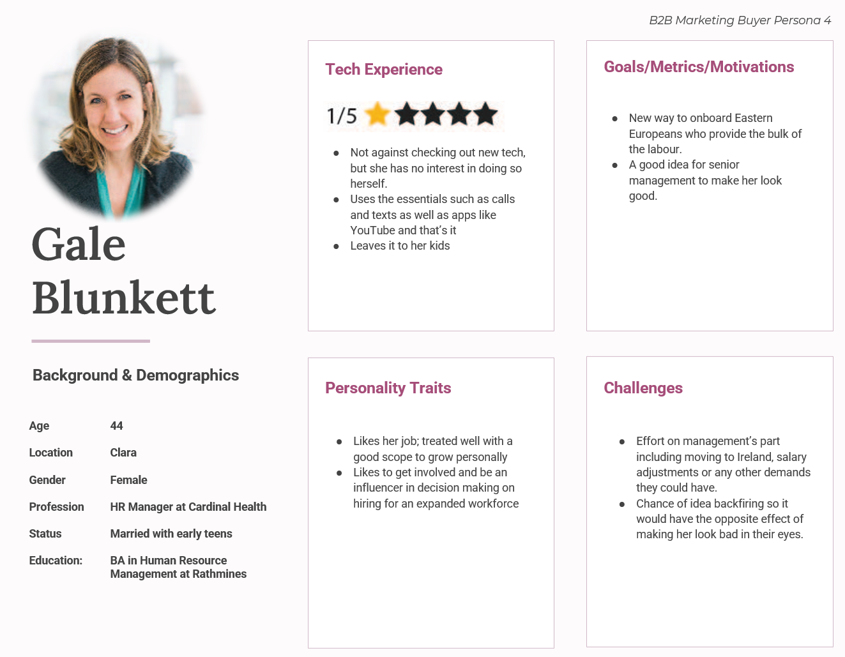
Figure 6 - The last four pages shows each customer persona provided by the company

Objectives
Reach
Performing activities needed to raise awareness and attract people to the brand. Drive users to the website through links from social media channels, SEO optimisation, etc. This can be measured through impressions to determine the number of users who are aware of the brand.
Engage
Focus on activities that nurture a relationship with the audience. Create content that incentivises the audience to engage with the brand. This can be measured through engagement rate to determine the people who interact with the brand against those who are aware of it
Activate
Focus on activities that provide users with the call to action. This can be measured through the conversion rate.
Research  Objectives | Increasing Brand Awareness | Increasing social media  engagement and creating a strategy around that | Continue to develop the website to increase SERP  and site health
Specific | Increase brand awareness to attract new talent. | Continue to build up a following on each social media platform. | Continue to update the Avatar Academy website and rectify issues affecting SEO.
Measurable | The number of reactions from customers can be measured against previous numbers and determines the results.  Use previous attempts of brand awareness as a reference point. | Insights from each social media page can be used.  Comparing the number of followers to the length of time each profile is active.  Comparing average engagement rates to the length of time each profile was active. | Since the site is brand new, there is a lack of info on past statistics, making it difficult to set the standard for now, will be addressed.  Results from the SEO audit can be used to resolve issues.
Actionable | Utilising various channels to push the brand message.  Create content that captures the interest of potential employees (images, informative, understanding, convincing others of the brand’s value). | Discover content that has been previously successful  Take inspiration from competitors and other relevant social media profiles.  Create different content for each page to give users a reason to follow more than one page while maintaining the same brand message.  Create content at a consistent rate to attract new users.  Include elements that encourage engagement such as links and imagery. | Accessing the website’s management system (WordPress, Wix, etc) so the admin can install plugins to keep track of SEO elements as well as connect Google Analytics to make it easier to manage the site around SEO.  Keywords can be better. incorporated; meta tag and descriptions created.
Relevant | Enhance Mersus’ reputation as a trusted brand and generate new talent that is interested based on what they see online. | These factors are more likely to create interest in a profile. Improves online presence. Indirectly helps with SEO through links to the site in front of a larger audience. | Pages can be improved and so the site has a better chance of exposure, hence, more traffic.
Timebound | Campaign specifically for attracting more attention in relevant areas done by May.  Overall increase in online presence by May. | 900 Facebook followers by May.  550 Instagram followers by May.  3,650 Twitter followers by May.  600 LinkedIn followers by May.  350 YouTube subscribers by May. | 10-15 blogs created before May.  Site Health over 90% before May.  Fix issues discovered through SEMRush before May.

Strategy

STP
Segmentation: Groupings based on demographics, geographic and behavioural factors were made. Based on geographic, the company’s target market is found in Ireland. This is reflected in the statistics for social media where the majority of users are found within the country. Gender-wise, there is a balanced ratio between the number of men and women on each page. As for age, most users were found to be within the 35-44 and 45-54 age ranges, followed by 25-34.
Based on demographic, the chosen industry is Life Science. In this area, virtual reality has been utilised to gamify patient journeys like showing users in VR how they would look if they made changes to their lifestyle or how they could look if they continued with an unhealthy habit. The healthcare & life sciences virtual reality market is projected to reach $8.03 billion by 2027 (Financial Express, 2021).
Targeting: Mersus Technologies specifically targets the Biopharma and MedTech segments of the industry. There are around 30,000 people working in over 85 Biopharma companies like Abbott, Pfizer, Johnson & Johnson and Cara Partners. (Murray, 2020), (IDA Ireland, 2020). Meanwhile, around 38,000 – 40,000 people are employed in over 300 MedTech companies including Boston Scientific, Siemens, Medtronic and Zimmer Biomet (GetReskilled, 2020). Currently, there is no official information from the government regarding AR/VR revenue and performance in Ireland. That being said, ‘Ireland is one of the top five global MedTech hubs, with particularly strong growth in the past two years’ and Biopharma firms in Ireland like NIBRT and BPC Skillnet have already made investments into immersive technologies and utilised them through virtual biopharmaceutical training, educational courses and more.
After sorting through a list of 44 companies in Ireland that fit the industry criteria, the most popular locations were narrowed down. 29 of those companies had establishments either Galway or Dublin or both, 7 had establishments in Cork and 5 were in Limerick. It aligns with the Facebook analytics, where some of the top locations included Dublin and Galway (Innopharma Education, n.d.).

Positioning: The Avatar Academy can be used to solve issues in the workplace. It helps nullify potential threats to health & safety, errors with physical pieces of machinery normally used during the training process and overuse of resources for the sake of training as every element of the training process is done in the virtual reality landscape. Outside of that, Mersus can accommodate for many types of companies when it comes to creating projects thanks to a budget toggle for when a client fills in the contact form as well as the type of work and project description areas. This is so Mersus can create projects in line with the client’s desired budget and allows the client to specify their desired direction for the project.
Mersus can create unique experiences for their clients. These experiences are proven to improve information retention compared to listening to instructions passively, which causes low completion rates and lower numbers of time spent on these activities. Even outside of clients, the portfolios seen on the Mersus website provides visitors with projects that can catch their eye. Emotionally, these can impress the visitors, whether it is due to a style or the technology behind it.

Figure 7 - The STP summarised and divided into three sections

Marketing Mix
Product: The product itself needs to create value and fulfil a purpose. The product needs to stand out against its competitors and those differences should be stated and expanded to further platforms. The company needs to convince users why they need to use their product, whether it’s by borrowing information like the statistics for immersive learning or explaining their unique selling points. The freedom of hand tracking technology for example helps to make the user's experience of interacting with the product simpler, an explanation such as this should be spread to each platform rather than just being confined to a channel waiting to be found.
Price: Pricing determines a business’ profit margins as well as the value of the product itself. The idea of the Avatar Academy is to render high fidelity graphics perform admirably on low-cost hardware. On the Mersus website, there is already a contact form allowing the client to choose the type of work they want done through any category, whether it’s 2D or 3D animation, live-action and virtual reality as well as selecting their own budget range to accommodate for this.
Place: The company can use social media insights and inside information to identify areas of interest. To further verify this, Google Analytics can be integrated into the site to find out where conversions are coming from, the most popular locations for visitors as well as those who are engaging with the call to action. Improving the technical aspects of their digital aspects will help to improve the profile of Mersus and especially the Avatar Academy.
Promotion: The purpose of promotion is to communicate the benefits of products and services. As part of a digital marketing strategy, brand promotion across all social media encourages cross-channel marketing by including various calls to action, incentivising users to follow each platform. A marketing campaign can also be done to attract new users to each channel as well. The effectiveness can be enhanced through features like paid advertising, hashtags, making the website more user friendly, upcoming events, etc.
People: Mersus’ main priority is to hire new people who can provide extra talent to the workplace. When using social media, the company needs to provide the audience with a window into how it feels to work there. By continuing to involve employees in content and creating a profile that is welcoming to these people. Using hashtags that are relevant in this context, promoting a healthy work environment and showcasing work done by employees to let potential candidates know what they are capable of are other methods for attracting potential newcomers to Mersus. There is also considerations on updating the communication aspect of the website for potential clients by incorporating a chatbot and calendar, so a brief discussion can be scheduled between both companies regarding the project written in the contact form.
Process: The delivery of the product is started with scheduling a demo through the website. This provides the opportunity for Mersus to have a conversation with its client and discuss how they want the project to be approached. Once that is done, it becomes available on the Avatar Academy headset for the client to utilise in practice during training sessions. Explanations of those experiences alongside live action and animation projects are part of the website’s portfolio. For a company with a specific purpose, it is important for their potential users to get an understanding of the call-to-action. This is a reason why it is integral to use other platforms alongside the site, which can aid in further explaining each stage of the explanation to the audience.
Physical Evidence: Mersus Technologies is a company that is renowned in its industry. With the testimonials and accolades from various entities, it gives the consumer a sense of familiarity as well as a reference point to the company’s reliability in the field. Taking advantage of this credibility in video form will not only create a higher level of engagement, but also provide audiences with recognisable names that have an association to the company.

Unique Selling Points
Mersus’ primary focus is on virtual reality. Its Avatar Academy platform aims to provide a service where companies can perform workplace training in a way where factors like health and safety, resources and expensive gear are not put at risk.
Hand Tracking Technology: One of Mersus’ major selling points is the implementation of hand tracking technology, meaning that no accessories or controllers are required for any Avatar Acdemy project, though that is still an option. This means that Mersus can design experiences to be more involved. For example, rather than pressing an input on a controller to perform an action, a user can instead use their hands like they would in the real world, whether it’s to grab an item or push a button. By eliminating the need for additional accessories, companies can use the technology in a way that is authentic to workplace training in real life. On top of that, the experience gained from training in VR carries over to real life thanks to the real-world environments and equipment being replicated into the virtual world.
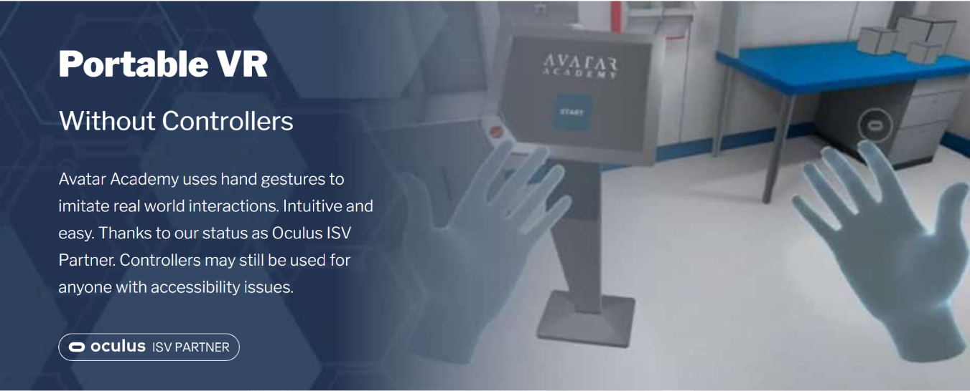
Figure 8 - An image on the Avatar Academy website pointing out being able to use hand tracking without requiring a controller
Low-Cost Hardware: Another important selling point is the ability to make high fidelity graphics perform admirably on low-cost hardware. In a niche, innovative area, it is important to create enough accessibility and by setting a lower price for this hardware compared to other headsets, it reduces the price barrier, therefore, opening the window to a bigger potential audience.
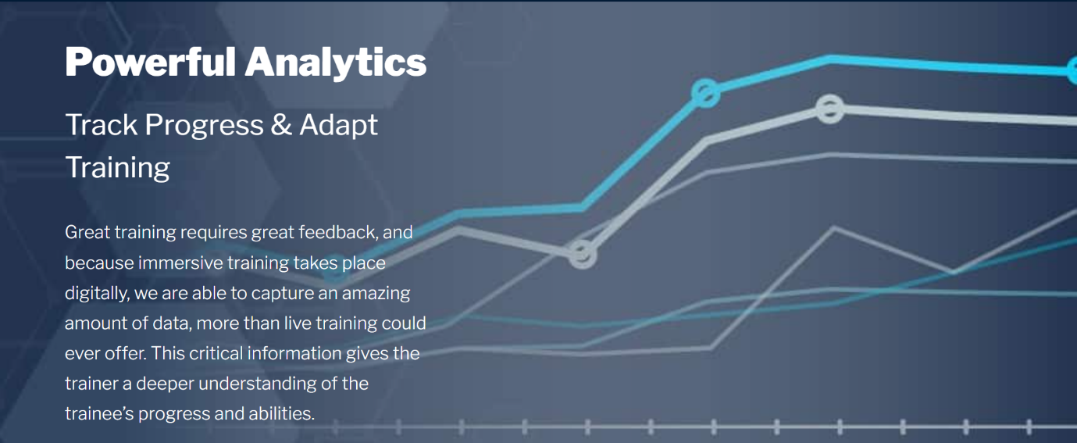
Training Analytics: Detailed analytics provide the performance of each person in each virtual training space. By providing crucial information, a company will be able to tell which people performed the best in each task and provides a deeper understanding of the trainee’s progress and abilities including strengths and weaknesses.

Figure 9 - An image on the Avatar Academy website pointing out progression tracking and data capture on a user’s performance during immersive training.

Branding/IMC Strategy
Mersus Technologies has two coinciding logos. Both have a blue colour motif but are used for different purposes, with the one on the left as a profile picture for the company’s social media pages and the banner on the right used for the main Mersus website. Psychologically, blue represents trust, reliability, efficiency and stability. The colour is commonly linked to creativity, which is encouraged in the industry Mersus falls into. It encourages better mind flow and performance, promotes a relaxing atmosphere to study or work in, stimulates a better state of mind, so you can keep the ideas flowing continuously. Stronger shades of blue support the brain’s thought process, while lighter shades help improve concentration (Barker Whittle, 2014). It also provides a sense of serenity and inspiration. Both logos show this use of multiple shades of blue to get this message across. The left image also includes a subtle design in the shape of someone using a VR headset, indicating what the company offers.



Figure 10 - The Mersus logo used for profile pictures (Left) and the website alongside being the main logo (Right)
A brand voice is required to have an identity that consumers can latch on and associate with the company. Mersus Technologies’ aim is to get involved in the evolution of technology and to create accessible content through virtual and augmented reality. The company aims to provide content that is informational and educative. Based on the writing found on both websites, this is evident. Both sites provide the user with an understanding of the company’s technology, statistics for immersive learning and portfolios and case studies of projects for previous clients. Since they target their services to other business as well as having the desire to attract and hire some new talent, an informative approach to the content is important. Since there is a lot of information to take in for any outsiders, educating any potential audience on the subject matter and providing an easy understanding of it is imperative.
The company should tell a story that captures every aspect of their identity. Ideas could include behind the scenes discussions of previous projects and how they came to be, collaborating with previous clients to tell the audience about how they felt Mersus handled their projects, a company timeline beginning from when they were known as Makin Media Mobile to the present day and content about the team behind the brand to provide authenticity as well as making the company seem more approachable to potential clients or employees.
Finding out what the competitor is doing with their social media page will be of significant help. In this case, it is no harm to research the type of content published by VRAI on their respective social media platforms as a reference point to gauge the standard of Mersus’ own posts as well as a potential point of inspiration for any future posts. While VRAI is the main competitor in this field, it is also important to look to other relevant profiles such as Immerse for further inspiration.

Utilising the promotional mix, IMC tools can be conceptualised to help achieve the common marketing goal.
Digital Marketing: With all five of Mersus’ social media accounts, they can use these to integrate organic links back to the website pages for overarching engagement and a chance of conversion. Each respective social media page should feel like they come from the same umbrella, but at the same time, differentiate themselves to give the audience a reason to follow them on more than one channel
Events: In Ireland, virtual reality and immersive technology has only really developed a presence in recent years. With that, relatively new events and exhibitions have shown up including the ARVR INNOVATE Conference and Expo, Dublin Tech Summit and ACE Virtual Open Event 2021 among others. Regardless of if the company takes part in the event or appear as a spectator, the company can walk away with valuable information. These include the size of the audience; how other companies utilise immersive technology, gain information on how they could market themselves in person and if they take part in it, giving other people an impression of the tech and a clearer understanding of the experience.
Personal Selling: The way the company provides their services require interaction between them and the client. While the client comes to Mersus with their ideas, it allows the company to communicate with the client directly, figure out exactly what kind of project they want completed and to make that project a reality. The relationship between the two organisations builds up and when the project is completed, leaves room for positive experiences aimed at Mersus.

Figure 11 - Diagram highlighting the IMC tools the company have used or can be utilised. Done by SmartArt through Diverging Radial

SEO Strategy
As described from the SEO Audit done in SEMRush, various issues arose that be solved.
4xx status code
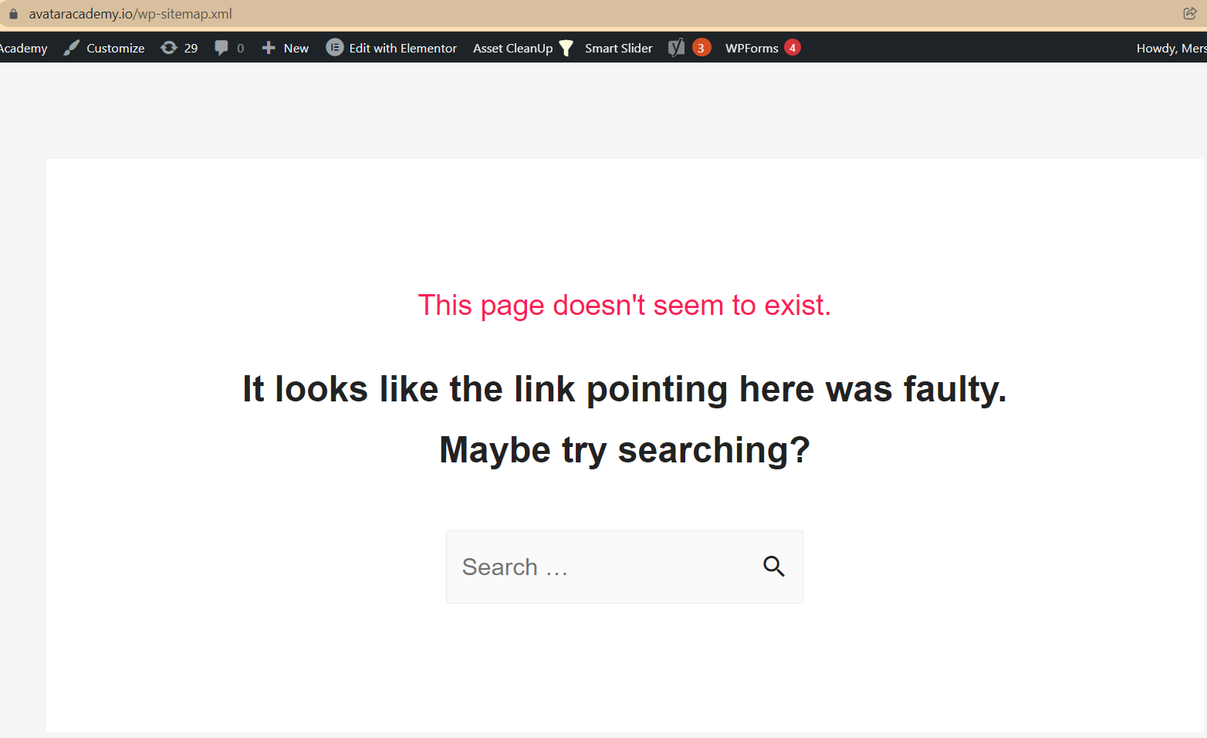
A 4xx status code occurs from broken links, meaning the page cannot be accessed. In this case, it is due to the XML sitemap, which is found in a different URL. By using the plugin YoastSEO, it enables the ability to turn on and off for sitemap XMLs.
Figure 12 – The error page occurring when typing ‘sitemap.xml’ into the URL for the Avatar Academy website
Duplicate title tags
The culprit for the duplicate title tags is the analytics login section of the website. It makes it difficult for search engines to determine which of a website’s pages is relevant for a specific search query, and which one should be prioritized in search results.

Meta descriptions
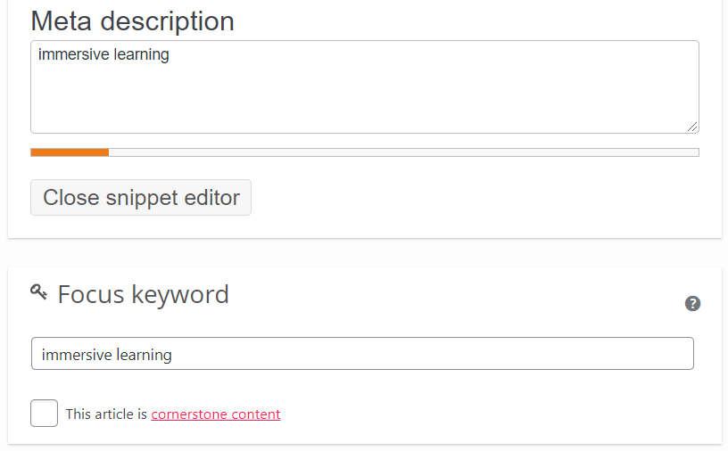
When a user goes on the search engine, they will notice a description under each link to a webpage. Ideally, the meta description needs to fulfil criteria such as having enough characters to fill the screen and include the chosen keyword delegated to that page. For example, if “immersive learning” is the focus keyword, it is essential to implement that same word into the meta description. When the user searches that keyword and if the page shows up on the search engine, “immersive learning” should be highlighted in bold. The meta description should be written so that it includes that page’s chosen keyword and reach a character limit so the entire description can fit in the page, which is encouraged by the search engine. Keywords should be chosen to accommodate each page on the Avatar Academy site.
Figure 13 - Example of the change to a meta description and focus keyword on WordPress

Low text/ HTML ratio
This means that there is less text on the page than code. A simple fix would be to increase the amount of the text on the page, but certain pages may not be designed with that in mind. Since most of the pages meet the 300-word minimum requirement according to YoastSEO, it is very likely that the coding is the cause of this. By influencing the amount of code, it can also potentially increase the loading speed of the page and website in general. To do this, the site should

By HTTPS page leading to HTTP page
What this means is that some links on the website could contain an older version of the page in question. The page leading to the project for NIBRT contains a HTTP link. The HTTPS is the updated version. To do this, an SSL Certificate is needed. By doing this, it should stop the search engine from becoming confused as to which version of the page they should rank.
Internal and External links
In one page, there is a lack of internal links, which can be easily rectified by linking to another page on the Avatar Academy through the page editor on Wordpress, whether it’s by a traditional link or through integrating it into a hyperlink on the relevant word. The majority of pages however include external links with nofollow attributes. Encouraging the search engine not to use a link. The unintentional use of nofollow attributes may have a negative impact on the crawling process and rankings. If nofollow is unintentional, the issue can be fixed by getting them removed from <a> tags by finding the appropriate plugin.

Social Media Strategy
The issue is that there has not been much of a social media presence this year aside from LinkedIn. The lack of activity on Facebook, Instagram and Twitter are evident of this, there were bigger priorities in the company’s eyes. Because of this, the number of followers has not been increasing. When creating content on social media, it is crucial that content is audited every month to figure out the performance for each individual piece of content. By doing this, the strategy can be tweaked regularly to ensure optimal results. Each social media platform fulfils different niches:
- Facebook: Building a following for your brand and interacting with the community through questions, comments, engagements, calls to action, etc.
- Twitter: Following and engaging with other users that would be interested in what you have to offer and building relationships with people within your network, whether they are part of the current or potential audience.
- Instagram: Publishing and viewing visually appealing content such as videos, and photos
- LinkedIn: Connecting and engaging with other business professionals, showcasing the workplace, and posting new job opportunities for potential employees.
- YouTube: Publishing and viewing video content.
From the insights found in the situation analysis, there were no incidents of paid posts and even when attempting to create an ad, the Facebook page specifically is restricted from advertising. When boosting posts, a selected amount of money is spent in tandem with the number of possible impressions. Boosting posts allow the poster to set goals and target an audience based on locations, age range and interests.
The ultimate purpose of publishing content on social media is to achieve tasks, whether its increasing brand awareness and lead generation. Because of Mersus’ specific objectives, one of the tasks is to create demand for people wanting to work for them. By focusing on the areas of interest for this demographic, whether it’s through content relating to virtual reality, arts, storytelling or all the above, social media is the outlet to where they will be able to fulfil this objective by spreading themselves to a wider audience.

Content Strategy
Due to its B2B nature, Mersus Technologies aims for their content to have an informative/educational approach. It is important to consider the needs of companies and to be able to capitalise on that. To attract returning and potential users to the website, the company should maintain a consistent schedule to let users know when content is posted and create a rhythm. The company needs to create content designed to educate the customers. On the Avatar Academy websites, some of the selling points are listed. However, this needs to extend to the other channels. The company needs to use multiple outlets to tell people what makes their product/service stand out from competitors.
Designing different content for different channels are important alongside creating content that easily translates across each channel. As the company wishes for their content to be informative and educational, the writing must reflect this. Currently, the Avatar Academy website provides content that is informative and visually appealing through images and statistics. This information can easily be translated into content for the social media side in different ways like infographics, charts, video, etc.
As alluded to previously, one of the goals is to have blogs created for the website. Creating blogs is one way for the website itself to create relevant content that will engage the audience. When researching the blogs created on the Mersus website, the focus was on topics such as VR training, VR and AR talent and interviews with leading members of the industry. Since the Avatar Academy website is dedicated to that software, it is logical to make content based on the Avatar Academy. This can include the architecture of the product, showcasing the development of Avatar Academy projects, inspiration behind the brand, more statistics behind the effects of immersive learning and more. It is essential to push this content to channels that provide potential for exposure and engagement.

Tactics
Four tactics have been devised for each objective.
Increasing Brand Awareness
- As previously mentioned, it is important to have an identity that consumers can latch on and associate with the company. This idea should be consistent across all channels. Since the main purpose is to attract new talent, there should be overlap in content and the type of content to be created should be of interest to that crowd.
- Multi-channel marketing blends various communication channels for the purpose of marketing. This can include things like cross-promotion between two or more social media channels, external links to the website or other platforms, providing calls to action
- Monitor Brand interactions across each channel. The most important question to ask is ‘where is your brand being mentioned?’ Monitoring your online presence doesn’t stop at engagements or analytics. It can go beyond profiles, whether it’s through Google searches, using the name of your page through search tools on social media, hashtags that you may have been used, engagement of your content that has been shared or mentions in other users’ content and the level of engagement there. The goal is to find out the most popular places where the brand is referenced and learn from that for the future.
- While the Avatar Academy is connected to Mersus, the Avatar Academy brand is significant to the point that it has a domain dedicated to it. Since the Academy can be seen as its own entity, it is important to develop a voice for the brand and see how it can work alongside the company brand.

Increasing social media engagement and creating a strategy around that
- In order to engage with the audience regularly, a consistent posting schedule needs to be created for every social media channel. By making content regularly, the customer gets to see more of the brand, given them more opportunities to interact with posts, hence higher levels of engagement compared to before.
- With Mersus’ speciality in VR, AR and animations, it is a perfect match for visual content creation. Mersus has shared videos and images on its social media before based on previous undertakings. This kind of content works because it has the potential to transfer seamlessly into other channels. It also leaves room for extra posts that need to be created from the top. It was predicted that for this year, 40% of marketers predicted between 51% and 80% of businesses would heavily rely on visual content. (Mawhinney, 2020)
- Since Mersus’ primary goal is awareness, a campaign can be set up to accomplish this. Paid ads or posts can significantly boost impressions, possibly leading to extra engagement. This can be used in important circumstances like posts that lead back to the website, new events or updates and posts telling people that the company is hiring.
- As more posts are made, insights that give more insights and clarity are generated. The importance of insights extends to elements like the time of day the audience is active, growth of followers, views, location, percentage of the type of posts made, etc.
Continue to develop the website to increase SERP and site health
- The company wants to develop blogs for the Avatar Academy like they have done so already for the main Mersus website. The aim is to create content that is informative and educational regarding the subject of immersive technology. Blogs can easily be transformed to accommodate for social media platforms, or it can be done as an incentive for users to click into the website. To further enhance the effectiveness of blogs, insert into social media pages for longevity and another avenue of engagement
- No page on the website has any tailored keyword to focus on. By integrating appropriate keywords onto each page, it gives them their own focus and SEO practices can be tailored to that page. Keywords should be used in every opportunity, whether its in blogs, the title of the page, meta description, URL, etc. The keyword is used two or three times per page and should be worded in a way that is natural rather than abusing the system by constantly repeating the word for SEO. It is advised to use a different keyword for every page to better accommodate for a specific topic and to create a diverse line of keywords the site can rank for.
- Another idea is to connect the site to Google Analytics via the Google Search Console. By registering the website with Google Analytics, it gives the company a way to monitor its performance in areas such as engagement, audience behaviour, sources of traffic, location, devices, etc.
- Like with the keywords, it is important for each page of the website to have its own tags and descriptions.

Research  Objective | Increasing Brand Awareness | Increasing social media  engagement and creating a strategy around that | Continue to develop the website to increase SERP  and site health
Research  Tactics | - Develop a consistent brand voice across all channels.  - Multi-channel marketing to cover all fronts.  - Monitor Brand interactions across each channel.  - Develop a voice of the Avatar Academy brand and how it can work alongside the company brand. | - Create a consistent posting schedule for every channel.  - Develop new visual content supporting the brand on social media.  - Create social media campaigns for the purpose of increasing engagement.  - Regularly monitor insights to identify areas that need to be improved as well as those that work. | - Develop blogs on the website.  - Set up and track website analytics.  - Integrate appropriate focus keywords into content for the website.  - Implement various SEO techniques.  - Add tags and meta descriptions.

Actions

Content Plan
The content plan goes over the specific pieces of content to be created over the coming weeks under the six platforms shown below. This is susceptible to change with more ideas cropping up as time goes on. The plan doesn’t include potential important news from Mersus, articles from other sources to be shared and most elements of the timeline section.
Content Calendar: January
Week | Facebook | Twitter | Instagram | LinkedIn | YouTube | Website
1 | Post a link letting people know about the Avatar Academy website. | Post a link letting people know about the Avatar Academy website. | Virtual Reality fun fact 1. | Immersive Reality trends for 2022.  Post a link letting people know about the Avatar Academy website. | Update About page to include all channels. | Connect Google Analytics to the site.  Fix keyword focus, slug and meta descriptions for current pages.
2 | Share first blog post from website.  Industry statistics done like an infographic. | Share first blog post from website. | Industry statistics done like an infographic.  Story explaining the Avatar Academy in a visually appealing way.  Augmented Reality fun fact 1. | Poll: Ask audience if they have ever used VR themselves before?  Share first blog post from website.  ‘Fill in the blank’ update. |  | Install SEO plugins (YoastSEO & MonsterInsights).  Set up blog page.  Create the 1st blog.
3 | Collection of testimonials done in a video.  Behind-the-scenes pictures of staff at work. |  | Word cloud with words relating to immersive technology in the shape of headset  Virtual Reality fun fact 2 | Behind-the-scenes pictures of staff at work.  Collection of testimonials done in a video.  VR/AR post relating to education for International Education Day. |  | Create the 2nd blog.  Gather desired keywords.  Optimise images (alt tags).
Content Calendar: February
Week | Facebook | Twitter | Instagram | LinkedIn | YouTube | Website
4 | Infographic detailing the evolution of Mersus. | Retweet other users with VR and AR showcases. | Augmented Reality fun fact 2.  Showing other small accounts with VR and AR showcases. | Infographic detailing the evolution of Mersus. | Video showing a live preview of the Avatar Academy headset. | Integrate calendar into booking a demo section.
5 | Start of campaign for attracting talented people in the VR/AR, Arts & Storytelling.  Contest for people to create individual art/animation/story, share across channels. | Infographic detailing the evolution of Mersus  Post letting people know about the campaign. | Virtual Reality fun fact 3.  Post letting people know about the campaign. | Video of Virtual Reality being used in other occupations.  Post letting people know about the campaign |  | Create the 3rd blog.  Update HTTP page to HTTPS.  Minor changes to page (add internal link & remove unnecessary h1 heading).
6 | Post connecting VR/AR to Valentine’s Day. | Post connecting VR/AR to Valentine’s Day. | Augmented Reality fun fact 3.  Post connecting VR/AR to Valentine’s Day. | Post linking to a Virtual Reality Self-Assessment Tool  Poll: Ask audience what aspect of VR they find most interesting. |  | Create the 4th blog.
7 | Immersive learning from the perspective of the employee. | Virtual Reality and collaboration in the workplace. | Post of VR clip telling a person to move their phone left/right for a moment.  Virtual Reality fun fact 4.  Virtual Reality and collaboration in the workplace. | Survey about the virtual reality experience.  Virtual Reality in the stages of recruitment. | Video showing staff working behind the scenes. | Fix external links with unnecessary nofollow attributes.  Improve loading speed, find issue causing this.  Create the 5th blog.

Content Calendar: March
Week | Facebook | Twitter | Instagram | LinkedIn | YouTube | Website
8 | Borrow statistics from the Avatar Academy website and group them in one post.  Remind users of the demo section calendar from Week 5. | Poll: Ask audience if they have ever used VR themselves before?  Remind users of the demo section calendar from Week 5. | Borrow statistics from the Avatar Academy website and group them in one post  Augmented Reality fun fact 4. | Borrow statistics from the Avatar Academy website and group them in one post.  Remind users of the demo section calendar from Week 5. |  | Create the 6th blog.  Display an FAQ to provide users with a better understanding of the Avatar Academy.
9 | International Women's Day post  Showcasing creations from the campaign contest and allowing users to vote for their favourite. | International Women's Day post  Showcasing creations from the campaign contest allowing users to vote for their favourite. | Virtual Reality fun fact 5.  Showcasing creations from the campaign contest allowing users to vote for their favourite. | Showcasing creations from the campaign contest allowing users to vote for their favourite. | Video showing the Avatar Academy being used elsewhere. | Solve low text/ HTML ratio issue.
10 | Post connecting VR/AR to St. Patrick’s Day.  Post a section of the FAQ from week 8 (different for every platform). | Post connecting VR/AR to St. Patrick’s Day.  Poll: Name your headset of choice. | Augmented Reality fun fact 5.  Post connecting VR/AR to St. Patrick’s Day. | Post a section of the FAQ from week 8 (different for every platform). |  | Create the 7th blog.
11 |  | Post a section of the FAQ from week 8 (different for every platform). | Virtual Reality fun fact 6.

Content Calendar: April
Week | Facebook | Twitter | Instagram | LinkedIn | YouTube | Website
12 |  |  | Augmented Reality fun fact 6.  Post a section of the FAQ from week 8 (different for every platform). |  | Evolution of Mersus reworked for video. | Create the 8th blog.
13 |  | Poll: Which of these industries do you think VR will evolve the most? | Virtual Reality fun fact 7.
14 | Post connecting VR/AR to Easter. | Post connecting VR/AR to Easter. | Augmented Reality fun fact 7.  Post connecting VR/AR to Easter. |  |  | Create the 9th blog.
15 |  |  | Virtual Reality fun fact 8 |  | v | Create the 10th blog.

Timeline
RESEARCH OBJECTIVE 1 | PLAN WEEK START | PLAN  WEEK DURATION
Increase Brand Awareness and Develop a Strong Digital Presence | 1 | 15
Develop Brand IMC Strategy | 2 | 15
Develop Engagement Strategy | 2 | 15
Campaigns on social media pages | 5 | 13
Develop a consistent brand  voice across all channels | 1 | 15
Integrate digital channels | 2 | 15
Increase Brand Communication engagement across all platforms | 1 | 15
Post some content only found on individual channels to incentivise users to follow each page | 3 | 12
Create content that captures the interest of potential employees | 1 | 15
Monitor Brand interactions  across all channels | 1 | 15

RESEARCH OBJECTIVE 2 | PLAN WEEK START | PLAN  WEEK DURATION
1. Facebook
Create posts emphasising the value of the brand | 1 | 15
Use paid ads and posts to drive traffic | 3 | 15
Repost links to blogs on the Avatar Academy website | 2 | 15
Facebook Insights Monitoring | 1 | 15
Add Messenger support to the page | 3 | 4
Evaluate content performance to figure out what works and what doesn’t | 4 | 15
Long Term ad campaign designed to attract talented people in the areas VR/AR and arts, showcasing synergy between these fields | 5 | 15
2. Instagram
Develop new imagery content supporting the brand on social media | 1 | 15
Instagram Insights Monitoring | 1 | 15
Publish content that encourages users to interact and engage | 2 | 15
Translate information from the website to posts/stories in a format appropriate to the platform. | 2 | 15
Switch to Professional Account if not done already | 3 | 4
3. LinkedIn
LinkedIn Insights Monitoring | 1 | 15
Long Term ad campaign designed to attract talented people in the areas VR/AR and arts, showcasing synergy between these fields | 5 | 15
Polls for improved engagement as well as feedback | 2 | 15
Sharing articles and posts relevant to the industry | 1 | 15
Repost links to blogs on the Avatar Academy website | 2 | 15
4. Twitter
Tweets linking back to Avatar Academy website (include hashtags) | 1 | 15
Search relevant terms and share tweets by smaller profiles (better chance of following back than larger companies) | 1 | 15
Mention other entities in tweets for more potential impressions | 1 | 15
Twitter Insights Monitoring | 1 | 15
Switch to Professional Account | 3 | 4
5. YouTube
Video(s) behind the scenes at Mersus | 4 | 5
Share videos to other social media pages | 4 | 15
YouTube Insights Monitoring | 1 | 15
Update About section | 1 | 1
Video of Avatar Academy under different circumstances | 7 | 8

RESEARCH OBJECTIVE 3 | PLAN WEEK START | PLAN  WEEK DURATION
Connect Google Anaytics to establish statistics | 1 | 2
Fix technical issues found from SEMRush and remove unnecessary elements that slow down the site | 3 | 15
Implement focus keywords and meta descriptions into each page | 1 | 3
Implement on-page SEO techniques. | 3 | 15
Implement Of-page SEO Techniques | 3 | 15
Install important WordPress plugins | 2 | 4
Develop a backlink campaign | 4 | 15
Set up a blog page and develop content for it | 2 | 15
Develop a keyword strategy and get into the first page of the search engine through other keywords | 2 | 15

Controls
To develop an effective measurement plan, Mersus Technologies need to follow these steps:
Step 1: Document business objectives
The three objectives outlined for Mersus are increasing its brand awareness, social media engagement and website performance. The overall purpose of these objectives is to increase their online presence. To fulfil their main priority, the company should invest their time into digital marketing, especially with the post potential considering the industry they are in. Since Mersus already excels with creating experiences and visuals appealing to the eye, it provides a window of opportunity. Their past projects are malleable and provides a simple crossover to the marketing channels discussed in this report. On top of that, new content can be made to not only entertain current followers, but to entice new ones to follow each page.
Step 2: Create important goals
Having goals will help the company accomplish these objectives. Goals should be set on a regular basis to monitor and build up on in the future. These include:
- Post regularly on social media sites.
- Rank for more keywords on SEO.
- Continue to develop the website and make it more viable on the search engine.
- Attract more users to all platforms.
Step 3: Key Performance Indicators
KPI determines the numbers for various elements like social, SEO, PPC, email, referrals & content to help the company find out what works and what doesn’t.

With the website, the most important factor at the moment is visitors. While there is a way for users to access the website through the Mersus website, there is potential for that number to increase. Without visitor impressions, the site cannot record numbers in any other area. Another factor is the conversion rate. The image below acts as the call-to-action as it prompts a response from the user and leads to the point where they can act in the company’s favour. The engagement rate is the next important KPI. While many users may be aware of the website, it doesn’t mean anything if nobody engages with it. In this case, it is valuable because of the blogs to be made since they have their own comments and metrics of engagement. Through analytics, it can be determined how long users spent reading each blog and estimate how much of it they read. Outside of that, a high engagement rate in general indicates that the site is of high quality and interesting enough to most users. Lastly, there is traffic, in this case, it refers to the source of traffic where users came from. By recording this information, the company can determine how users reach the site, whether this is done organically, or through direct or referral means.
Figure 14 - Call to action on the website, with the demo scheduling found on 'Contact Us'
Considering Mersus’ overall social media status, the biggest priority is to create a consistent posting schedule to ensure a better chance of gaining better results. The first metric is impressions/reach, the number of people who are aware of each post. Like with the website, it is a valuable metric as it counts every user that is aware of the post in some way, whether it was on their news feed or they saw it. However, that means nothing if there are no engagements made. It proves that users have enough interest in a post to either like, share, comment or click a link, depending on the post itself. Another vital metric is follower count as it ensures that these users will always come across the page’s posts and it means they have enough interest in the profile to keep up with the latest content. Lastly, there is conversions, which indicates a user has performed what a business wanted them to do. This could include visiting the website, following the blogs, following the other social media channels, filling out a form, etc.
With SEO, search rankings are very important as established. Typing a keyword and finding the site falls under direct traffic as the user goes out of their way to look for it. It directly correlates with SEO success and makes it easier for the website to be sound directly. The site may rank when typing in ‘avatar academy’, but the aim is to rank for broader terms that users are more likely to search. The next metric is domain authority, essentially predicting how likely the entire website is to appear in SERPs, specifically on how they would compare to their competitors on the search engine. This is ranked from 0 to 100. Speaking of competitors, it is important to research how they rank on the search engine. By comparing keywords, the company can analyse how the competitor managed to rank as well as find inspiration for improvements to their own search engine position. Outside of competitors, the company can analyse other pages to find out how they were able to rank for any desired keywords. Lastly, backlinks are the connections from one website to a page on another. The more backlinks that a website has, the better chance it has of achieving higher search rankings. A page with many backlinks can indicate that other places view the website favourably enough to create links for users to interact with.
Important Key performance indicators for Mersus Technologies’ digital marketing channels
Website | Website Visitors | Conversion Rate | Engagement Rate | Traffic
Social Media | Impressions/Reach | Engagements | Follower Count | Conversions
SEO | Search Rankings | Domain Authority | Competitor Rankings | Backlinks

Step 4: Set targets
With these KPIs in mind, goals must be set in order to help measure performance. By having a goal set, the company has an incentive to push their channels to the market to try and reach the numeric values shown. Once the time has passed, they have a better idea on how realistic the goals were and how to readjust them for the future. The following are initial goals for Mersus in the areas of website, social media and SEO throughout January to May:
- Avatar Academy Website
  - Visitors – 1000 visitors
  - Conversions – 3-5% of visitors
  - Engagement Rate – At least 50%
- Social Media
  - Impressions (organic) – 2,000 (Facebook/Twitter), 35,000 views (YouTube), 2,000-4,000 (LinkedIn), 300 (Instagram)
  - Follower Count – 900 (Facebook), 550 (Instagram), 3,650 (Twitter), 600 (LinkedIn), 350 (YouTube)
  - Engagements – 500 (Facebook), 1-2% (Twitter), 2-3% engagement rate (Instagram), 200 (LinkedIn)
- SEO
  - Keyword Rankings – Rank on the 1st page for at least one of the three keywords
  - Domain Authority – At least 40-60

Conclusion
This project aims to set out a digital strategy for Mersus Technologies over the next few months. The marketing strategy establishes where content and actions can be put in place to build brand awareness, increase social media engagement and improve website analytics. By using the information given to them, Mersus can use these as a metric to see the types of people interested in their content as well as their background. Mersus specialises in a very specific area that has not yet made an impact on a grand scale, due to the virtual reality platform itself still being at its early growth. With the Avatar Academy, Mersus is contributing to make the platform more accessible to businesses. Ultimately, the type of content in mind is promoting the platform in general, creating more awareness for it so that business open up to the idea of immersive training and a better understanding of how it works. It is working in tandem to let other users get an understanding of this specific area and even get others interested in working in this area through the likes of the campaign and content that incentivises engagement. The purpose for this project is to show the current digital situation of Mersus Technologies and the considerations that can be made to improve this area. For a company specialising in a digital-oriented area, it is essential for them to make a mark in a digital market.

Bibliography
ARVR Innovate, n.d. Home. [Online]
Available at: https://arvrinnovate.com/
[Accessed 12 December 2021].
Barker Whittle, 2014. 3 Colours that Improve Concentration & Productivity. [Online]
Available at: https://www.barker-whittle.com.au/blog/3-colours-improve-concentration-productivity
[Accessed 10 December 2021].
Ducalis.io, 2020. REAN or RACE: what’s the difference. [Online]
Available at: https://medium.com/ducalis-blog/rean-or-race-whats-the-difference-2ad26773fc1d
[Accessed 13 December 2021].
Financial Express, 2021. Role of virtual reality in healthcare and life science research. [Online]
Available at: https://www.financialexpress.com/lifestyle/health/role-of-virtual-reality-in-healthcare-and-life-science-research/2276874/
[Accessed 3 January 2022].
Grenne, J., 2021. Social Media and SEO: How They Work Together to Boost Your Visibility. [Online]
Available at: https://databox.com/social-media-and-seo
[Accessed 13 December 2021].
Innopharma Education, n.d. The Pharma and MedTech Industries are booming in Ireland: here's a list of companies hiring. [Online]
Available at: https://www.innopharmaeducation.com/news/pharmaceutical-medical-technology-companies-ireland
Irish Times, 2019. Immersive Technologies from hype to hyper performance. [Online]
Available at: https://www.irishtimes.com/advertising-feature/immersive-technologies-from-hype-to-hyper-performance-1.3856902
[Accessed 12 December 2021].
Marinigh, L., 2016. A Breakdown of Social Media Platforms and Their Uses. [Online]
Available at: https://www.futurpreneur.ca/en/2016/a-breakdown-of-social-media-platforms-and-their-uses/
[Accessed 13 December 2021].
Mawhinney, J., 2020. 50 Visual Content Marketing Statistics You Should Know in 2021. [Online]
Available at: https://blog.hubspot.com/marketing/visual-content-marketing-strategy
[Accessed 13 December 2021].
Smart Insights, 2021. Define effective digital marketing KPIs to achieve your goals in 2022. [Online]
Available at: https://www.smartinsights.com/goal-setting-evaluation/goals-kpis/choosing-effective-digital-marketing-kpis/
[Accessed 14 December 2021].
The Irish Advantage, 2018. Irish medtech sector attracts €259 million in investment. [Online]
Available at: https://irishadvantage.com/irish-medtech-sector-259-million-investment/
[Accessed 3 January 2022].

Appendix

