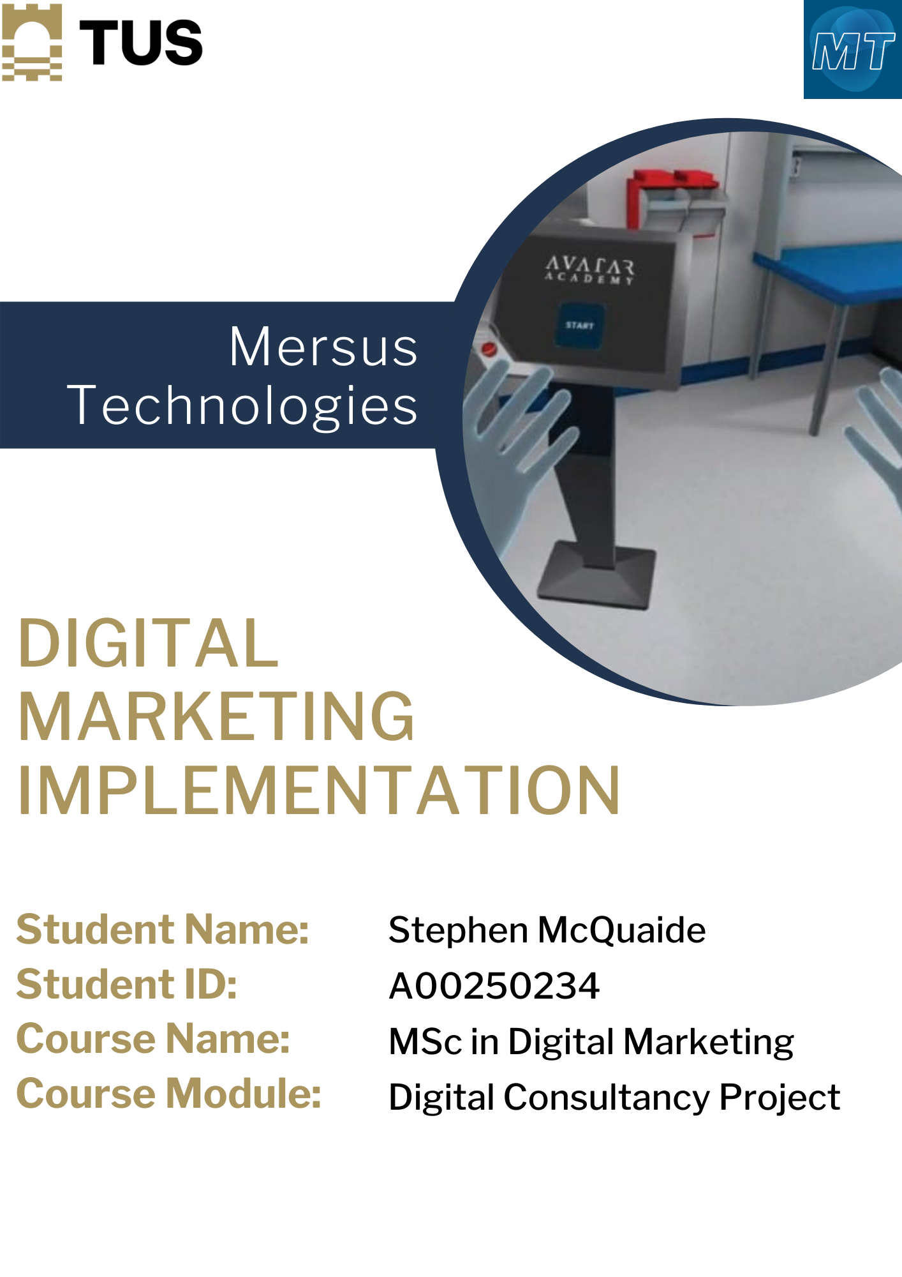



Contents
1. Executive Summary 1
2. SEO 2
2.1. Keyword Research 2
2.2. On-Page SEO 3
2.2.1. Title/Meta Description/Keywords 3
2.2.2. Keyword Rich URL Structure 25
2.2.3. Keyword Rich Content 26
2.2.4. Sitemap 27
2.3. Off-Page SEO 31
2.3.1. Backlinks 31
2.3.2. Google Algorithms 33
2.3.3. Domain Authority 33
2.4. Monthly Monitoring Insights 35
3. Social Media 39
3.1. Research/Investigation 39
3.2. Social Media Strategy 41
3.3. Posts Created/Engagement 42
3.3.1. Instagram 42
3.3.2. Facebook 44
3.3.3. Twitter 50
3.3.4. LinkedIn 57
3.4. Monthly Monitoring Insights 65
4. Design Content Creation 71
4.1. Image Creation 71
4.2. Video Creation 79
4.3. Other Digital Artifacts 83
5. Other Marketing Efforts 85
5.1. Email Marketing 85
5.2. Brand Image Development 85
5.3. Company Visits 86
5.4. Website Development 87
5.5. Paid Advertising 91
5.6. Future Suggestions 91
6. Professional Development Skills 93
6.1. Problem Solving 93
6.2. Initiative 93
6.3. Relationship Building & Engagement 94
6.4. Project Management 95
7. Conclusion 95

Executive Summary
This report goes over the implementation stage of this project. The report begins with Mersus’ On-Page SEO performance, factoring in the changes made to the Title Tags, Meta Descriptions and Focus Keywords, presence of keywords in the overall URL structure of the website, keywords integrated into each piece of content, the sitemap and the changes made to its navigation and implementation into the Google Search Console.
Off-Site SEO focuses on a backlink analysis for avataracademy.io, the Panda and Penguin Google algorithms and how they affect its performance on the search engine and domain authority as well as why it is important to create a network of connections to other websites. The SEO Monthly Monitoring Insights goes over a snapshot of the website’s Google Analytics and how it performed in multiple aspects over the course of the implementation stage.
Social Media delves into the research and investigation on each profile and their performances, the strategies done to improve on the current situation, summaries of every single post made on each platform over the last three months and Monthly Monitoring Insights into each social media page and their performances after implementation.
Design Content Creation highlights every image and video made during the implementation stage, how they were made, and the software used to make them as well as other digital artifacts; in this case, the updated company policies and the reasons for the additions.
Other Marketing Efforts includes anything outside of the content creation spectrum such as Paid Advertising, Email Marketing, Visits to the company, development of the brand image, development of the website and suggestions to be made for the future.
Lastly, Professional Development Skills goes into scenarios for developments in professional skills such as problem solving, using your initative, building on the relationship with the company and engaging with them and the different ways in which the project was managed, including tools and how each aspect of the implementation was linked to each objective.

SEO

Keyword Research
Prior to being able to access WordPress for the website, the three keywords mentioned during the situational analysis were ‘vr training’, ‘virtual reality training’ and ‘immersive learning’.
The keywords identified were done on a page by page basis, taking into consideration the content that was already published on each. As long as the keyword appeared in the page to a reasonable extent, it could be used. For example, ‘immersive learning’ was used for the ‘About’ section of the site, despite not appearing in the SEO title. This is because the keyword appeared a total of 3 times. Because of that, it was also integrated into the meta description. The focus keyword for the Camfil Experience page is ‘camfil’ as it is the name of the page and it is used multiple times in the text. The idea of this is to help each page rank better on Google and to pin down specific keywords in order to have a higher chance of ranking.

On-Page SEO

Title/Meta Description/Keywords
This section goes over the on-page SEO techniques performed on the Avatar Academy website. Analyses of the flaws of each page of the website were founded and tweaked using Yoast SEO on WordPress.
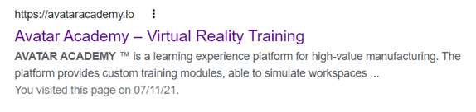
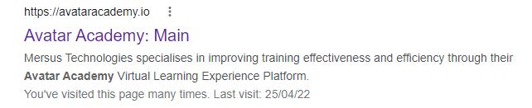

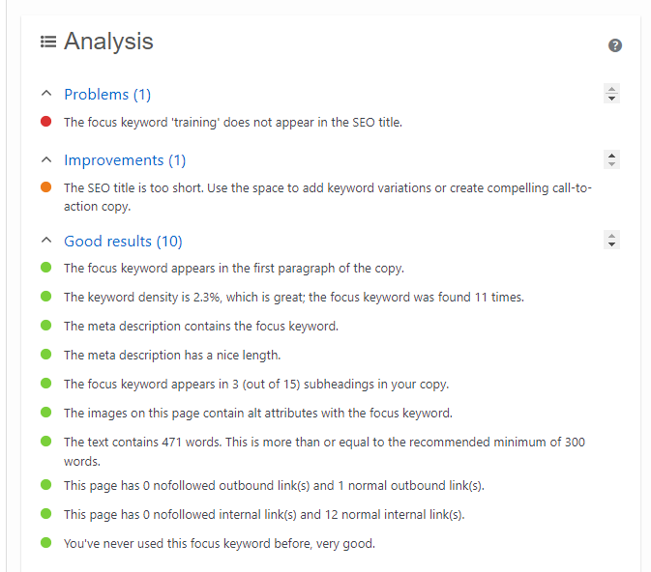
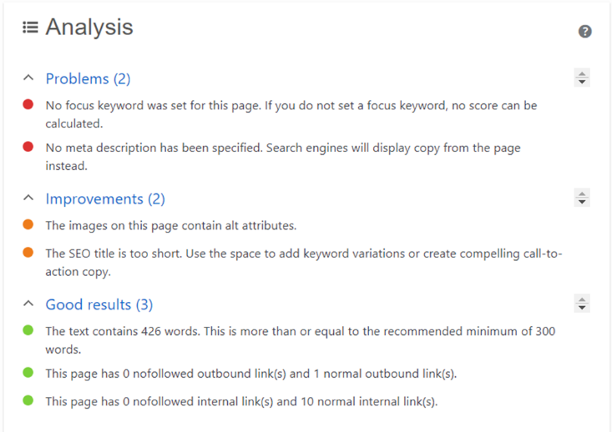

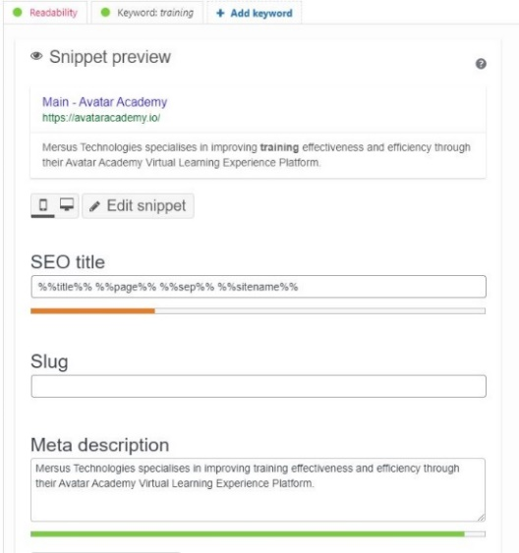

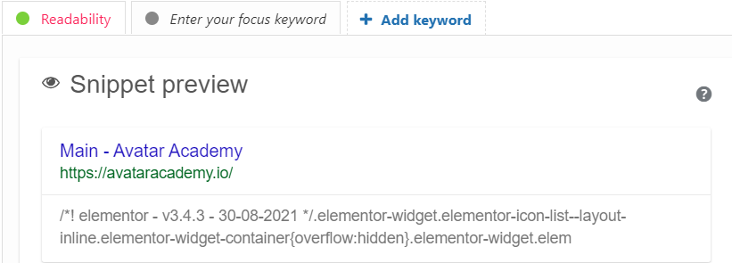

Figure 1 - Before (left) and After (right) images of the Home page's Google search display, focus keyword, meta description and analysis powered by YoastSEO through WordPress

Previously, the main page of the Avatar Academy website only displayed a generic description based on the first sentences seen on the webpage. It saw 3 good results, 2 elements that needed to be improved and 2 major problems on the page, being the lack of a focus keyword and proper meta description. Because of the lack of a keyword, the page’s SEO score could not be ranked. This was the same with every page on the site prior to the project.
After the changes made, the page now has 10 good results and only 1 improvement and 1 problem. The page is completely ranked green on both readability and SEO. The keyword was ‘training’ due to the nature of the Avatar Academy platform as well as the good keyword density level found on the page.

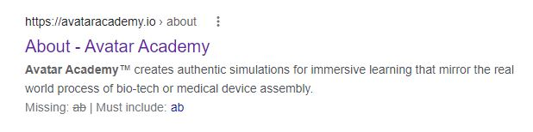
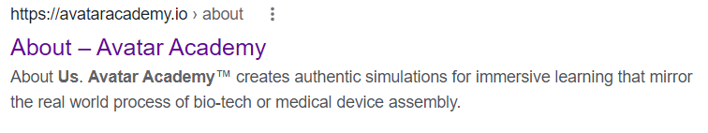
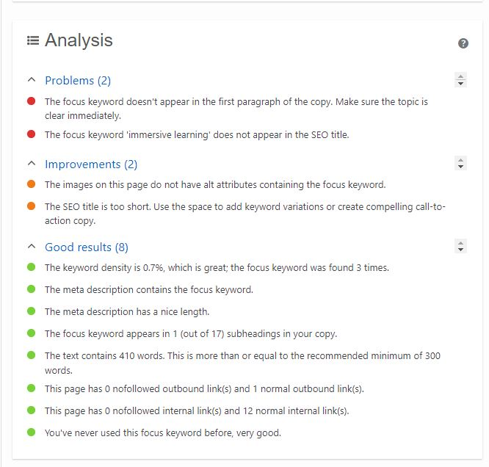
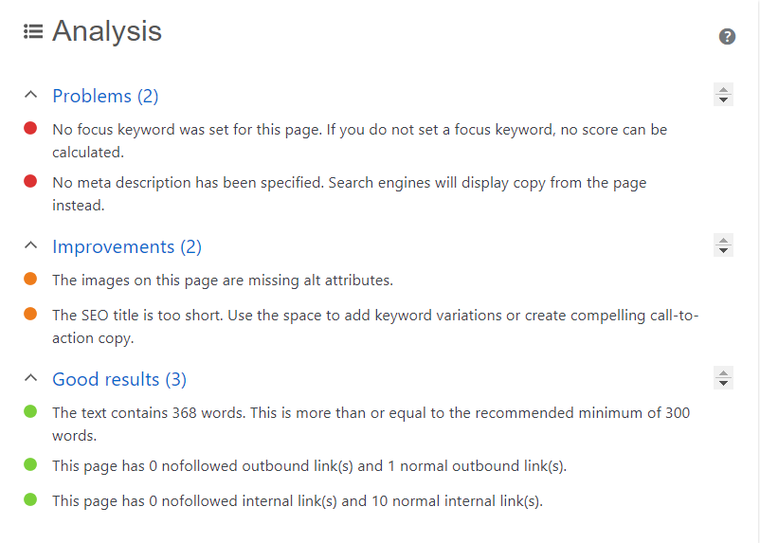

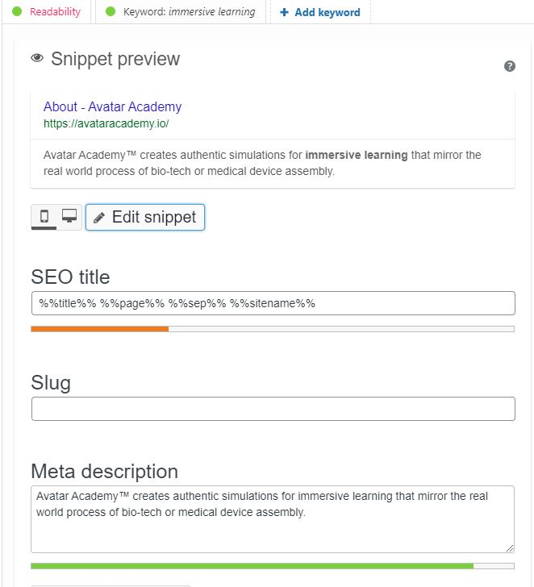

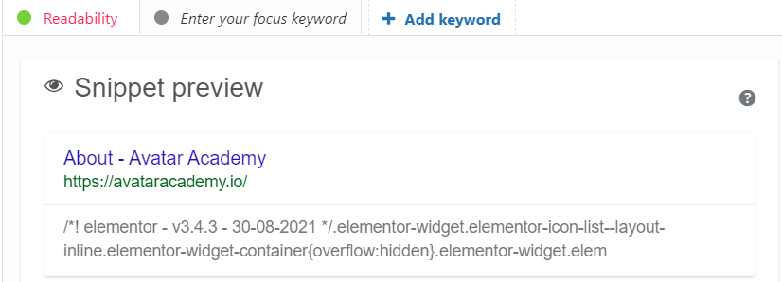

Figure 2- Before (left) and After (right) images of the About page's Google search display, focus keyword, meta description and analysis powered by YoastSEO through WordPress
Previously, the About page of the Avatar Academy website only displayed a generic description based on the first sentences seen on the webpage. It saw 3 good results, 2 elements that needed to be improved and 2 major problems on the page, being the lack of a focus keyword and a proper meta description. Because of the lack of a keyword, the page’s SEO score could not be ranked. This was the same with every page on the site prior to the project.
After the changes made, the page now has 8 good results, 2 improvements and 2 problems. The page is completely ranked green on both readability and SEO. The keyword was ‘immersive learning’ as it was one of the keywords suggested by the company as well as the good keyword density level.

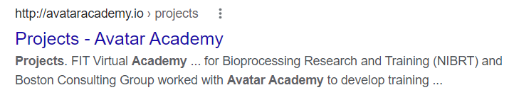

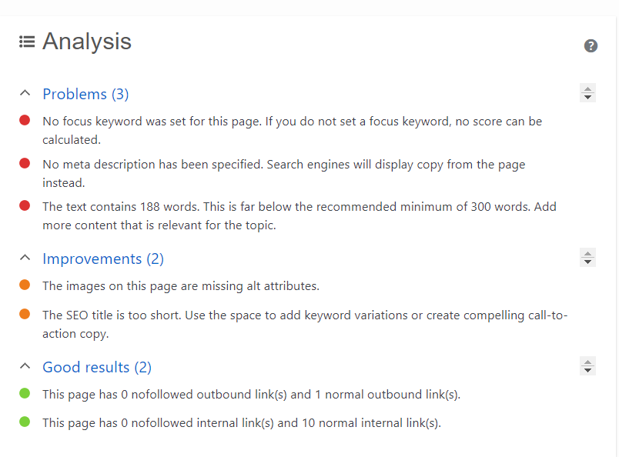
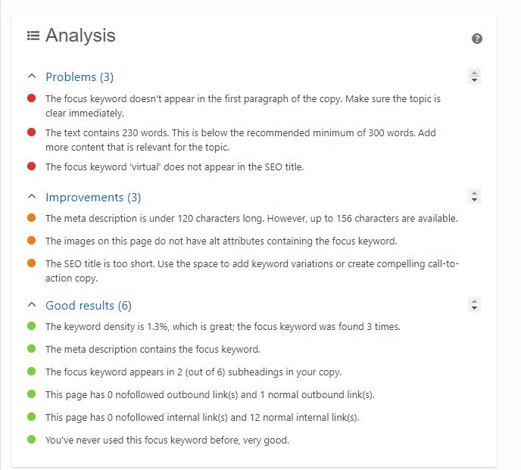

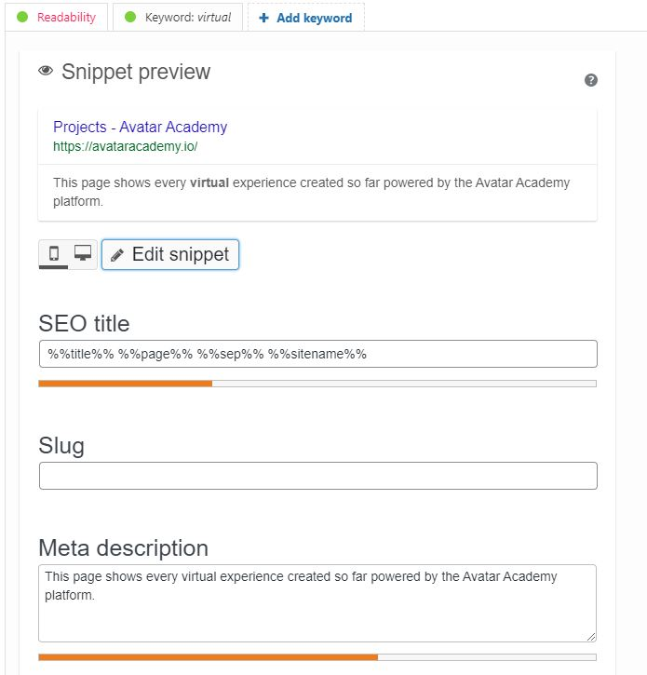
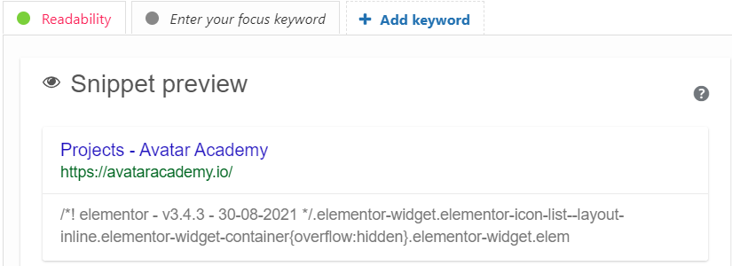
Figure 3 - Before (left) and After (right) images of the Projects page's Google search display, focus keyword, meta description and analysis powered by YoastSEO through WordPress
Previously, the Projects page only displayed a generic description based on the first sentences seen on the webpage. It saw 2 good results, 2 elements that needed to be improved and 3 major problems on the page. Because of the lack of a keyword, the page’s SEO score could not be ranked.
After the changes made, the page now has 6 good results, 3 improvements and 3 problems. The page is completely ranked green on both readability and SEO. The keyword was ‘virtual’ as it provides a good keyword density, it is relevant to the page and it appears in a couple of sub-headings.

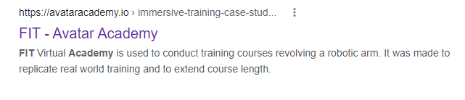
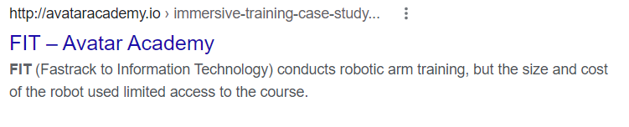
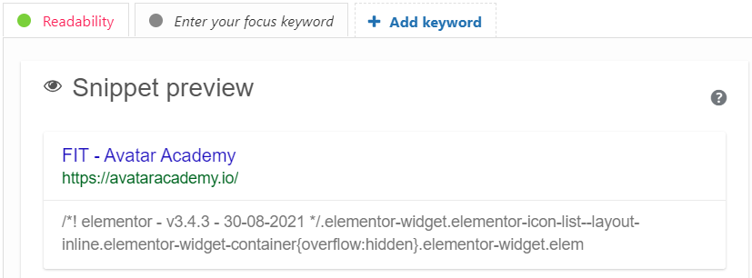
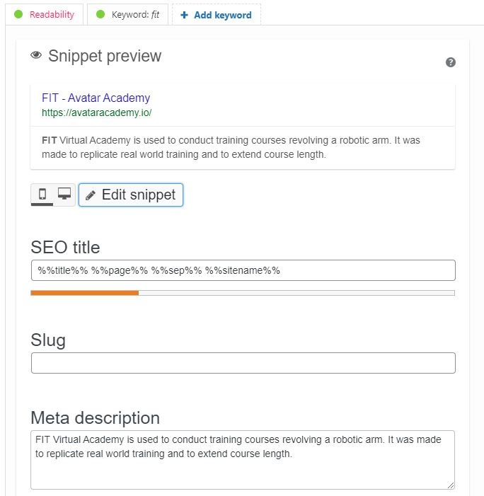
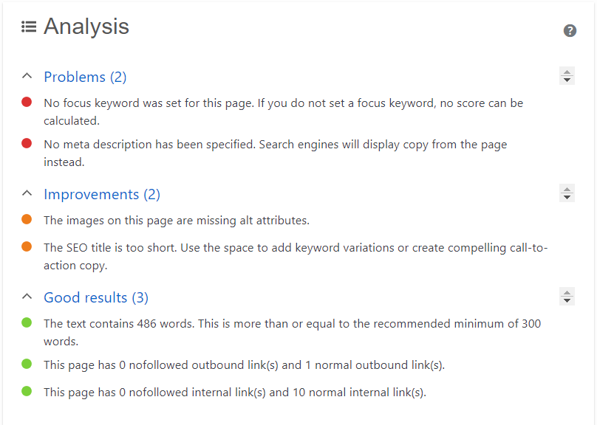
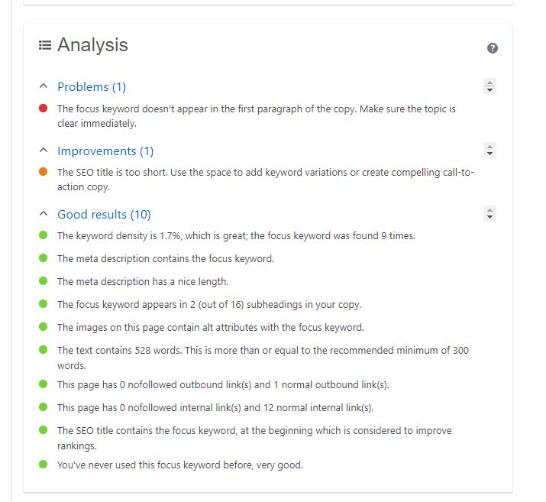
Figure 4 - Before (left) and After (right) images of the FIT page's Google search display, focus keyword, meta description and analysis powered by YoastSEO through WordPress
The page dedicated to the FIT Virtual Academy only displayed a generic description based on the first sentences seen on the webpage. It saw 3 good results, 2 elements that needed to be improved and 2 major problems on the page, being the lack of a focus keyword and proper meta description. Because of the lack of a keyword, the page’s SEO score could not be ranked.
After the changes made, the site now has 10 good results and only 1 improvement and 1 problem. The page is completely ranked green on both readability and SEO. The keyword was ‘fit’ since it is the name of the company the project relates to as well as the SEO title containing the word and keyword density.
Currently, the new meta description does not appear as intended on the Google Search despite it being changed and updated. This means that the page needs to be properly crawled and indexed so that the change can be updated.

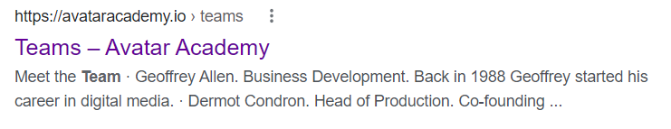
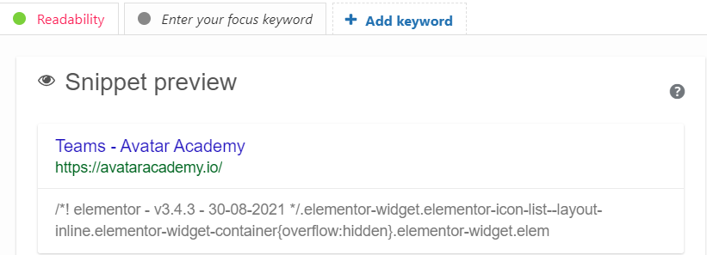
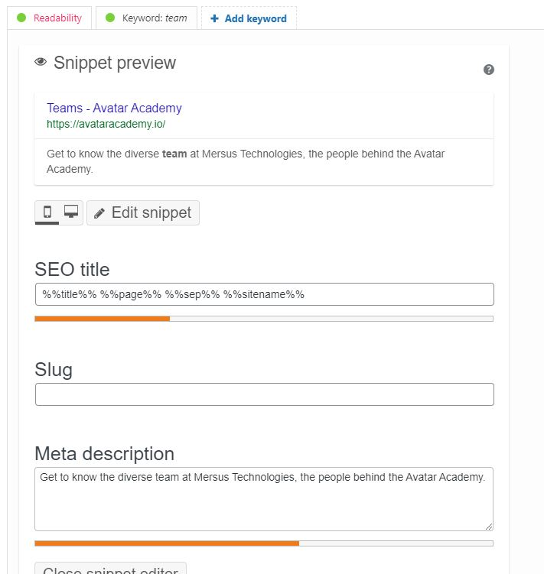
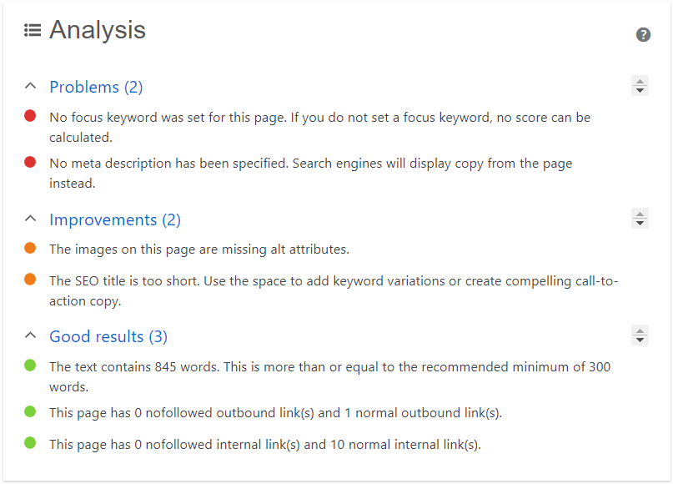
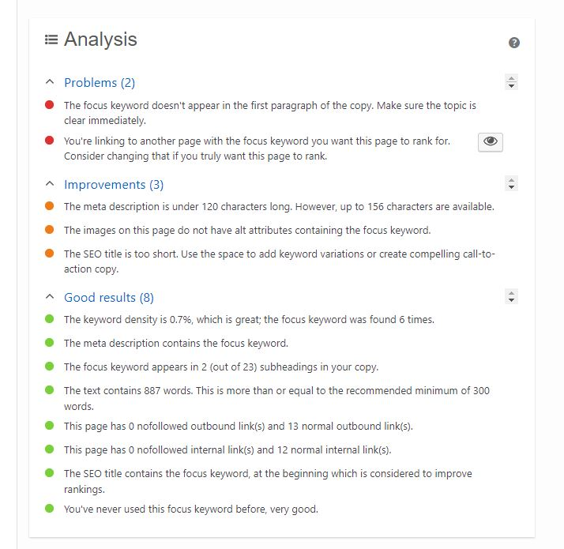
Figure 5 - Before (left) and After (right) images of the Teams page's Google search display, focus keyword, meta description and analysis powered by YoastSEO through WordPress
The Team page only displayed a generic description based on the first sentences seen on the webpage. It saw 3 good results, 2 elements that needed to be improved and 2 problems. Because of the lack of a keyword, the page’s SEO score could not be ranked.
After the changes made, the site now has 8 good results, 3 improvements and 2 problems. The page is completely ranked green on both readability and SEO. The keyword was team due to the relevance on the page, keyword density and the fact that it’s the name of the page.

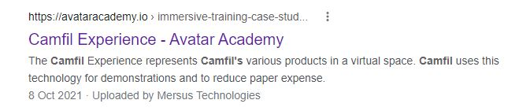
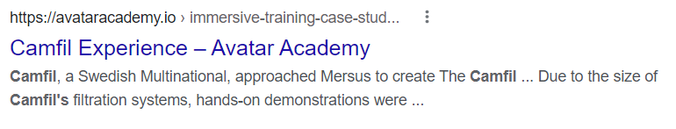
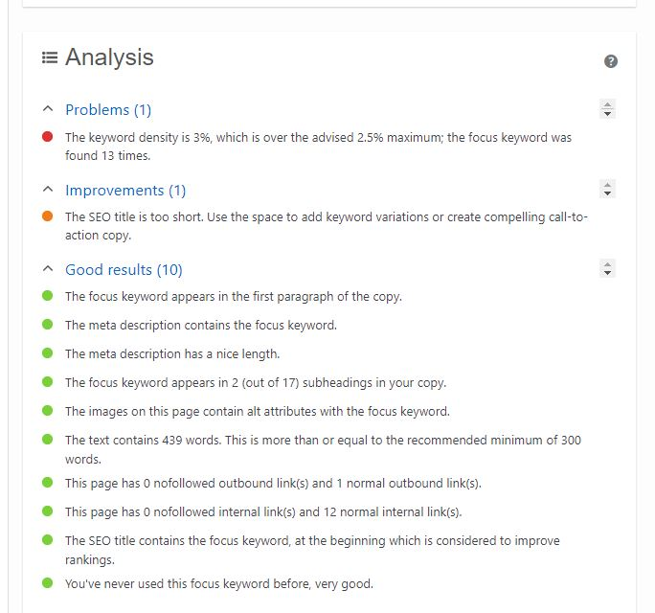
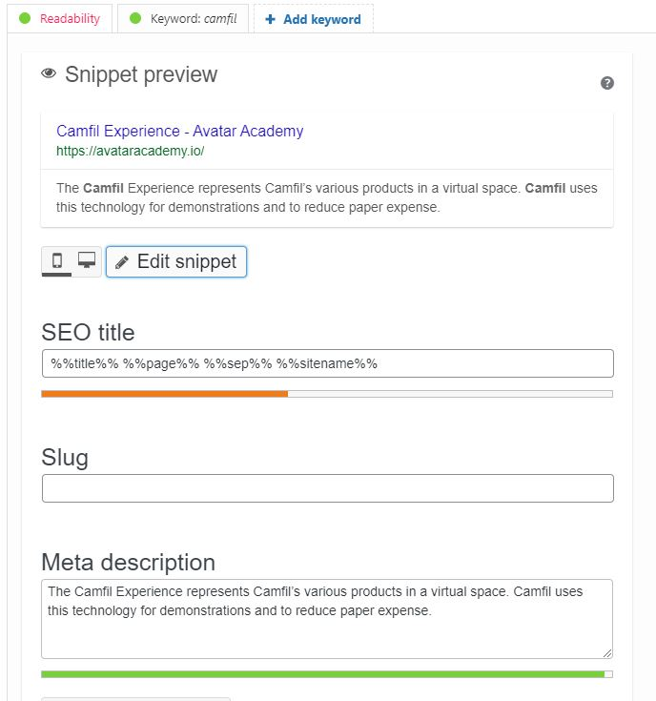
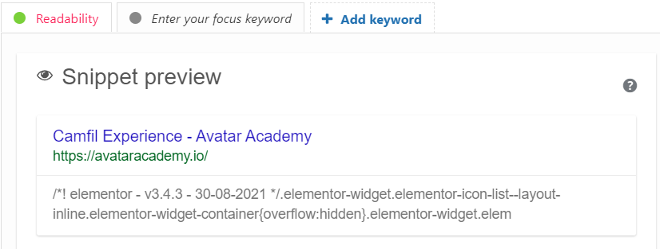
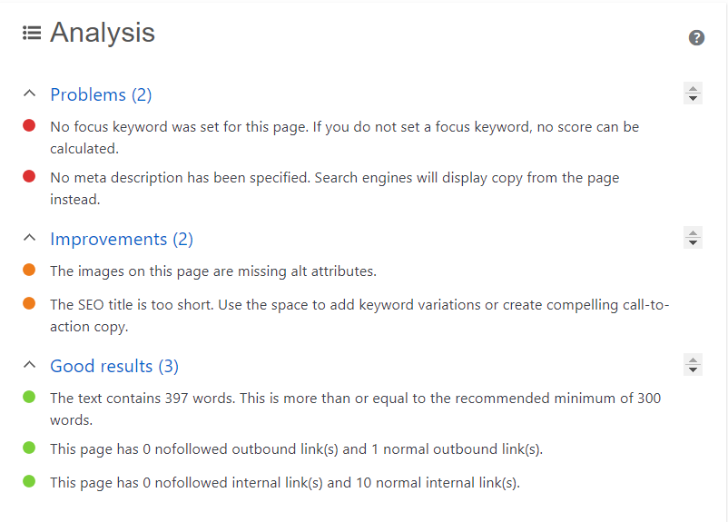
Figure 6 - Before (left) and After (right) images of the Camfil Experience page's Google search display, focus keyword, meta description and analysis powered by YoastSEO through WordPress
The page dedicated to the Camfil Experience only displayed a generic description based on the first sentences seen on the webpage. It saw 3 good results, 2 elements that needed to be improved and 2 major problems on the page, being the lack of a focus keyword and proper meta description. Because of the lack of a keyword, the page’s SEO score could not be ranked.
After the changes made, the site now has 10 good results and only 1 improvement and 1 problem. The page is completely ranked green on both readability and SEO. The keyword was ‘camfil’ since it is the name of the company the project relates to as well as the word being specific to one entity, so it is narrowed down, meaning a better chance of ranking.

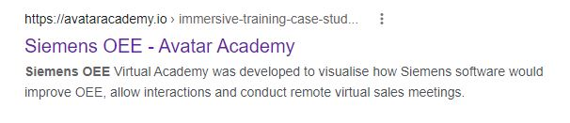
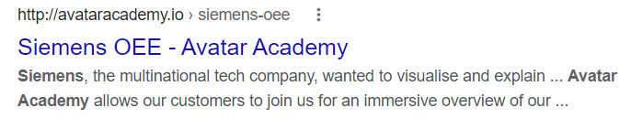
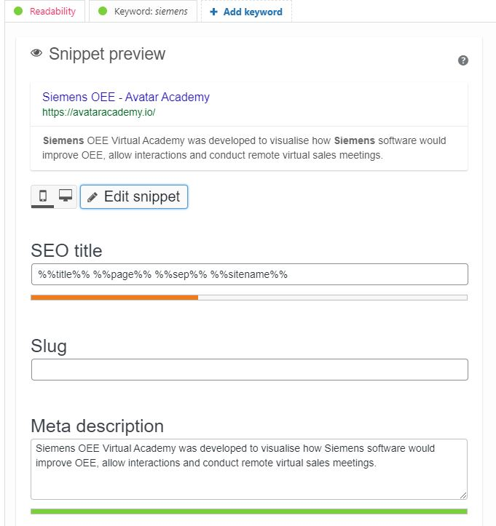
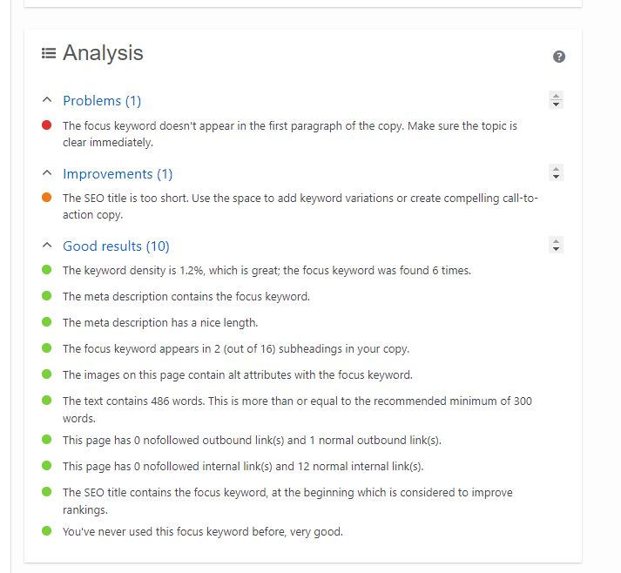
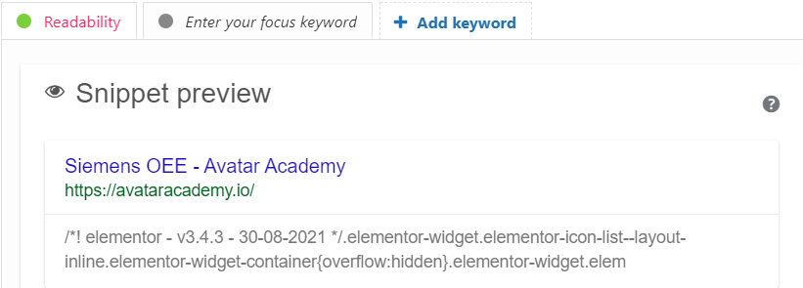
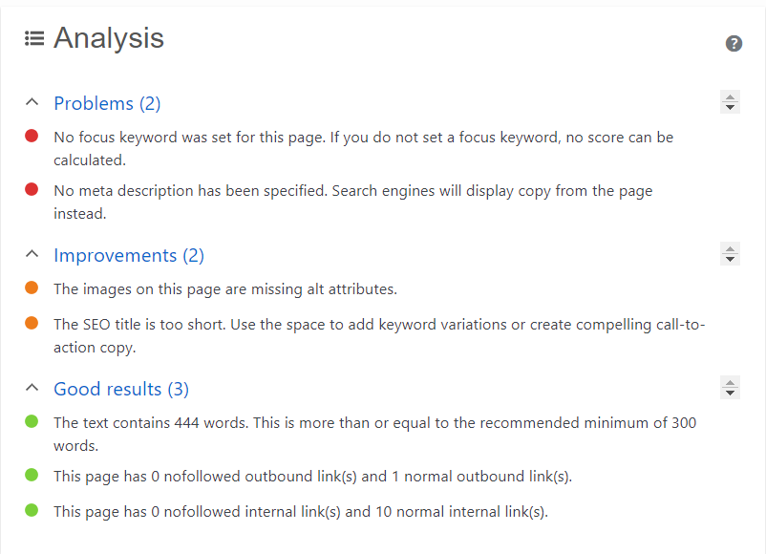
Figure 7 - Before (left) and After (right) images of the Siemens OEE page's Google search display, focus keyword, meta description and analysis powered by YoastSEO through WordPress
The page dedicated to Siemens OEE only displayed a generic description based on the first sentences seen on the webpage. It saw 3 good results, 2 elements that needed to be improved and 2 major problems on the page, being the lack of a focus keyword and proper meta description. Because of the lack of a keyword, the page’s SEO score could not be ranked.
After the changes made, the site now has 10 good results and only 1 improvement and 1 problem. The page is completely ranked green on both readability and SEO. The keyword was ‘siemens’ since it is the name of the company the project relates to as well as the word being specific to one entity, so it is narrowed down, meaning a better chance of ranking.

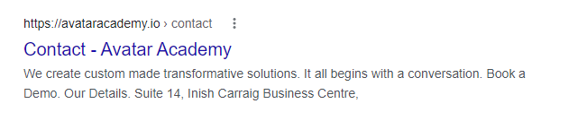

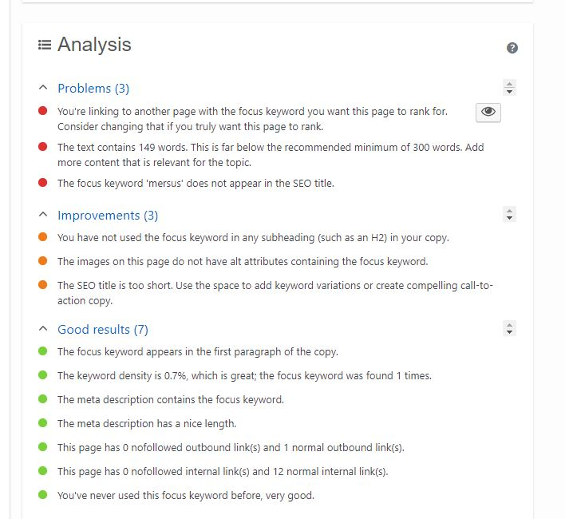
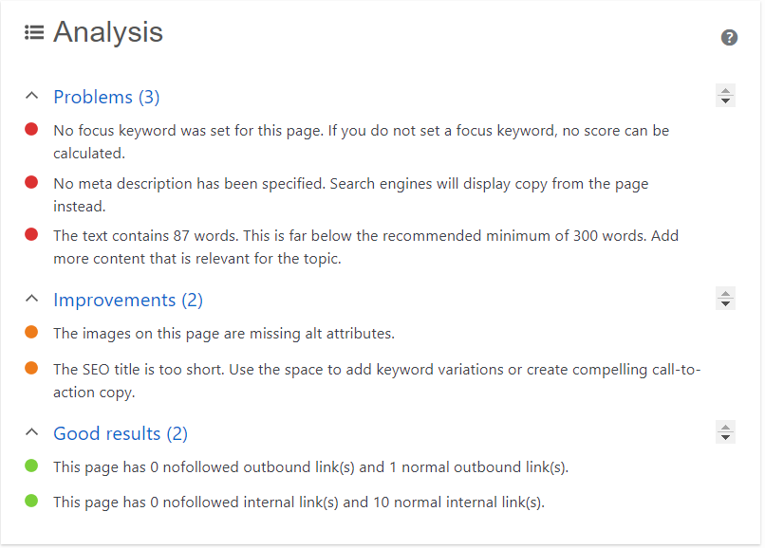

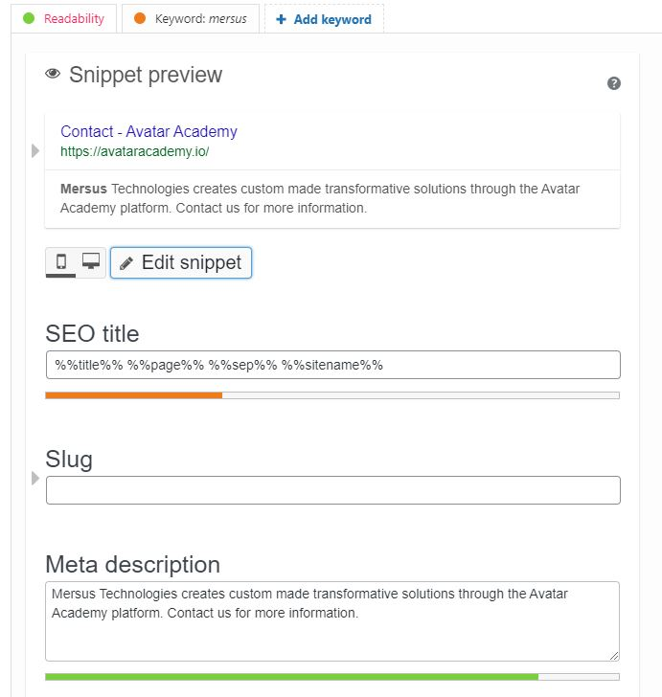

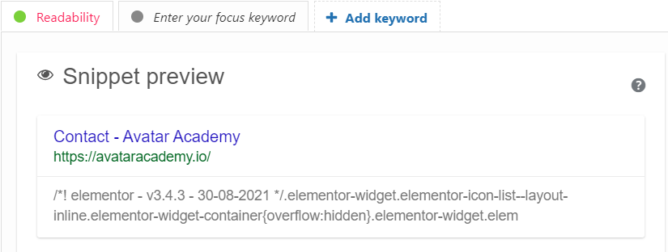

Figure 8 - Before (left) and After (right) images of the Contact page's Google search display, focus keyword, meta description and analysis powered by YoastSEO through WordPress

The Contacts page only displayed a generic description based on the first sentences seen on the webpage. It saw 2 good results, 2 elements that needed to be improved and 3 major problems on the page, being the lack of a focus keyword, proper meta description and low word count. Because of the lack of a keyword, the page’s SEO score could not be ranked.
After the changes made, the site now has 7 good results, 3 improvements and 3 problems. The page is ranked orange on SEO due to the number of problems and improvements being close to the number of good results. The keyword was ‘mersus’ as there many options for keywords to relate back to this page. If a keyword like ‘contact’ was used, it would be too broad, so by putting in ‘mersus’, if people were to look up Mersus Technologies, they might come across this Avatar Academy page and figure out the connection that way.
Currently, the new meta description does not appear as intended on the Google Search despite it being changed and updated. This means that the page needs to be properly crawled and indexed so that the change can be updated.

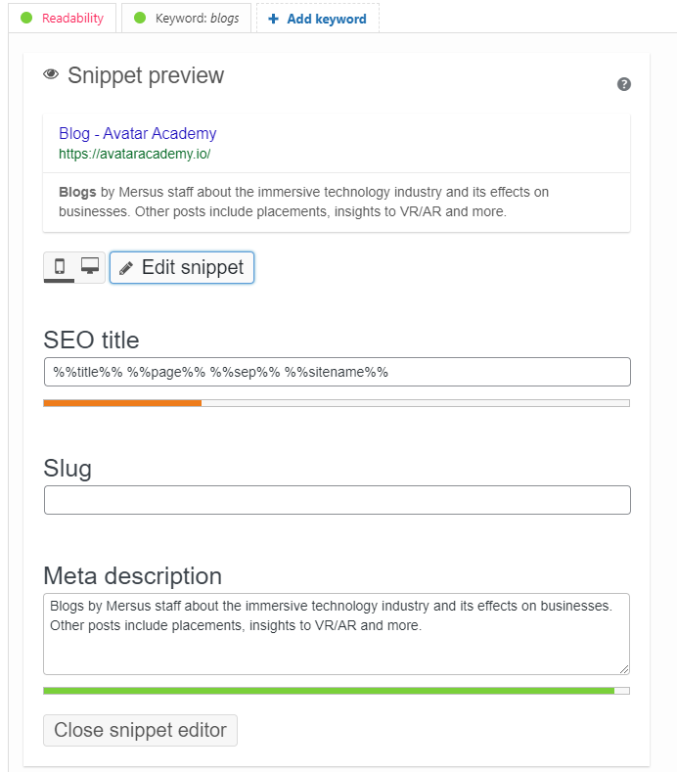
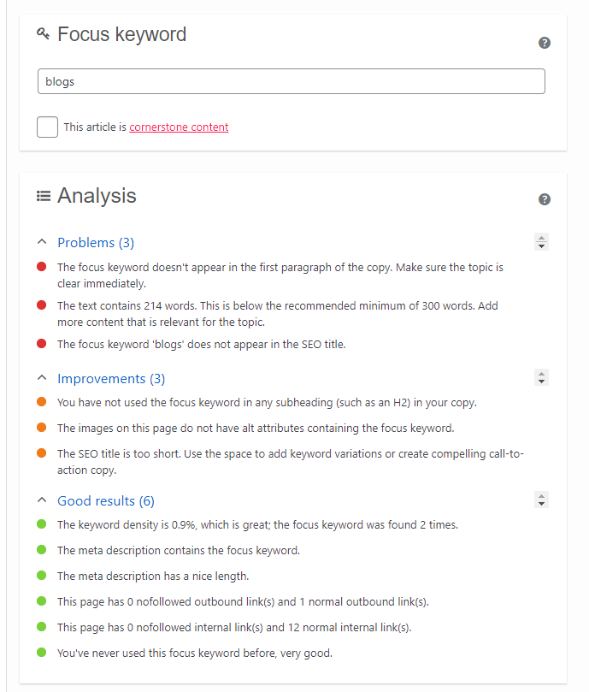
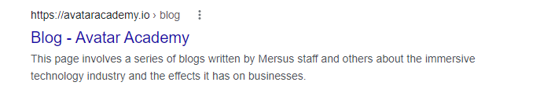
Figure 9 – Images of the Blog page's current Google search display, focus keyword, meta description and analysis powered by YoastSEO through WordPress

The rest of the pages onward are completely original, so there are no previous comparisons. The Blog page was created with the intent of including links to blog posts on the website. The page was optimised through using a focus keyword, in this case; ‘blogs’. As a result of that, the page received 6 good results, 3 areas of improvements and 3 problems. The page has a high score as indicated with the green marks in both SEO and readability.

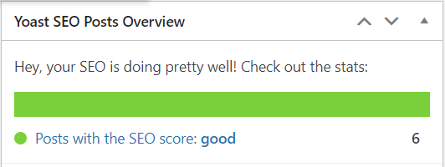

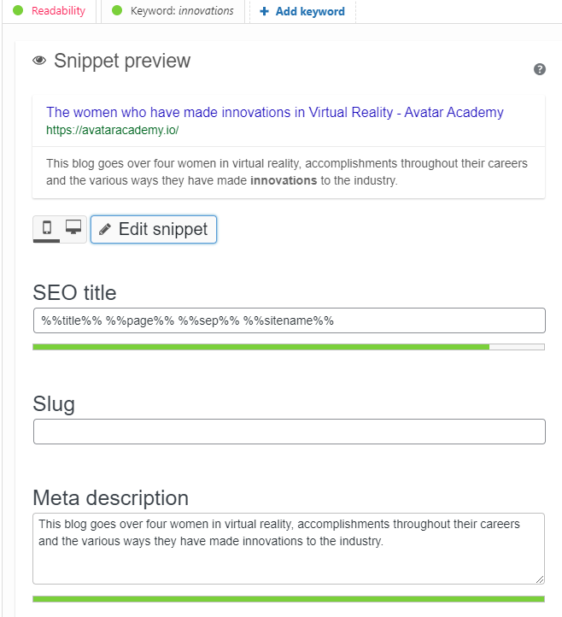
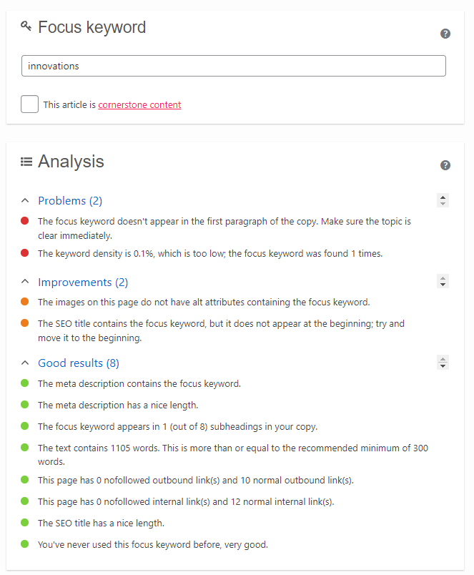

Figure 10 – Images of The Women who have made innovations in Virtual Reality blog’s current Google search display, focus keyword, meta description and analysis powered by YoastSEO through WordPress

The International Women’s Day blog page was created with the intent of including links to blog posts on the website. The page was optimised through using a focus keyword, in this case; ‘innovations’. This word was chosen as it had low competition, it was included in the title and it is relevant to the content. As a result of that, the page resulted in 8 good results, 2 areas to improve and 3 problems. The page has a high score as indicated with the green marks in both SEO and readability.

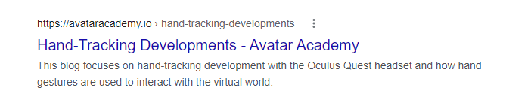

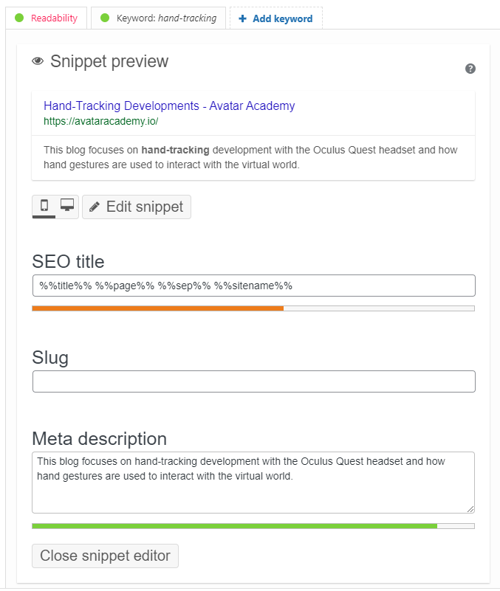
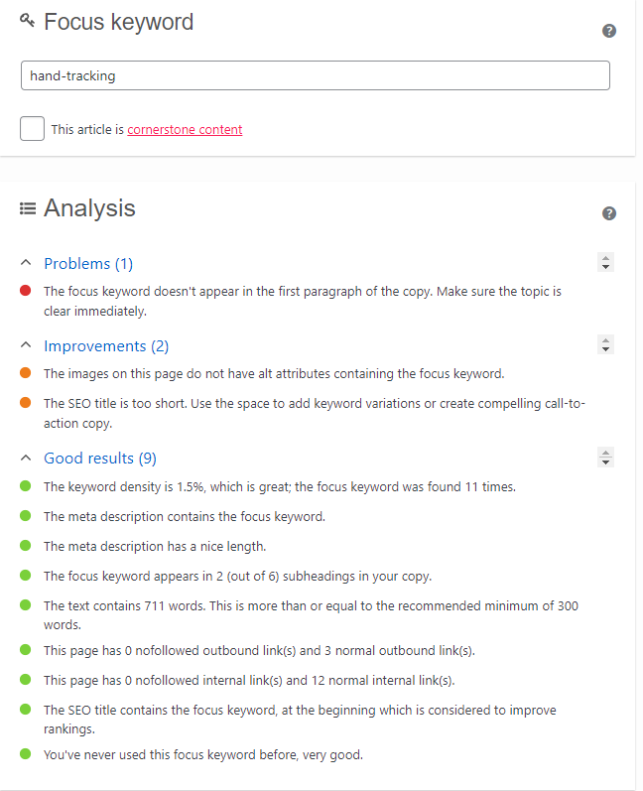

Figure 11 – Images of the Hand-Tracking Developments blog’s current Google search display, focus keyword, meta description and analysis powered by YoastSEO through WordPress

Hand-Tracking Developments was optimised through using a focus keyword, in this case; ‘hand-tracking’. This word was chosen as it is very specific so it narrows down the possibilities, it is relevant to the content and is included in the title. As a result of that, the page resulted in 8 good results, 2 areas to improve and 1 problem. The page has a high score as indicated with the green marks in both SEO and readability.

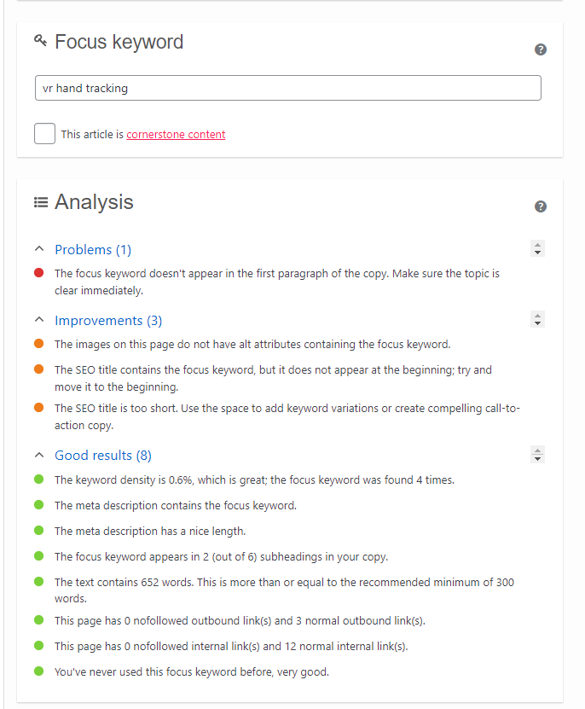
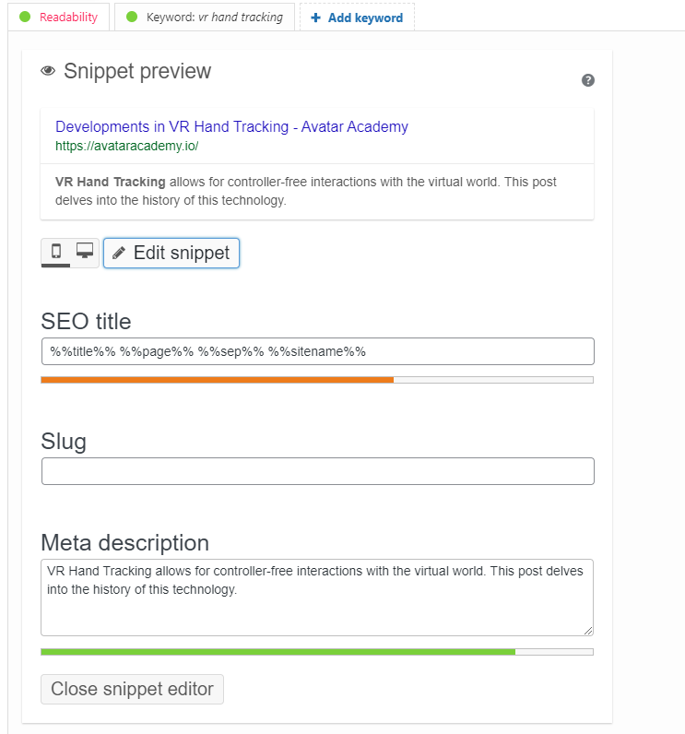
Figure 12 – Images of the Developments in VR Hand Tracking blog’s current Google search display, focus keyword, meta description and analysis powered by YoastSEO through WordPress

Developments in VR Hand Tracking was optimised through using a focus keyword, in this case; ‘vr hand tracking’. This word was chosen as it is a very specific term, it is found in the title and the keyword is found a few times within the content. As a result of that, the page resulted in 8 good results, 3 areas to improve and 1 problem. The page has a high score as indicated with the green marks in both SEO and readability.

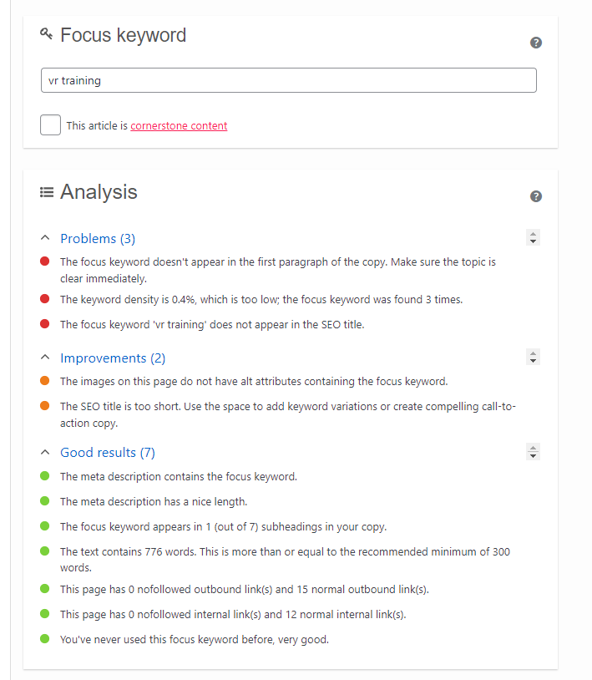
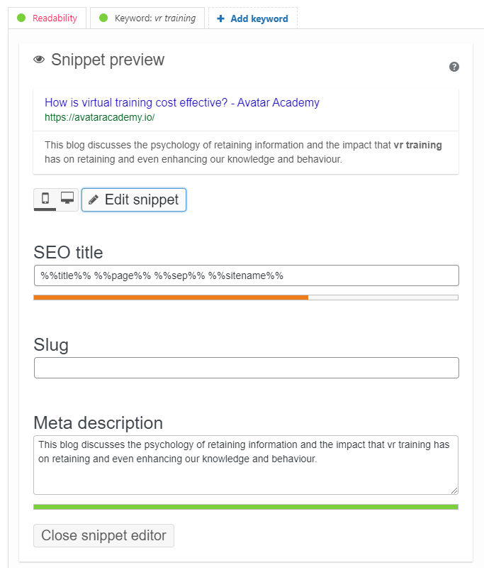

Figure 13 – Images of the How is virtual training cost effective? blog’s current Google search display, focus keyword, meta description and analysis powered by YoastSEO through WordPress

How is virtual training cost effective? was optimised through using a focus keyword, in this case; ‘vr training’. This word was chosen as it relevant to the content and because it was a word that the company wanted to be ranked for so the idea was to find a page to implement it in without drastic changes. As a result of that, the page resulted in 7 good results, 2 areas to improve and 3 problems. The page has a high score as indicated with the green marks in both SEO and readability.

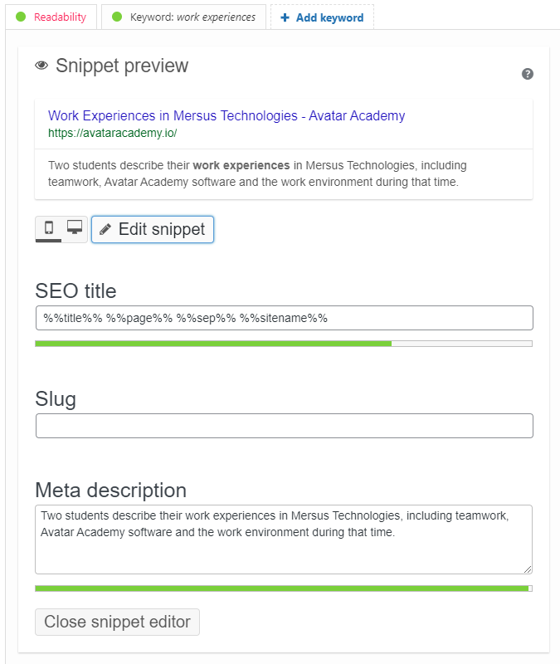
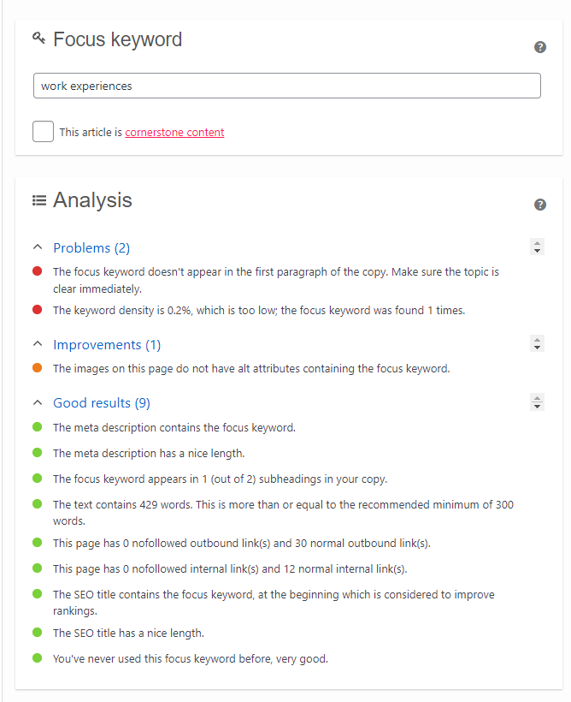
Figure 14 – Images of the Work Experiences in Mersus Technologies blog’s current Google search display, focus keyword, meta description and analysis powered by YoastSEO through WordPress

Work Experiences in Mersus Technologies blog page was created with the intent of including links to blog posts on the website. The page was optimised through using a focus keyword, in this case; ‘work experiences’. This word was chosen as it is a very specific term, it is found in the title and it is relevant to the content. As a result of that, the page resulted in 9 good results, 1 area to improve and 2 problems. The page has a high score as indicated with the green marks in both SEO and readability.

Keyword Rich URL Structure
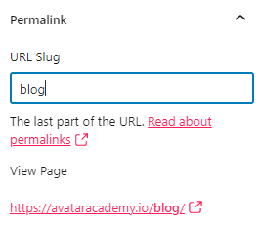
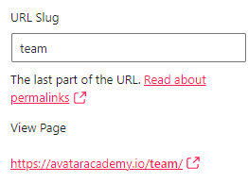
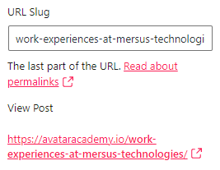
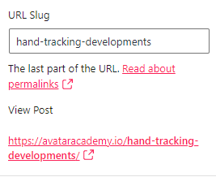
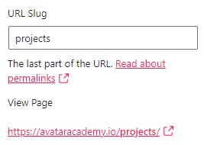
The key to an SEO-friendly URL is that it is easy to remember and that it conveys meaningful context to what the page is about. In the same way as the pages, the URL structure was done on a page by page basis. Each URL is the same name as their respective pages. For example, the Blog page in the Avatar Academy uses the slug ‘blog’ for consistency. The Team page uses the slug ‘team’, the Projects page uses the slug ‘projects’, as they all are the same as their page names as well as keywords, making them SEO-friendly URLs.
Figure 15 – Slugs for the Blog, Teams, Work Experiences blog, Hand Tracking Developments blog and Projects pages to demonstrate the consistency of the site’s URL structure.

This is a similar case for the blog pages, with the slug reflecting the name of the blog itself. The Work Experiences at Mersus Technologies, Hand Tracking Developments and The Women Who Have Made Innovations in Virtual Reality all use slugs that are the same as each respective page. This ensures consistency between the URL and the content on the page.
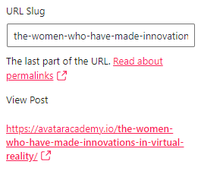

Figure 16 – Slugs for the Work Experiences, Hand Tracking and International Women’s Day blogs to highlight that the URL for each page is the same as the page name.

Each slug mentioned provides strong hints that what the content of the page in question is about. As shown, there are no duplicate URLs so it doesn’t complicate users nor lead to them getting confused about whether they reached the correct page. Hyphens are also utilised to distinguish each word as a replacement for spaces and therefore, make it easier to read.

Keyword Rich Content
Each focus keyword chosen was based around not only the page name, but also the content on each page. There is a factoring element called keyword density, which counts the number of times a keyword is used on a page as well its percentage of the word count compared to the rest of the page. With YoastSEO, it will tell the user if there are too many or too little keywords on a page.
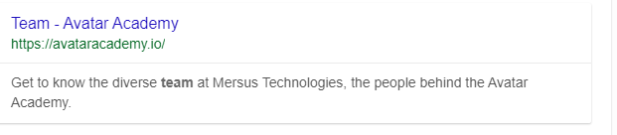

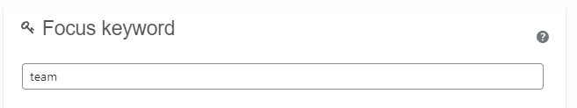

Figure 17 – Focus keywords for the Blog and Team pages to highlight the level of keyword use in the meta description and the content.
Figure 18 – Focus keywords for the Women’s Day and Hand-Tracking Developments pages to highlight the level of keyword use in the meta description and the content as well as the extent of keyword density.

As shown on each image, there is a variety in the number of keywords on various pages. Blog only has its keyword appear twice on the page, yet the percentage is high enough for it to turn into a good SEO score. This is because there isn’t too much content on the page, so there is no need to put in an excessive number of keywords, otherwise the website would be punished by the Google search ranking. Meanwhile, Hand-Tracking Developments has a total of 11 instances where the focus keyword is used. Despite that, it maintains a good result as it only takes up 1.5% of the page. This indicates that the page has a significant amount of content as it is a blog post. Google will reward a website for using a reasonable number of keywords in the content as long as that keyword is relevant to the content, is found in the meta description and within the URL. The extent of that reward would depend on the levels of competitions and search volumes that each keyword brings in.

Sitemap
On the website, the sitemap needs to be accessed through YoastSEO. Previously, when typing “sitemap.xml” into the URL space, it would lead into a 4xx error, as the page technically did not exist. This was the same case with “wp-sitemap.xml”. This was affecting the site health. To solve this problem, a line of code was used in the YoastSEO plugin, specifically in the .htaccess file, which could be edited.
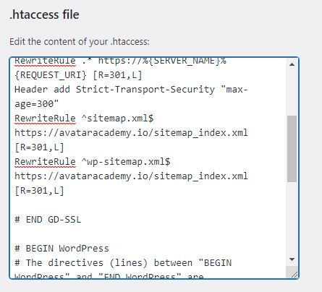
By inputting two lines of code and inputting each sitemap link as well as the domain name into it, It would help to redirect the links that would normally lead to an empty page, back into the sitemap, which was always found through “sitemap_index.xml”

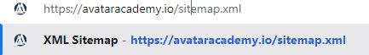
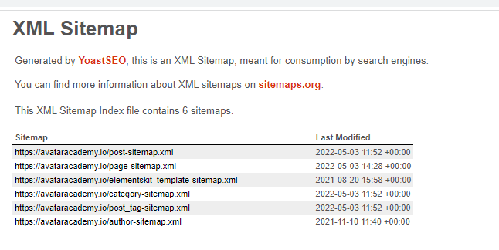
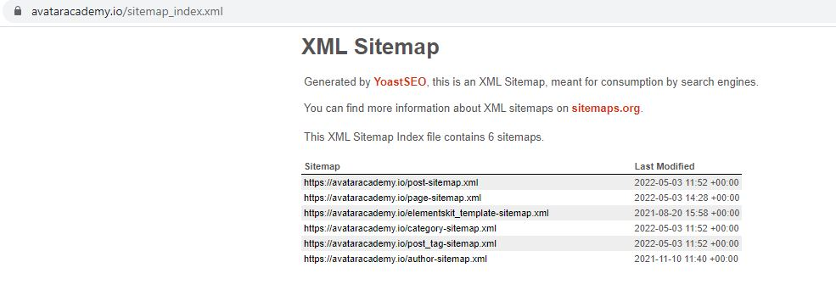
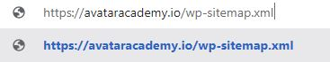

Figure 19 – .htaccess file accessed through YoastSEO, which was edited to redirect the broken sitemap links to the XML Sitemap generated by Yoast and a demonstration of what happens if someone puts both links into the URL.

The sitemap was also connected to the Google Search Console so that the sitemap can be indexed and read by Google. The sitemap can also be accessed from the Search Console this way.
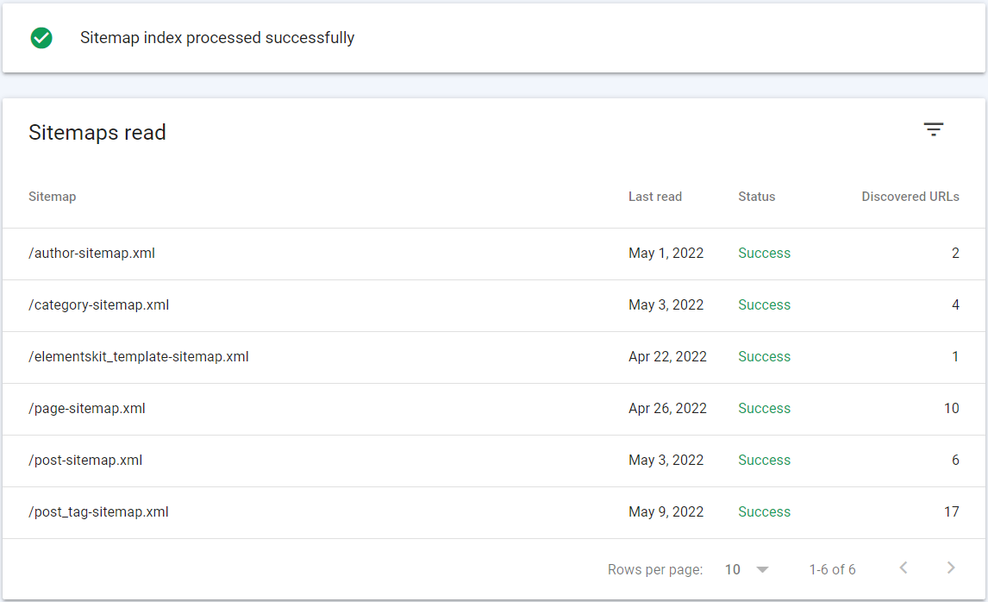
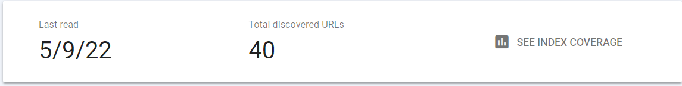
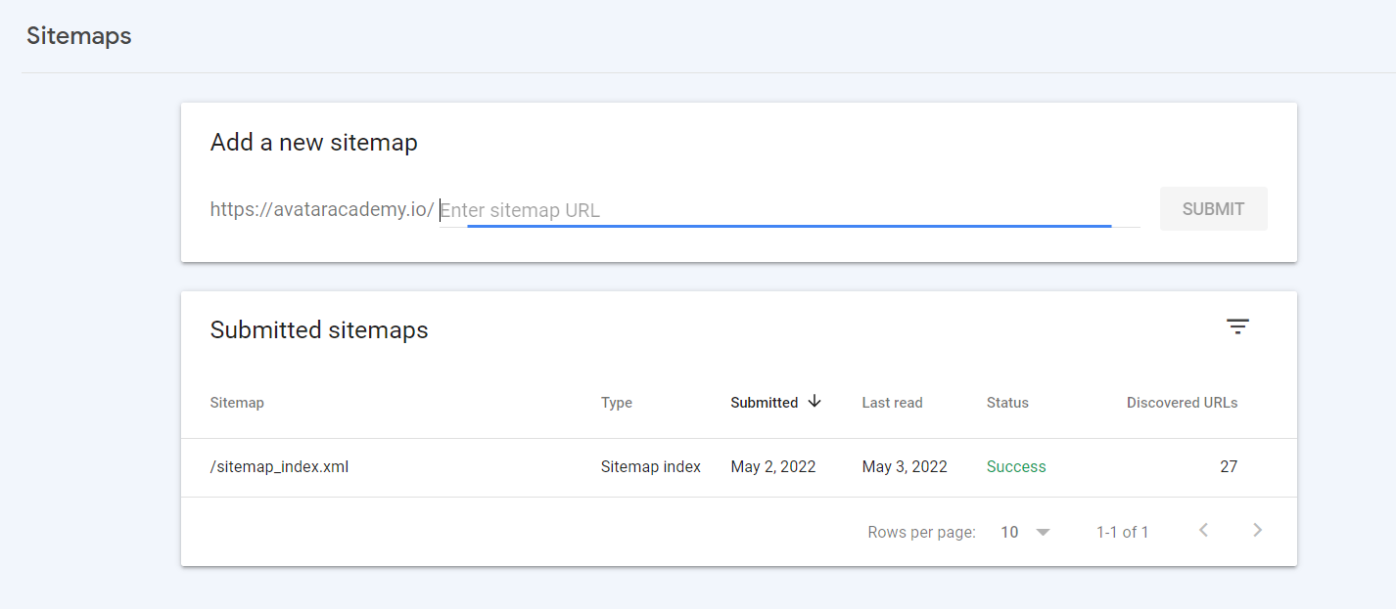
Figure 20 – Evidence of the sitemap being uploaded onto the Google Search Console so that it can be read and identified by Google.
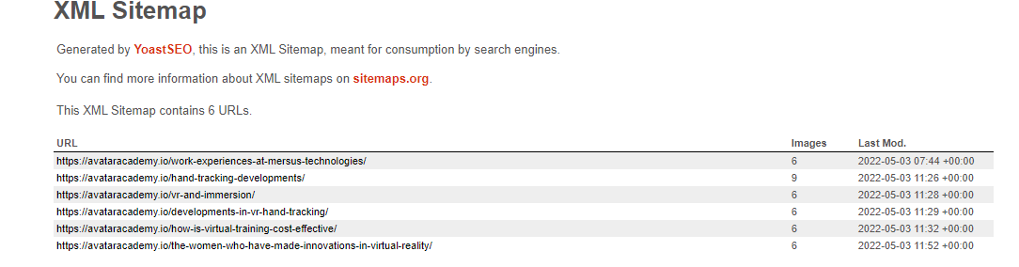
There are now 6 sitemaps listed on the Avatar Academy website and a total of 40 URLs overall.

Figure 21 – The ‘post-sitemap.xml’

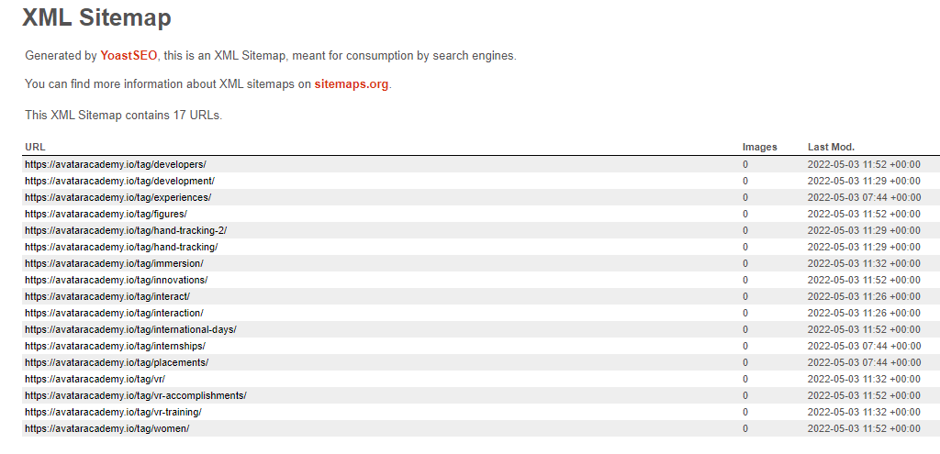
The ‘post-sitemap.xml’, contains 6 URLs, which represents each of the posts published on the site.
Figure 22 – The ‘post_tag-sitemap.xml’

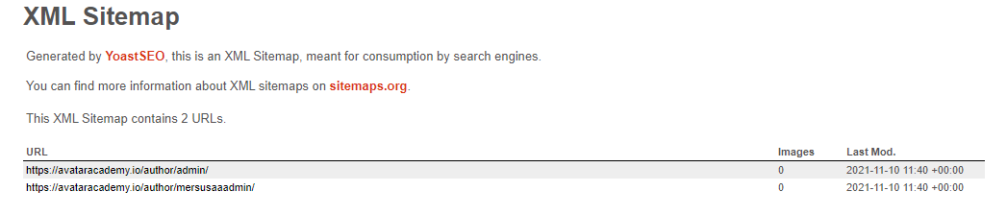
The ‘post_tag-sitemap.xml’ contains 17 URLs, all of which are tags on each blog post that are used as labels to describe what type of blog is being written.
Figure 23 – The ‘author-sitemap.xml’
The ‘author-sitemap.xml’ contains 2 URLs, both of which being tags relating to each registered WordPress user for the site.

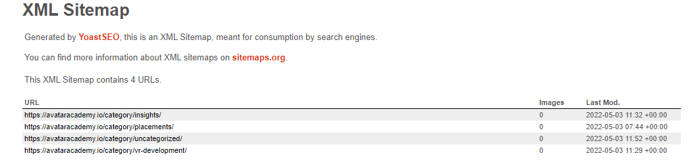
Figure 24 – The ‘category-sitemap.xml’
The ‘category-sitemap.xml’ contains 4 URLs, all of which categorises each blog. For example, if a user wants to find content relating to VR development, this category will filter blogs based on that category.
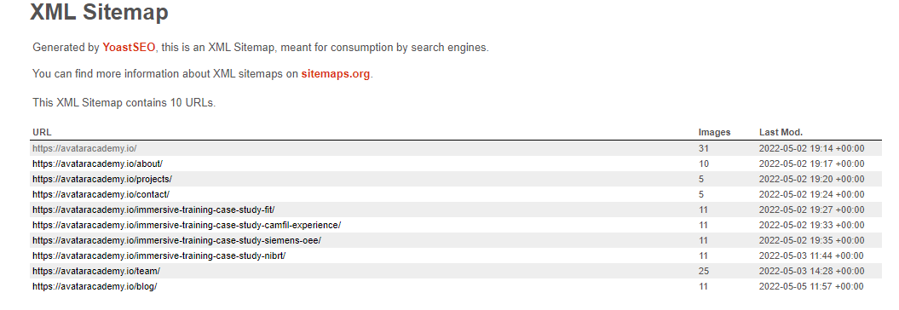
Figure 25 – The ‘page-sitemap.xml’
The ‘page-sitemap.xml’ contains 10 URLs, which involves every page and sub-page located on the website.

Off-Page SEO

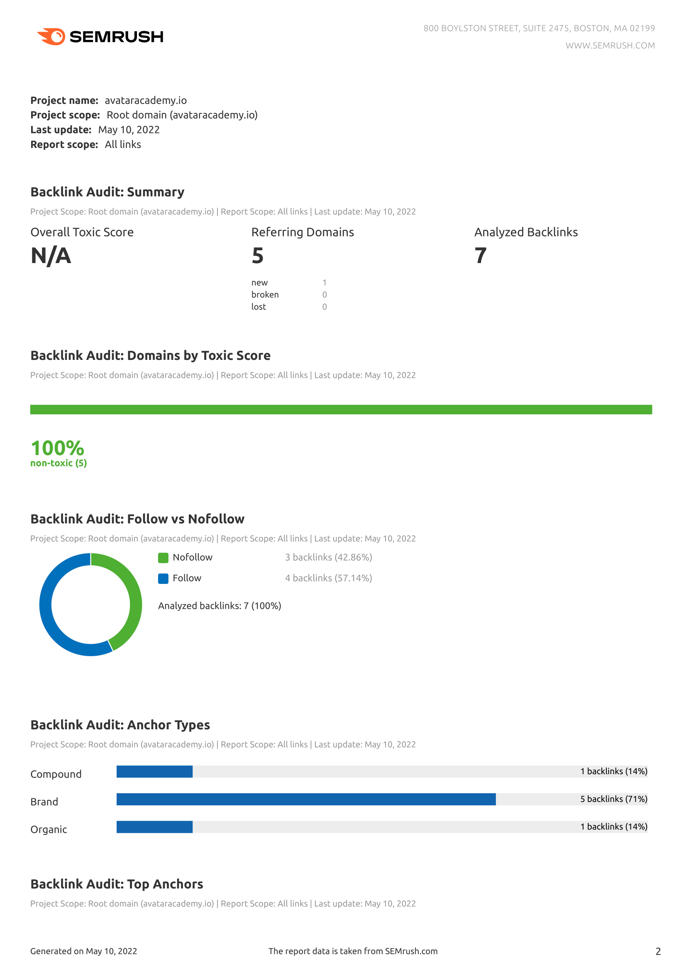
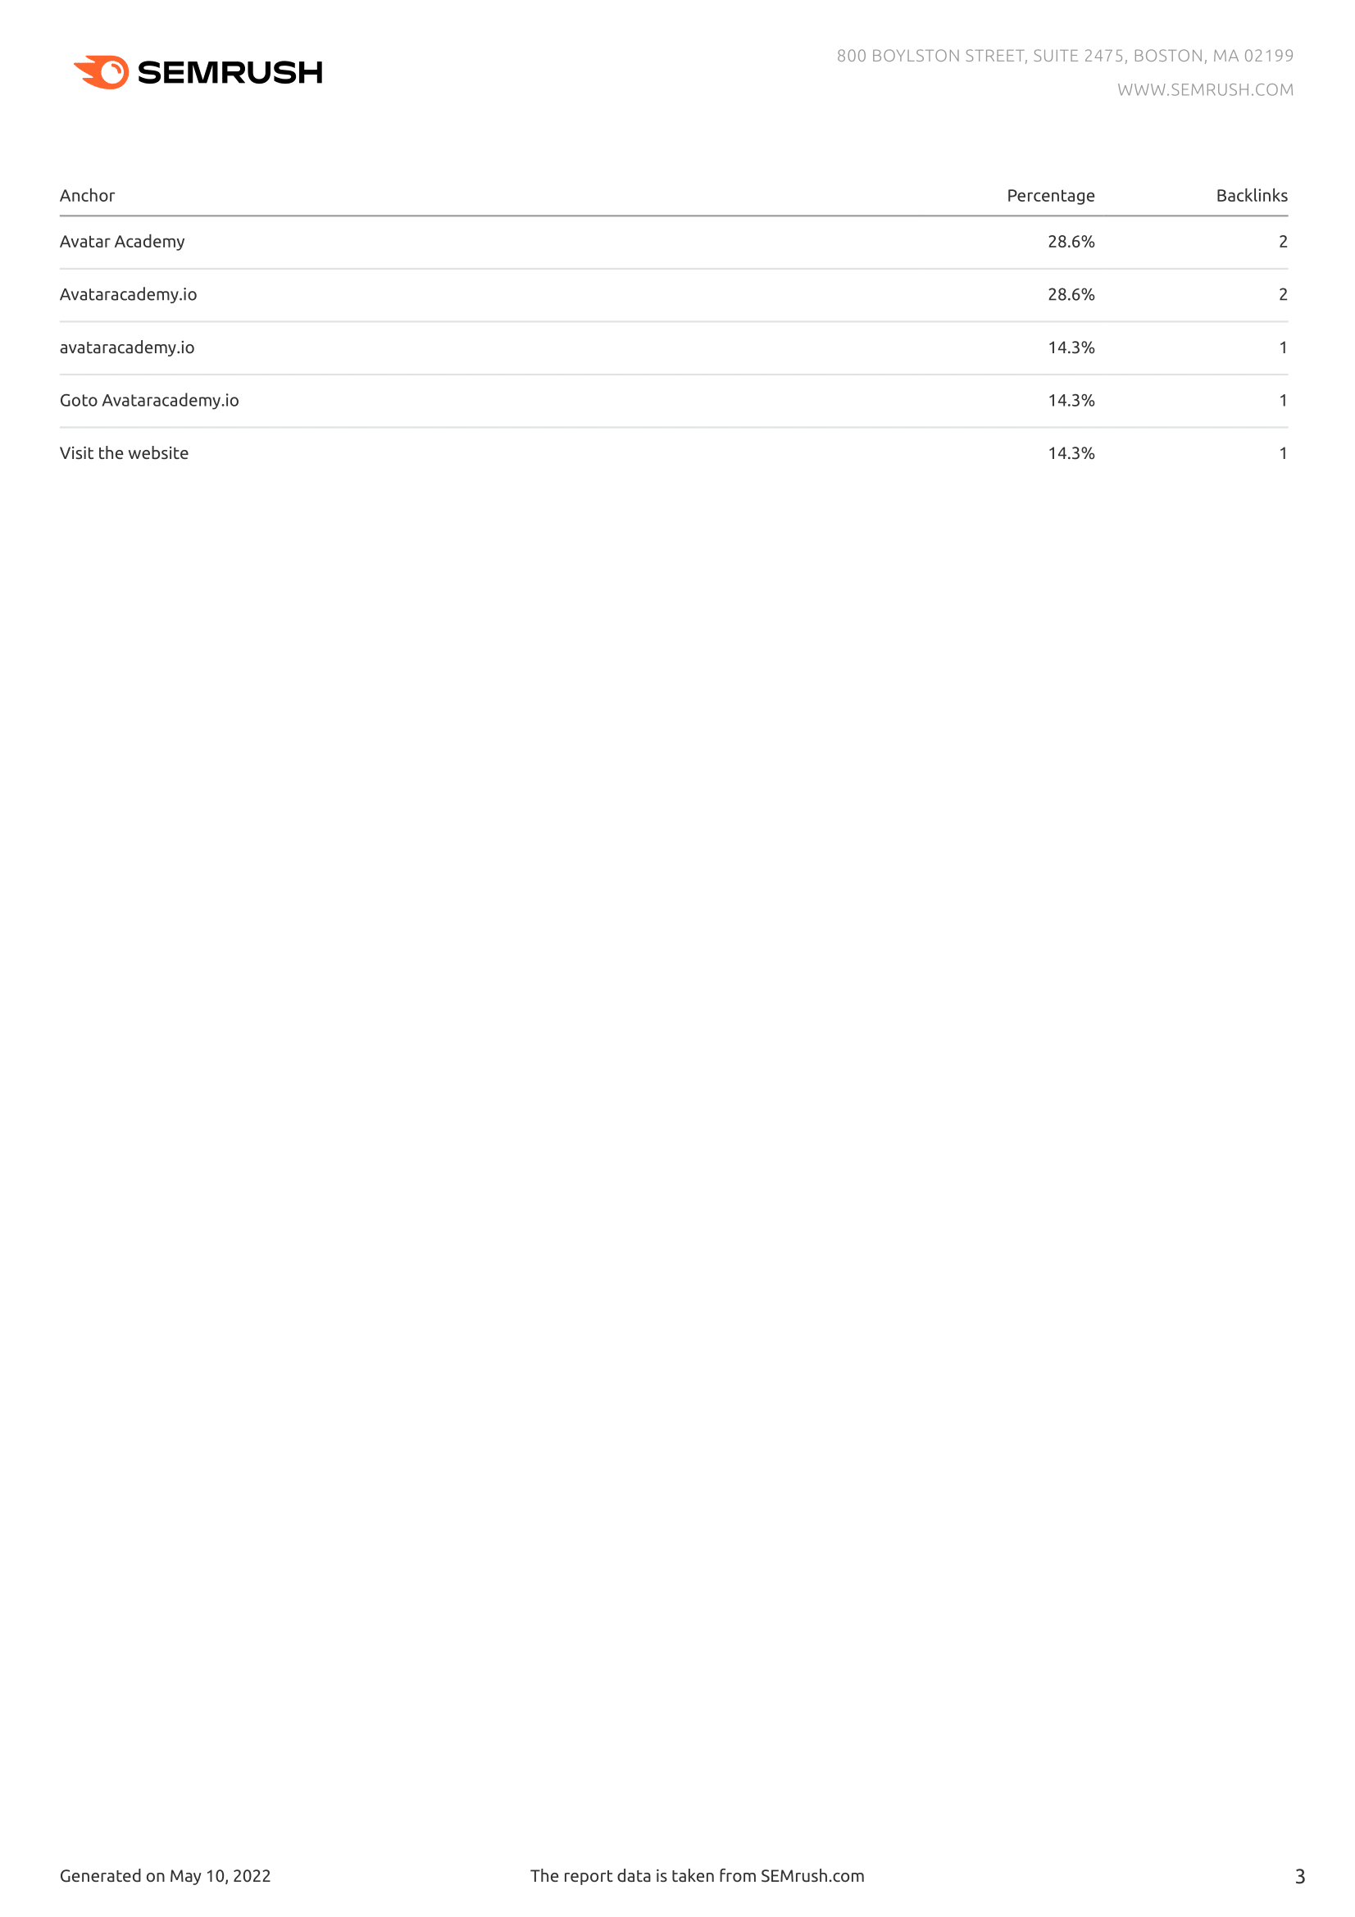
Backlinks

Figure 26 – The ‘Backlink Audit done for avataracademy.io through SEMrush

The Backlink Audit for the Avatar Academy website was done through SEMRush. The idea of backlinks are that they are links from one website to another. Each website should be encouraged to build up a backlink network through creating links to other websites, whether that is through content on the website or as an area with more information on a given subject.
On the SEMrush test, there were no toxic sites shown and because of this, Avatar Academy has a 1005 score. 43% of backlinks were nofollow, meaning links that aren’t indexed by the Google search engine, meanwhile 57% are. The top anchors, meaning text that hyperlinks are embedded into all show ‘Avatar Academy’ to some capacity.
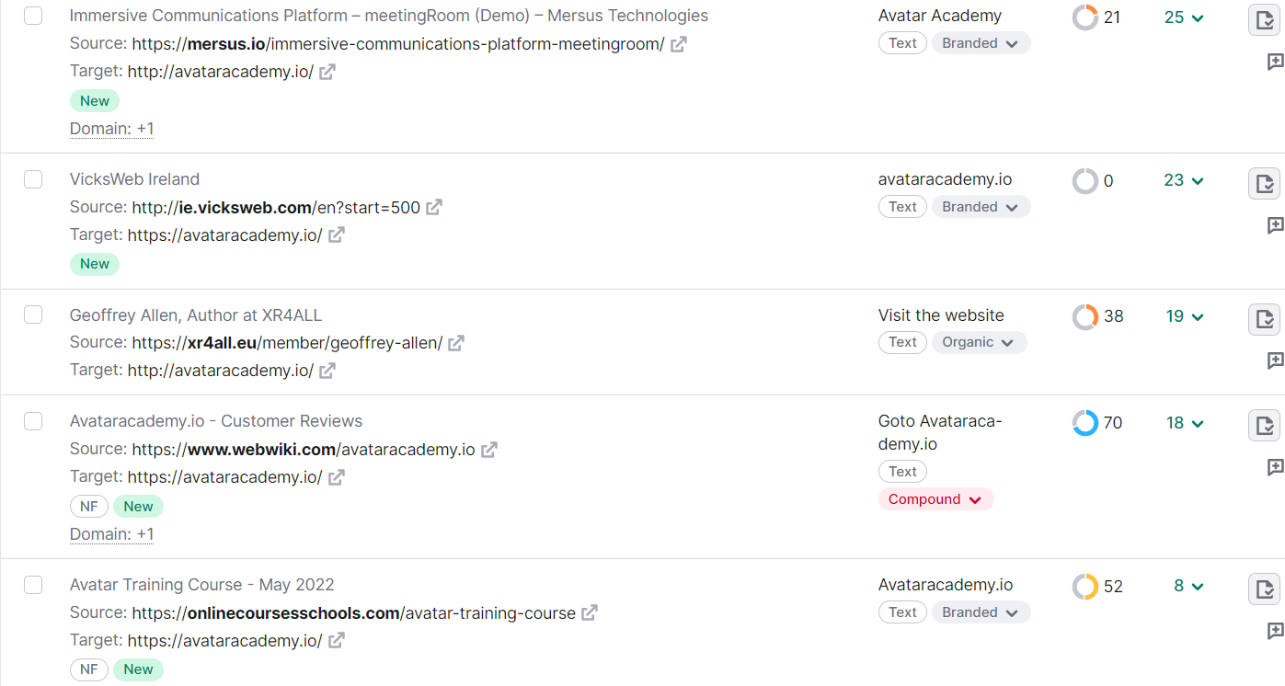
Figure 27 – Five sources of backlinks through other websites targeting avataracademy.io
SEMrush detects 5 links from other websites of varying quality. This has an influence on Avatar Academy’s quality. In an effort to expand this, the social media page can be used as a tool to increase the number of backlinks on the website. This would be done to create exposure to the website and so, potentially create opportunities for other websites to create links to the Avatar Academy site themselves.
The likes of the Blog page in hindsight have been set up on the website as a way to provide continuous content so there is an incentive for people to consistently visit the website. This is done in tandem by posting links to the social media pages to create further exposure and in turn, more opportunities to create links to the website.

Google Algorithms
Google`s algorithms retrieves data from the search index to provide the best and most relevant search results available.
Google's two main algorithms are Panda and Penguin and they can affect the SEO performance of avataracademy.io based on a number of factors.
Panda rewards sites with high quality content and penalize those with poor content. Avataracademy.io should follow Google's criteria for this algorithm to improve the search engine ranking. The content should not be duplicated, low quality nor contain grammatical problems.
Penguin rate backlinks sourced from other websites rather than their own. The idea of Penguin is that the lower the toxic score, the better chance the website has of being rewarded. As shown by the backlinks, there are no toxic links, so the toxic score is 100%. Most of the anchors listed appear to be related to the website because they have multiple variations of the "Avatar Academy", which represents text containing hyperlinks, therefore, when a user clicks on a variation of Avatar Academy, they are taken to that website.
Brand anchors (71%) make up the majority of the backlinks found. That is, the phrase contains a word that is different from the brand name. Compounds and organics saw the same percentage of backlinks. The former means that the brand name is included in the phrase, and the latter means that the link is provided from one website to another without the consent of the receiving website.

Domain Authority
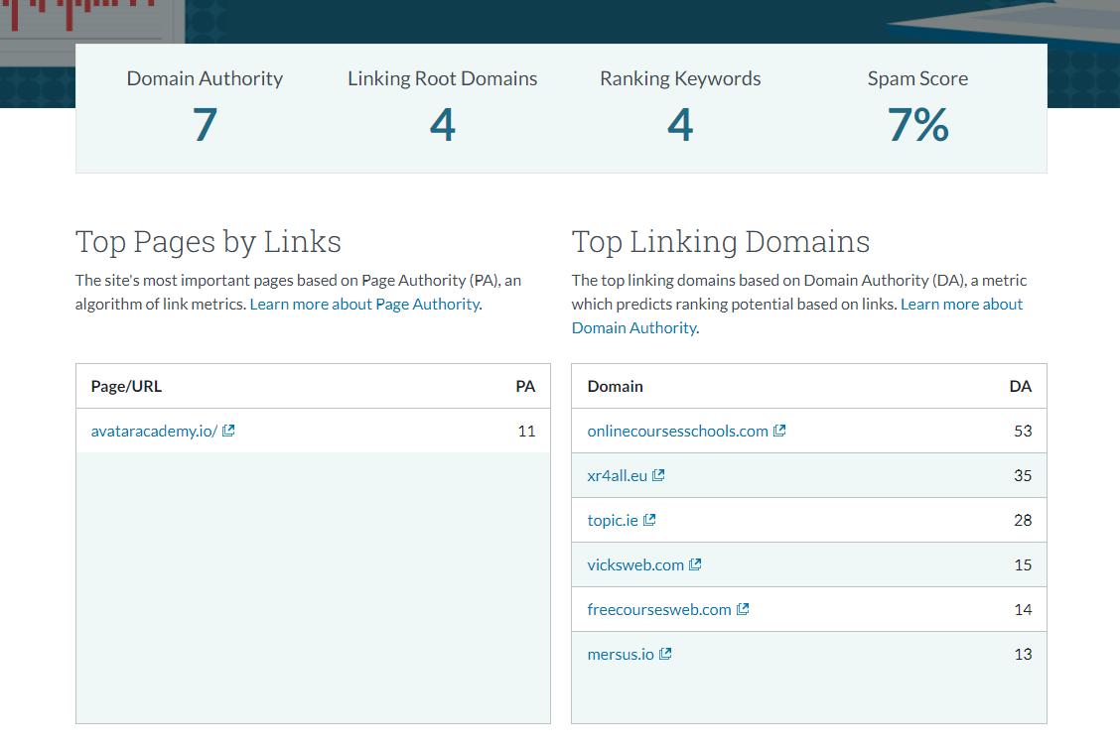

Figure 28 – The Domain Authority, Linking Root Domains, Ranking Keywords and Spam Score for avataracademy.io done through Moz.

The site’s domain authority was analysed using the website Moz. Despite efforts in optimising each page, it only resulted in a domain authority of 7 for the Avatar Academy website. This indicates that the site performs poor compared to their contemporaries. This is primarily due to the lack of links as well as the lack of quality from these links.

Figure 29 – Top Pages by Links and Top Linking Domains found when analysing Domain Authority for avataracademy.io through Moz
In the analysis, only one page is displayed for page authority, which is the Home page, resulting in a PA of 11. The other domains linking to the site have an average DA of 26. Spam Score is found as 7%, which is considered low but at the same time, there are not too many sites to work with.
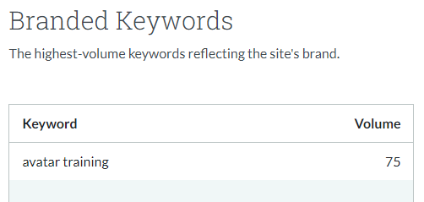
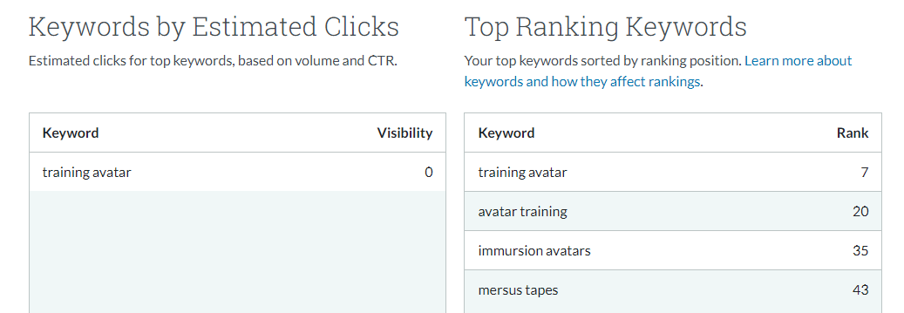

Figure 30 – Keywords by Estimated Clicks and Top Ranking Keywords found when analysing Domain Authority for avataracademy.io through Moz

This section also highlights the Top Ranking keywords relevant to them which all include either ‘mersus’ or ‘avatar’ in their name. The same goes for the Branded Keyword which has a high volume of 75, reflecting the brand of the site.

Monthly Monitoring Insights
To monitor SEO insights, Google Analytics will be used to analyse the performance of the website for each month.
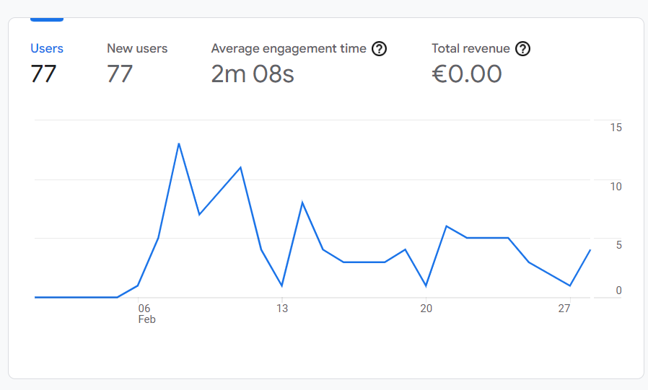
It was only on February 6th that the Google Analytics tracking code was implemented into the website, enabling it to connect with Google Analytics so we can get an idea of its performance in each area. Because of this, the first 5 days cannot be recorded. Otherwise, the website had a total of 77 users overall with an overall engagement time of 2 minutes and 8 seconds.

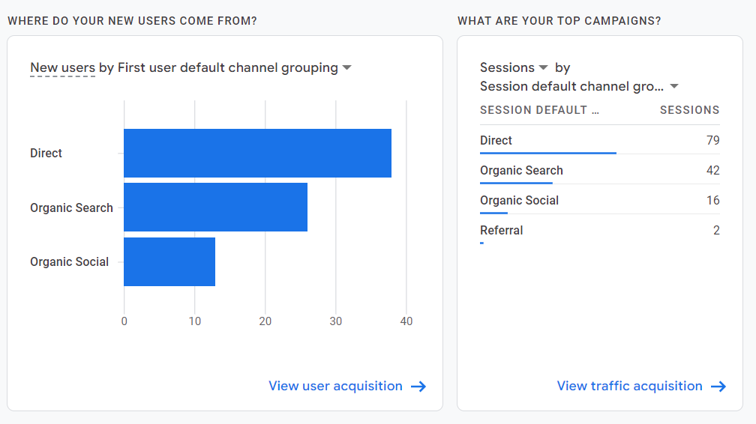
February the first month where the word was spread about the website itself through social media links. This is categorised in ‘Organic Social’. Other sources of traffic this month is from Direct so the majority of users found the site through typing the link into the URL and Organic Search by people who come across the Avatar Academy website on a Google search.
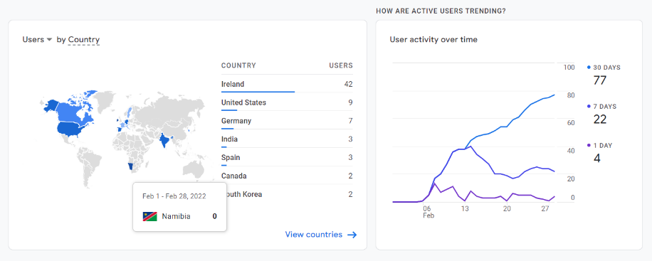
The majority of users come from Ireland at 42, with other countries like the United States, Germany, India and Spain as the runners-up. As for the user activity, showing a rising chart in the number of active users on website for 1 day (4 users), 7 days (22 users) and 30 days (77 users).

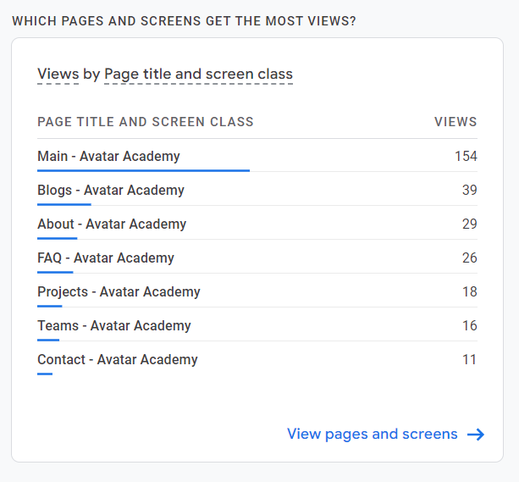
The most popular page on the website is naturally the home page since that was most posts made on social were linked to as well as the direct searches as seen earlier. Other pages that show up include the blog page, about section, FAQ since it was temporarily published and more.

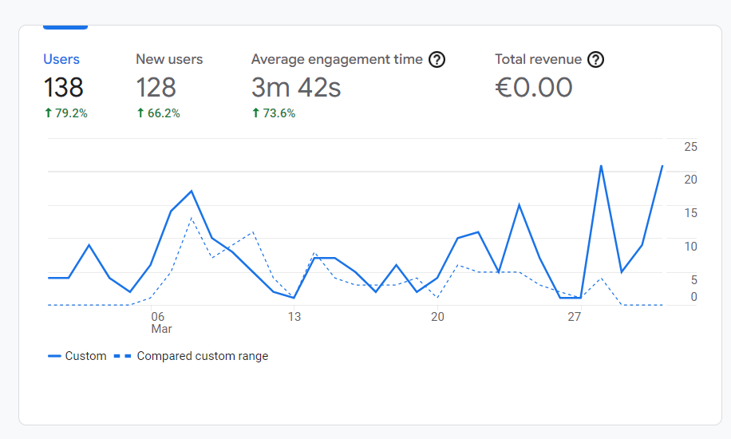
In March, the website had a total of 138 users overall, an increase of 79.2% compared to February. Out of that number, 128 of those were brand new users. The site also had an overall engagement time of 3 minutes and 42 seconds, which is nearly double the amount compared to February.

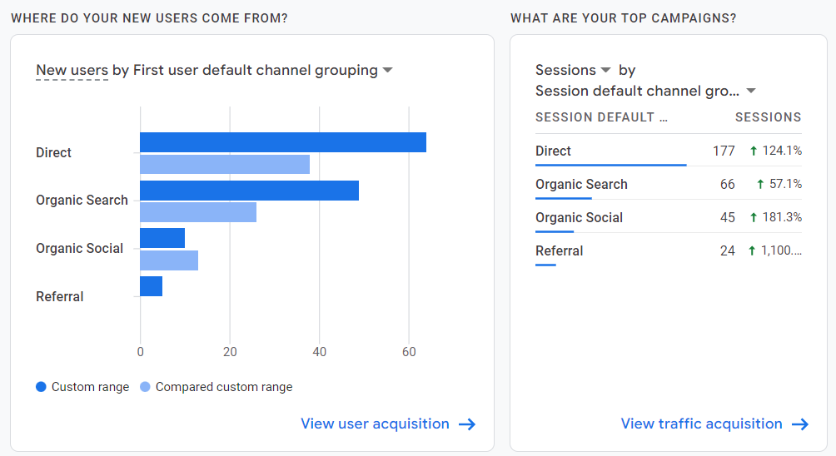
In comparison to February, there was mostly an increase in sessions and the types of traffic the user entered the website through. Most new users entered through Direct and Organic Search yet again. The Referral option now appears since users have entered the website through these means. There is a decrease in those who entered through Organic Social. As for sessions, there is an overall increase in every single area. Direct went up from 79 to 177, Organic Search from 42 to 66, Organic Social from 16 to 45 and Referral from 2 to 24.

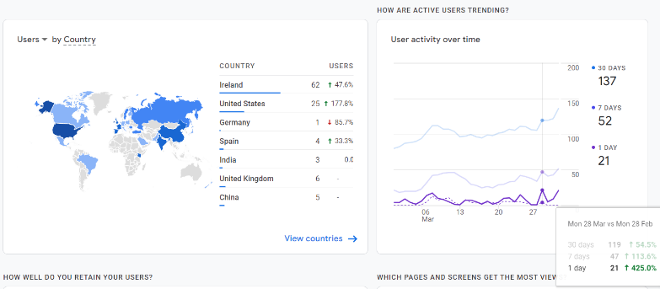
Most users come from Ireland at 62, with other countries like the United States, Germany, Spain and India. The only difference aside from the overall increases are the decrease in people visiting from Germany and Spain ranking ahead of India. As for the user activity, there is a huge increase compared to February with 21 users for 1 day, 52 users for 7 days and 137 users for 30 days.
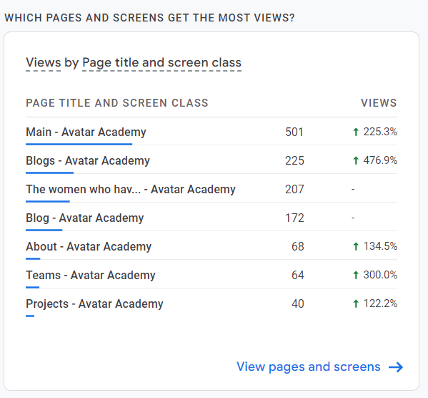
The most popular page on the website is still the home page, followed by Blogs which eventually changed name to Blog and the International Women’s Day blog since that was posted on social media. Each page listed here saw a huge increase that came with the increase of the number of users.

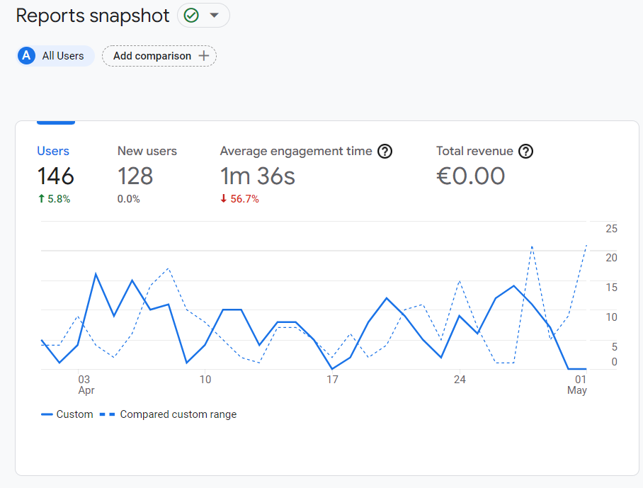
In April, the website had a total of 146 users, a 5.8% increase compared to February. Out of that number, 128 of those were brand new users. The site had an overall engagement time of 1 minute and 36 seconds, a 56% decrease compared to what was seen back in March.

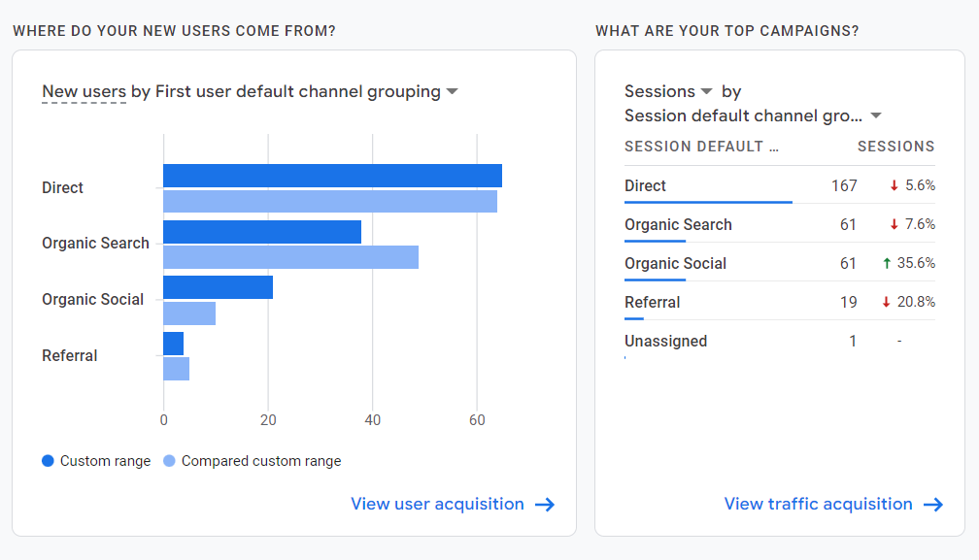
Compared to March, there was a decrease in the number of sessions except for Organic Social, which saw a 35.6% increase. As for traffic types, Most new users still came from Direct and Organic Search since they only saw 5.6% and 7.6% decreases respectfully.

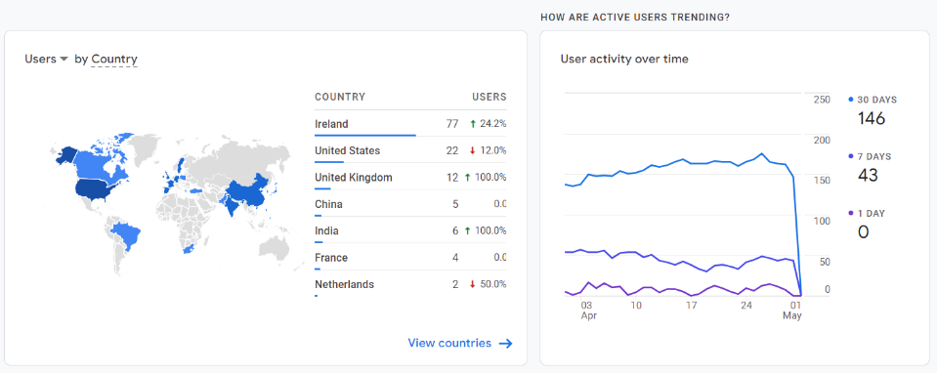
This month saw a shakeup in relation to countries. Though Ireland and the US still take 1st and 2nd place, the United Kingdom saw 12 visitors and China saw 5 visitors, meanwhile India also maintain their position in this ranking. User activity saw a sharp decline towards the very end of the month and with that, recorded 0 users for 1 day, 43 users for 7 days and 146 users for 30 days.

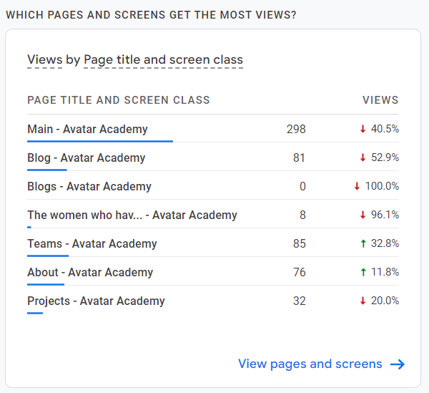
The most popular page on the website is still the home page, followed by Teams and Blog. Overall, there has been a decrease in views for all areas.

Social Media

Research/Investigation
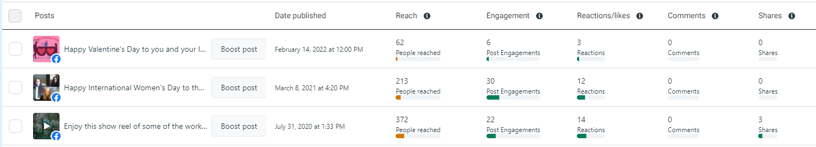
Prior to creating content for Mersus Technologies, the Meta Business Suite showed insights that Mersus Technologies had not posted on Facebook for almost a year. The last post before then was made in March 2021 while the post before that was created in July 2020. The company amassed a sizeable reach in the hundreds, especially comparable to their follower count. After that, users would have realised that the page’s status, so there was less interest due to its inactivity on Facebook.
Figure 31 – Statistics for three posts on Facebook demonstrating that no posts have been created in almost a year before the implementation
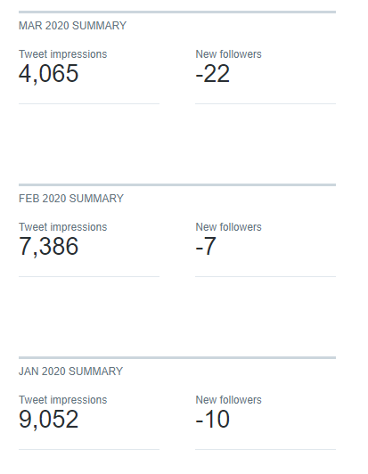
As for Twitter, the company made their last Tweet back in February 2021, almost exactly a year prior to the beginning of the implementation. Like the Facebook page, there was less interest in the Twitter page since it wasn’t active for a year. It didn’t help that the follower count had been decreasing for most months since May 2019.
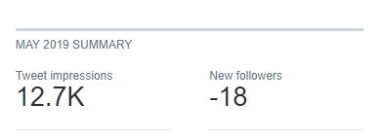
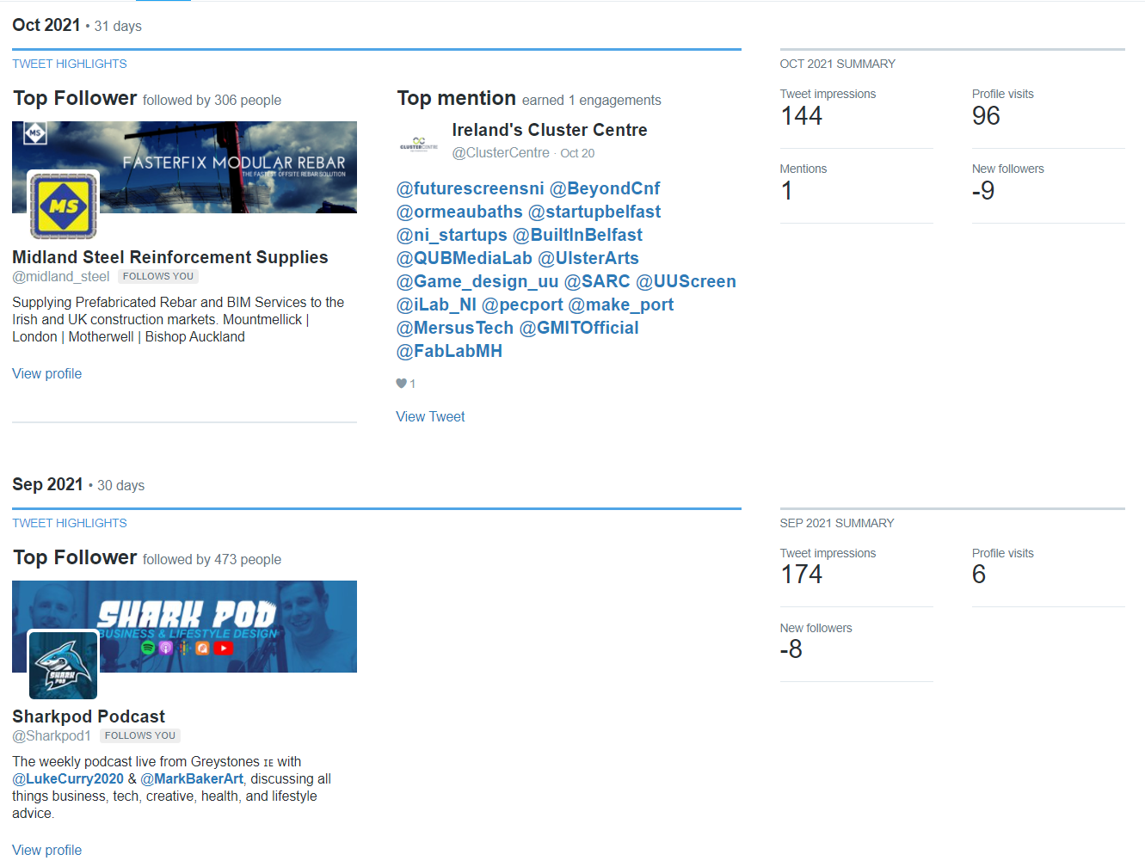
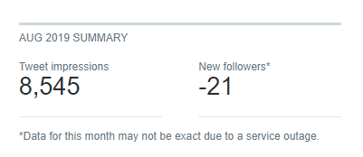
Figure 32 – Twitter analytics in various months from 2019-2021 highlighting the drastic decreases in follower count.

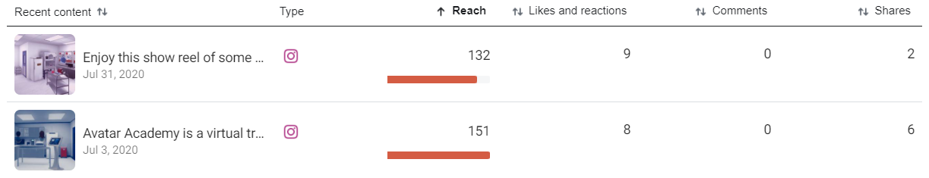
With LinkedIn, content was published more regularly compared to the other platforms prior to the implementation. The profile mostly saw likes of single digits and impressions in the 200s to 300s. The page itself wasn’t established as long as the other platforms and overtime, it became the company’s biggest social media focus as it was an area for them to create contacts with other businesses and important individuals.
Figure 33 – The last two posts done on Instagram prior to the implementation showing the gap between posting dates.
The focus shifted away from Instagram once the company completely transitioned away from animation. The page was previously a hub for them to post variety art. Once that shift occurred, the page went inactive for a year and a half from July 2020. Like with Facebook and Twitter, interest would decline as there was no content published nor activity from the platform.

Social Media Strategy
Based on the research carried out at the beginning of the year, it was really important for the company to have a consistent posting schedule, as it was found that they post sporadically. This is found on every platform except for LinkedIn. The lack of content is a reason for people to start unfollowing the page, hence engagement decreases as well as reach and follower count. To mitigate this issue, it is essential to post content on a regular basis, to have a schedule set in stone so that users have a reason to keep paying attention to the page. The goal was to create content every week, even a few times a week in order to maintain this position.
Avatar Academy occupies a very niche market of companies looking to perform digital transformations of workplace training into technology that has the capabilities of replicating a work environment as well as its training programmes. There is a lot of information to take in that is not familiar to the average social media user. With this in mind, it was important to further expose the Avatar Academy brand to the public, whether that was translating information into more digestible formats, explanations of how it can benefit companies, thoughts from companies who have utilised Avatar Academy in their own workplaces and creating a better understanding of the brand and technology that makes these experiences possible.
Prior to the implementation, there was little done to create awareness of the Avatar Academy website to the masses. With that, there was a need to create links to the website through social media posts. With that, the idea of creating blogs for the website occurred as a continuous way to drive traffic and new pieces of content for users to digest. A description of the blog was to be posted onto social media platforms which included links to the full post. Links to the website would also be posted in relation to posts such as the testimonials and videos/images explaining the benefits of the Avatar Academy.

Posts Created/Engagement
In the interest of the company and due to time constraints, the number of social media accounts to post on was reduced to three (Facebook, Twitter and LinkedIn), meaning that little to no additions were made to Instagram and YouTube.

Instagram
Prior to this project, the page had been inactive since July 2020, so it was clear that it wasn’t a priority to the company. Due to the inactivity of the account, the follower count decreased by 2% from 501 to 491 followers.
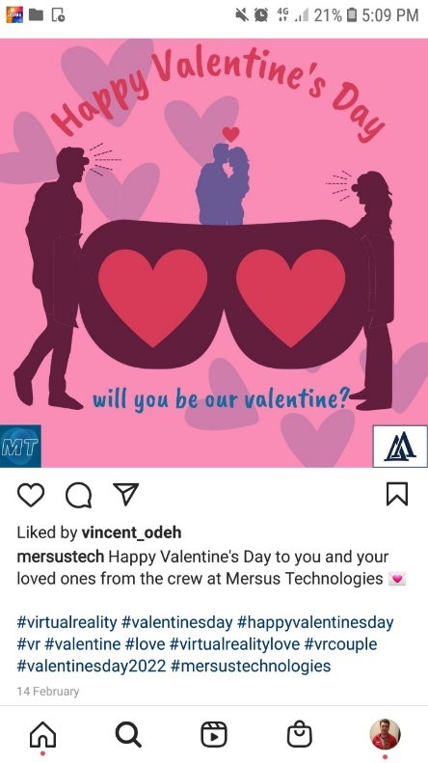
Post 1
The first Instagram post is a simple Valentine’s Day post that was created through Canva. The purpose of this post was to have content published on a day of celebration. The post wishes the user a Happy Valentine’s Day from the company. The hashtags below include a mix of ones relating to Valentine’s Day as they would have been relevant and popularity that day as well as virtual reality. In total, the post has 1 like.

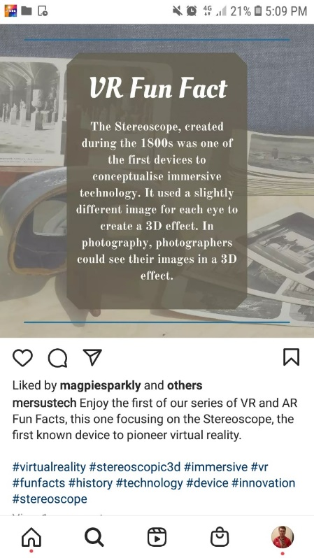
Post 2
The second Instagram post was intended to be part of a series of posts involving fun facts about VR and AR. This post was specifically relating to the Stereoscope and how this pioneer of VR technology worked and to get users to compare what VR was like then compared to now. A template was created displaying the information in the centre and the image relating to the topic in the background through Canva. In total, the post has 3 likes and 1 comment.

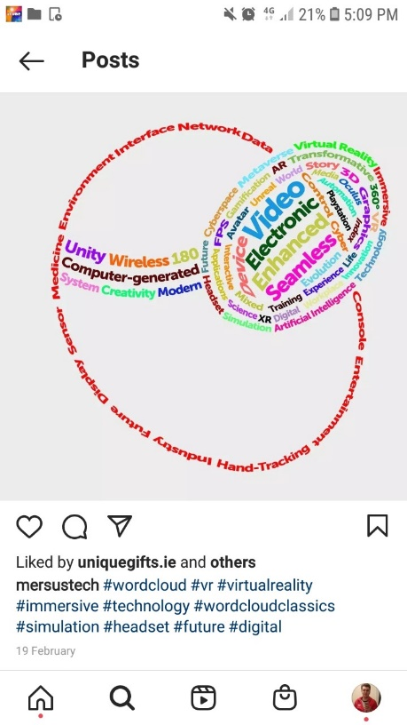
Post 3
The third and final Instagram post involved a word cloud including various words and terms related to virtual reality technology. The word cloud itself was formed in the shape of the Mersus Technologies icon to reflect the brand. The image was created through Photoshop by typing each word separate and reforming most of them in the shape of an arc to ensure a circular shape. In total, the post has 5 likes. After this, it was decided that Instagram would no longer be a focus due to time constraints as well as a bigger focus on the other three platforms. Certain posts that were originally intended for Instagram were repurposed for these platforms.

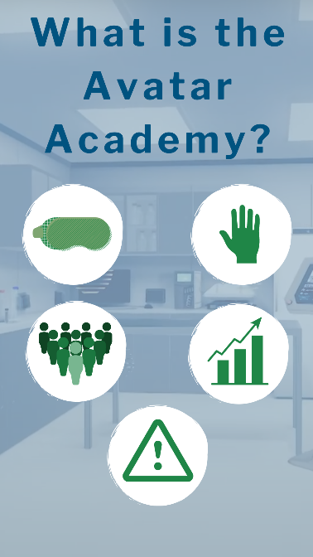
Story
One Instagram story was published. It is titled ‘What is the Avatar Academy?’ This content was repurposed to accommodate for a story structure. The purpose was to spread the word on what is the Avatar Academy, what it is for and how it can be beneficial compared to other alternatives. Because of how important the platform was, the images were used a story and saved onto the page.

Facebook
The Facebook page had built up a follower count of 864, a 0.7% increase compared to the 858 from the situation analysis.

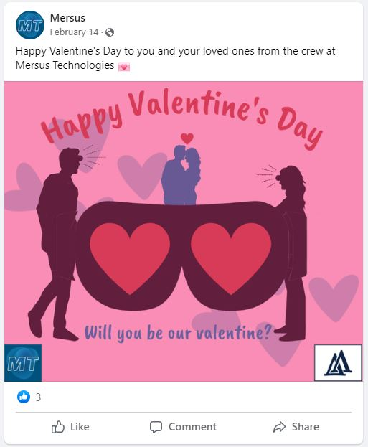
Post 1
The first Facebook post, like Instagram was a simple Valentine’s Day post that was created through Canva. The purpose of this post was to have content published on a day of celebration. The post wishes the user a Happy Valentine’s Day from the company. The layout of the image was changed to reflect the needed image size for Facebook posts as certain elements would get cut off when directly exporting from Instagram. In total, the post garnered 3 likes from 62 reaches and 6 engagements.

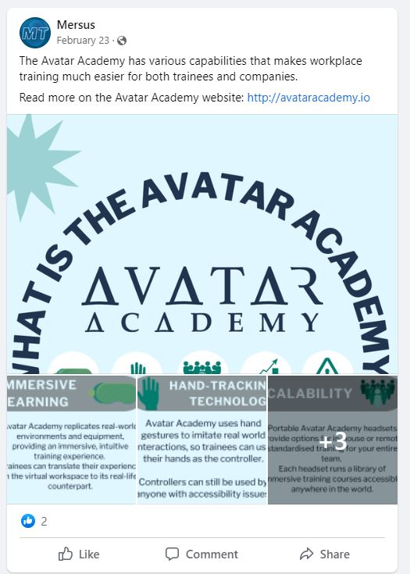
Post 2
The second Facebook post is a piece of content that was intended to be shaped like an infographic, but it could not fit into a post without important elements being cut off. With that, this post was split up into six images. The post in question is relating to the Avatar Academy. The purpose was to spread the word on what is the Avatar Academy, what it is for and how it can be beneficial compared to other alternatives. It contains information from the website that was translated into image form to make it more visually appealing and more digestible to the reader. It also includes a link back to the website so that the reader can learn more. The post garnered 2 likes from 85 reaches and 7 engagements.
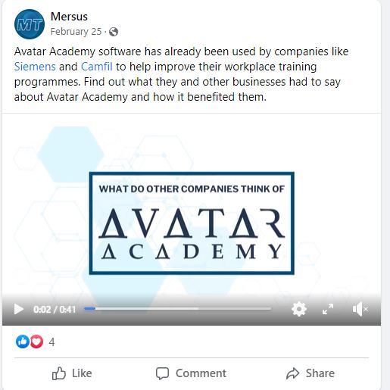
Post 3
The third Facebook post translates a series of testimonials from the website into video form. The purpose of this post was to get across other entities that have had a positive experience with the Avatar Academy platform and to showcase snippets of each piece of software to give the reader an idea of what the training programme is like. Both Siemens and Camfil were tagged as the video mentions them and to hope that their followers would notice the video. This post saw 4 likes from 8 engagements and 62 reaches.

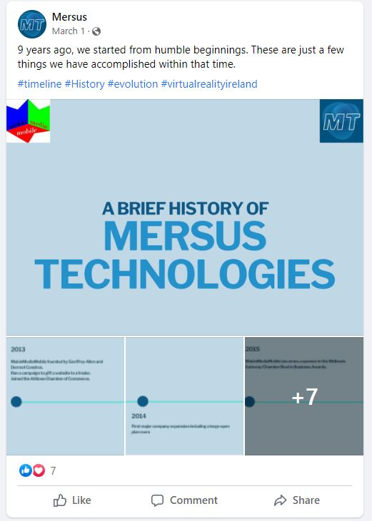
Post 4
The fourth post showcases a history of Mersus Technologies all the way back to 2013, when they were known as MakinMediaMobile. Like Post 2, this post was designed in a horizontal layout originally, but it could not be processed by Facebook properly, so it had to be broken up into a series of images representing each year on the timeline. The purpose of this image is to get more people to know about Mersus and its accolades from the last decade. To date, the post has 7 likes from 19 engagements and reached 167 people.

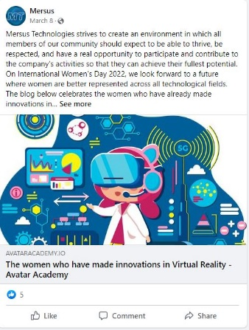
Post 5
The fifth post is a link to the first blog put up on the Avatar Academy website. This was also done in tandem as a way to celebrate International Women’s Day. The blog itself talks about a few women in the VR space and their accomplishments up to this point. The caption is a statement from the company about how they strive to create an equal opportunity environment and wishing for a future where women are better represented in the Immersive Technology industry. More blogs are linked as more content on the website, therefore, an incentive for people to keep visiting. The post has gained 5 likes from 8 engagements and reached 152 people.

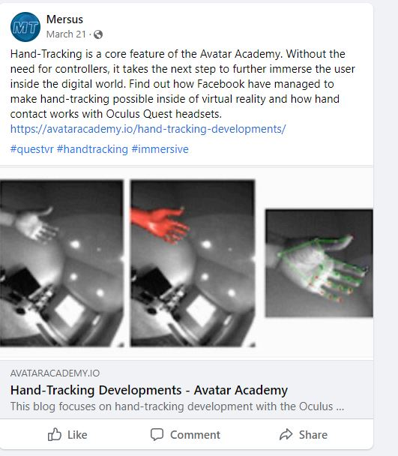
Post 6
The sixth post is a link to the second blog put up on the Avatar Academy website. The blog itself talks hand-tracking technology since it is a major selling point of the Avatar Academy brand. It is a piece written by a Mersus staff member about the technology and how Facebook made it possible on their Oculus Quest headsets. This post was done in order to create more traffic to the website through new content. The post saw no likes unfortunately, however, 3 engagements found were link clicks to the website out of 66 reaches.

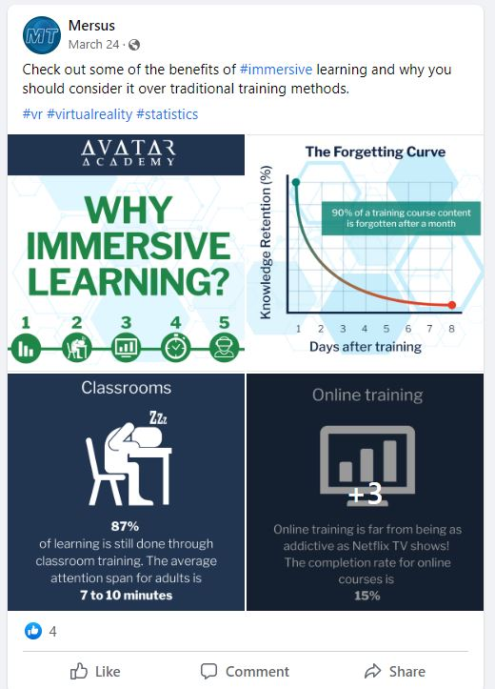
Post 7
The seventh post is a piece of content that was originally designed for Instagram, but the layout and content remained intact when translated to Facebook. The post showcases statistics of immersive learning from the website which is translated into imagery content. The idea is to show people why immersive learning can be more beneficial compared to traditional methods. The imagery involves assets taken from the website to better maintain representation of the brand. To date, the post has garnered 4 likes from 9 engagements and 96 people reached.

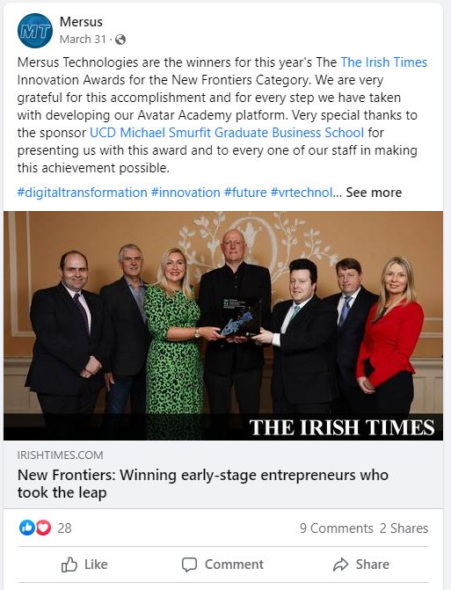
Post 8
The eighth post involves Mersus Technologies victory at the Irish Times Innovation Awards. The purpose of this content was to take advantage of an event that was a big deal and creating a post during that time period when the event would be on peoples’ minds. Because of this as well, the Irish Times and UCD were tagged since they were relevant in this event. The post received a staggering 28 likes, 9 comments and 2 shares out of 112 engagements. The post reached a total of 475 people.

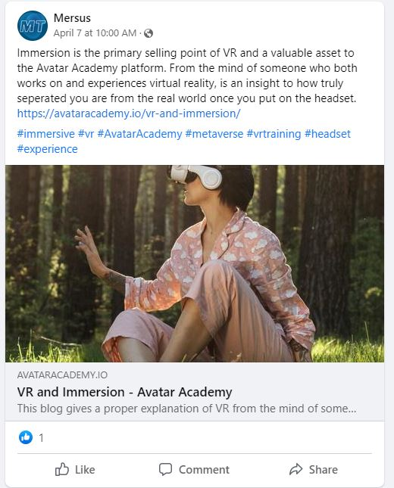
Post 9
The ninth post is a link to the third blog put up on the Avatar Academy website. Titled VR & Immersion, the blog goes in depth as to what it really means to be immersed in virtual reality and an insight into how truly separated the user is from the real world once they put on the headset. Since the blog is written by a staff member who both works in and experiences virtual reality first hand, it provides a perspective that wouldn’t be normally composed by others. Once again, the blog was put up to help direct traffic to the website and to increase the numbers as well as create awareness of the technology on top of that. The post has garnered 1 like from 4 engagements with 81 people reached.
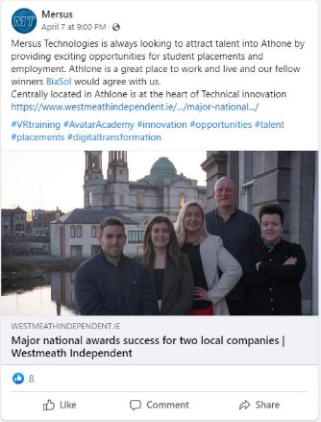
Post 10
The tenth post is a continuation of Post 8, linking to an article by the Westmeath Independent in relation to the Irish Times Innovation Awards. The purpose of this post is brand awareness as well as awareness for Athlone. Another Athlone company called BiaSol was tagged to drive this point home. The post saw 8 likes out of 20 engagements and It reached 154 people.

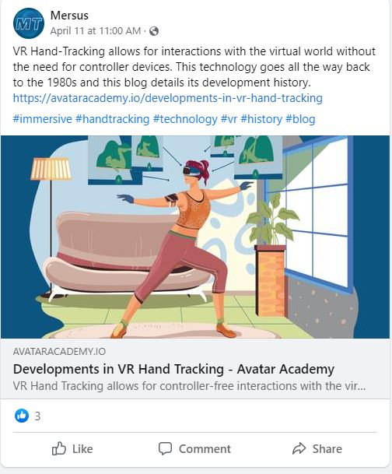
Post 11
The eleventh post is a link to the fourth blog put up on the Avatar Academy website. Titled Developments in VR Hand Tracking, the blog goes all the way back into the history of the technology as far back as the 1980s. The header image was a vector taken from Pixabay, with some of the colours edited to reflect the brand colours, so that it represents the user inside an Avatar Academy headset. The purpose of this post was to share a link to the website to drive traffic. The post has garnered 3 likes out of 6 engagements with 89 people reached.

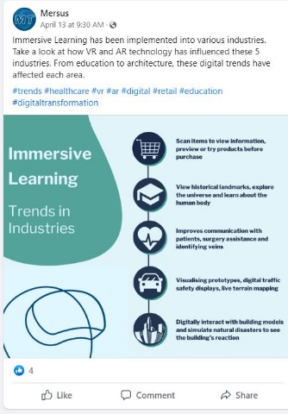
Post 12
The twelfth post is a remake of Post 4 on Twitter, highlighting Immersive Learning and the impact it has had on various industries from retail to healthcare to architecture. The image was created through Canva and compared to the old version, it uses the brand colours and creates a more simplified layout while retaining the information found. The purpose of this post was to create a high-quality piece of imagery as well as highlighting interesting uses of VR and AR in other industries. The post saw 4 likes out of 6 engagements and It reached 110 people.

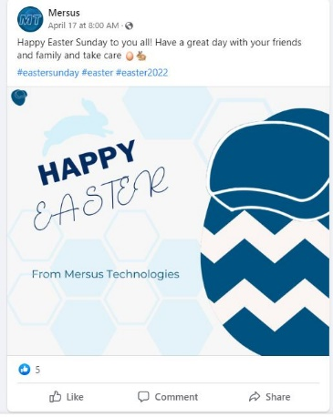
Post 13
The thirteenth post is a post wishing the reader a Happy Easter. The purpose of this post was to create a high-quality, creative piece of imagery showcasing an egg wearing a VR headset for creativity while maintaining the brand identity. This is evident in the colours as well as the background and fonts. The post saw 5 likes out of 7 engagements and It reached 91 people.

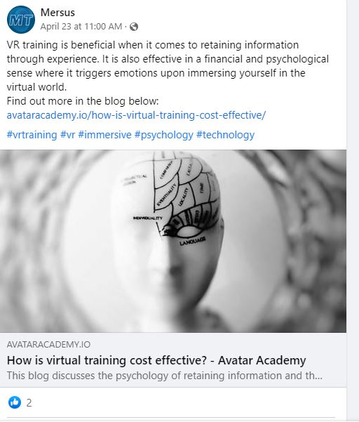
Post 14
The fourteenth post is a link to the fourth blog put up on the Avatar Academy website. Titled How is virtual training cost effective?, the blog delves into the psychological connections to virtual reality and the ability to retain information. The blog is posted here to increase awareness of the effectiveness of learning through a virtual experience as well as another piece of content to drive traffic back into the website. The post saw 2 likes out of 5 engagements and It reached 78 people.

Twitter
The Twitter page saw a decrease in following despite regular posting. That being said, the following is in the 1000s, so the chances of that happening is higher. The follower count decreased by 0.44%.

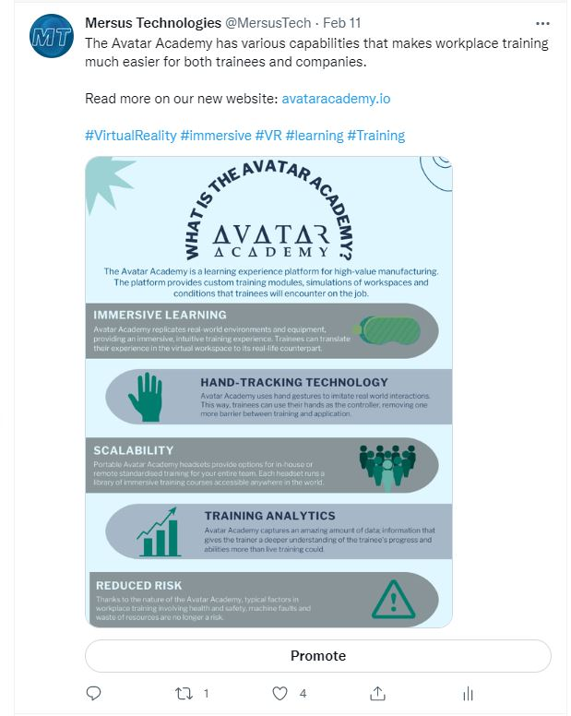
Post 1
Unlike Post 2 on Facebook, this image of “What is the Avatar Academy?” is able to be posted as intended as an infographic on Twitter, though it had to be slightly modified so it can all fit into a Twitter post. Like Facebook, the purpose was to spread the word on what is the Avatar Academy, what it is for and how it can be beneficial compared to other alternatives. On Twitter, The post garnered 2 likes, 1 retweet, 16 engagements and 235 impressions.

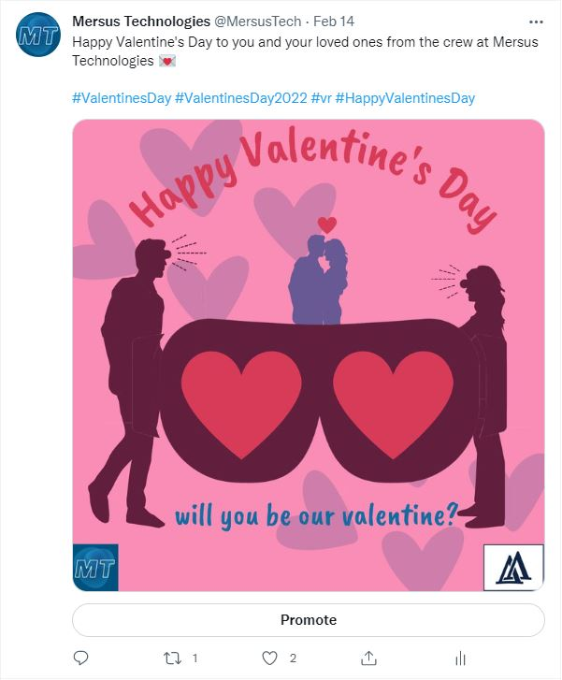
Post 2
The second Twitter post, was a simple Valentine’s Day post that was created through Canva. The purpose of this post was to have content published on a day of celebration. The post wishes the user a Happy Valentine’s Day from the company. The layout of the image was changed to reflect the needed image size for Twitter posts. In total, the post garnered 2 likes, 1 retweet, 4 engagements and 235 impressions

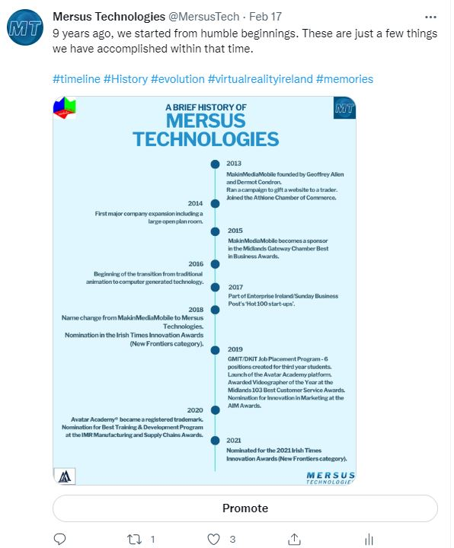
Post 3
The third post showcases a history of Mersus Technologies all the way back to 2013, when they were known as MakinMediaMobile. This post is also laid out the way it was originally intended in a vertical style, though like Post 1, the image had to be stretched out slightly in order for Twitter to include every piece of information. The purpose of this image is to get more people to know about Mersus and its accolades from the last decade. In total, the post got 3 likes, 1 retweet, 18 engagements and 416 impressions.

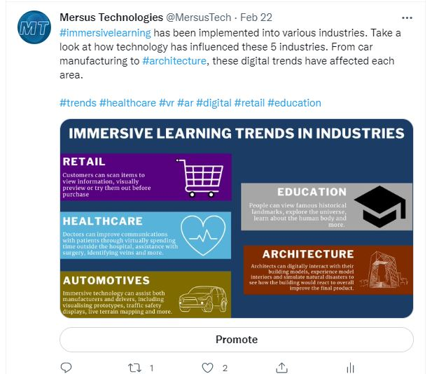
Post 4
The fourth Twitter post, talks about the various immersive learning trends in different industries and an idea of the influence that VR & AR had on each. The purpose of this post was to spread awareness of how much virtual reality and training can truly impact different areas. To date, the post has 2 likes, 1 retweet, 6 engagements and 231 impressions.

Post 5
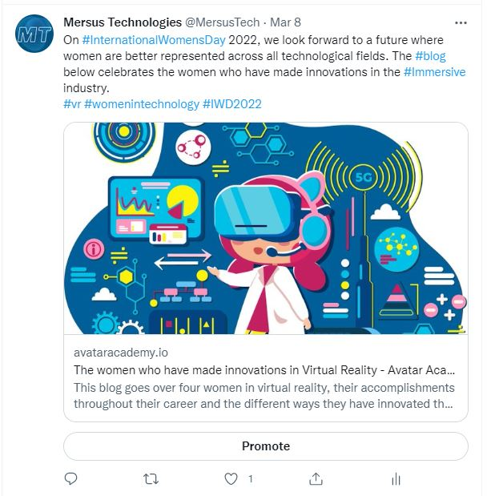
The fifth post is a link to the first blog put up on the Avatar Academy website. This was also done to celebrate International Women’s Day. The blog itself talks about women in the VR space and their accomplishments up to this point. The caption states that the strive for equal opportunities and a future where women are better represented in the Immersive Technology industry. More blogs are linked as more content on the website, therefore, an incentive for people to keep visiting. The post has gained 1 like, 4 engagements and 161 impressions.
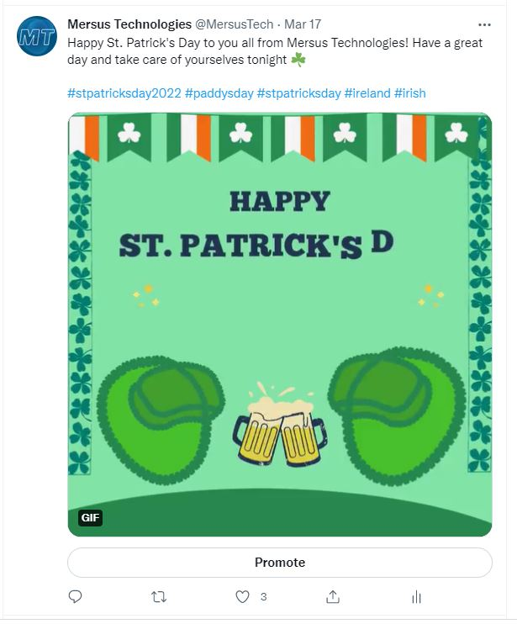
Post 6
The sixth post was created to celebrate St. Patrick’s Day. The image in question is a gif that was made through converting a video made on Canva. The two Mersus icons are replicated using shamrocks to cover the entirety of each and to celebrate the occasion. The brand identity is maintained through this and the text shown within. The post got a total of 3 likes, 14 engagements and 231 impressions.

Post 7
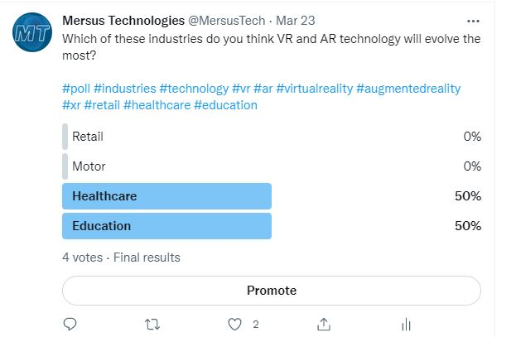
The seventh post was created for the sake of user interaction. The poll in question asked which industry did the user think would evolve the most in terms of VR & AR integration. Twitter was one of the platforms chosen for this post due to allowing up to four answers for each poll. It lasted for a week to ensure that the users have the most time needed to interact with the post. In the end, 4 people voted which created a tie between ‘Healthcare’ and ‘Education’ The post also got 2 likes, 9 engagements and 173 impressions.

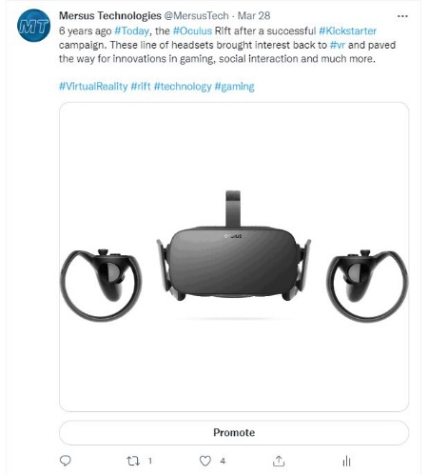
Post 8
The eighth post was made for the anniversary of the Oculus Rift, which released 6 years ago on that day. A post was dedicated to it as it helped to revive interest in VR and paved the way for significant developments in this field. It is possible that Mersus would not be where they are today without its release. The post got 4 likes, 1 retweet, 10 engagements and 800 impressions.
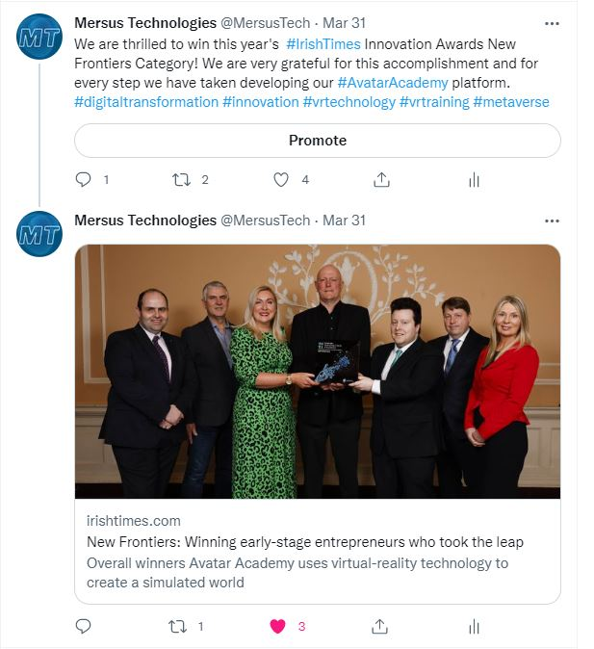
Post 9
The ninth post involves Mersus Technologies victory at the Irish Times Innovation Awards. The purpose of this content was to take advantage of an event that was a big deal and creating a post during that time period when the event would be on peoples’ minds. Because of this as well, the Irish Times and UCD were tagged since they were relevant in this event. Due to Twitter’s character limit, the URL of the article had to be inserted into the reply section. The main post garnered 4 likes, 2 retweets, 15 engagements and 361 impressions. Meanwhile, the reply including the URL garnered 3 likes, 1 retweet, 9 engagements and 195 impressions.
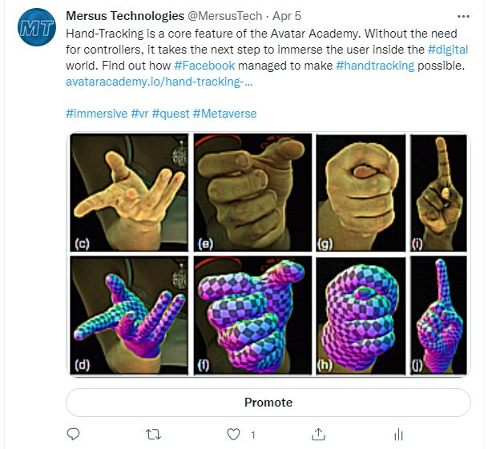
Post 10
The tenth post is a link to the second blog put up on the Avatar Academy website. The blog itself talks about hand-tracking technology since it is a major selling point of the Avatar Academy brand. This post was done in order to create more traffic to the website through new content. The post saw 1 like, 5 engagements and 123 impressions.

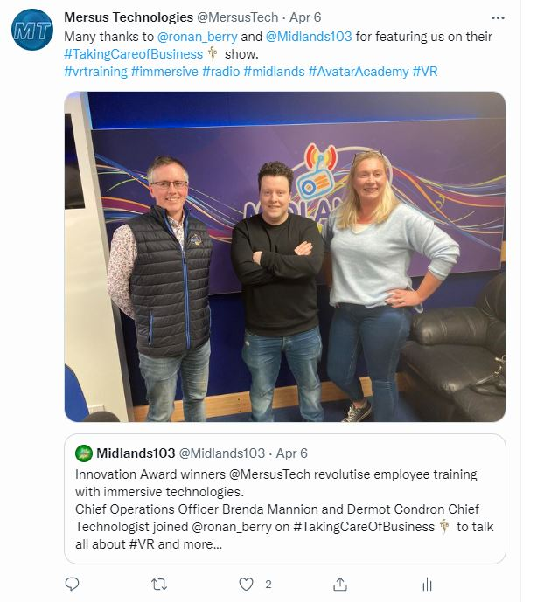
Post 11
The eleventh post refers to a link to Midlands 103 as they talked to Mersus about their victory in the Irish Times Awards. This post was created as it is a brand awareness opportunity on the behalf of a relatively known radio station in the country and especially the midlands. This post is also an opportunity to further create brand awareness by tagging the station and including the link to direct users to the audio recording of the discussion. This post saw 2 likes, 5 engagements and 130 impressions.
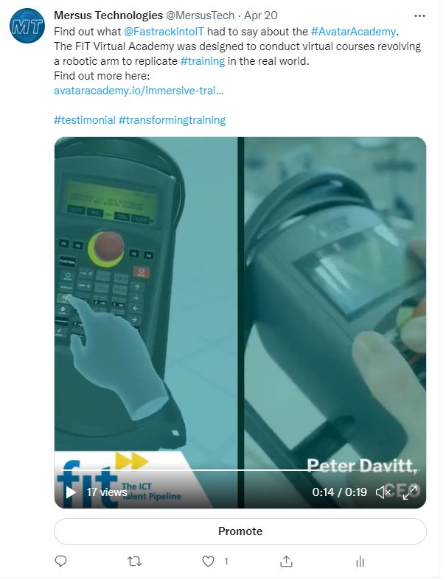
Post 12
The twelfth post is a clip taken from Facebook Post 3, involving the testimonials for the Avatar Academy platform. This video only involves the company FIT and their own VR training programme created by Mersus. The reason for this split was the assumption that shorter videos would perform better compared to long-form. On top of that, there were changes to transitions as well as the aspect ratio at the request of the company. The video saw 1 like, 6 engagements and 55 impressions.

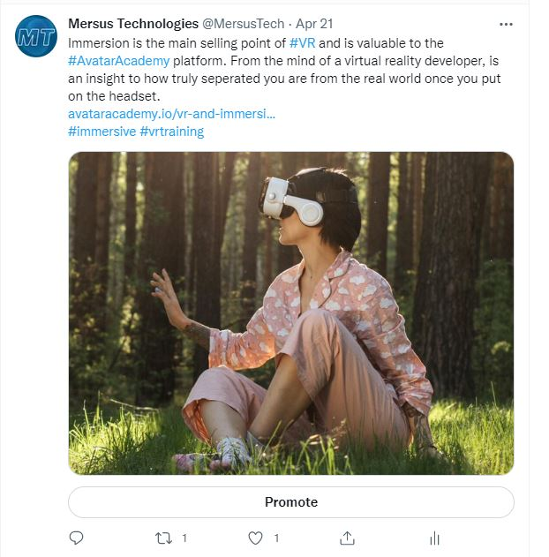
Post 13
The thirteenth post is a link to the third blog put up on the Avatar Academy website. Titled VR & Immersion, the blog goes in depth as to what it really means to be immersed in virtual reality and an insight into how truly separated the user is from the real world once they put on the headset. Once again, the blog was put up to help direct traffic to the website and to increase the numbers as well as create awareness of the technology on top of that. The post has garnered 1 like, 1 retweet, 6 engagements and 89 impressions.

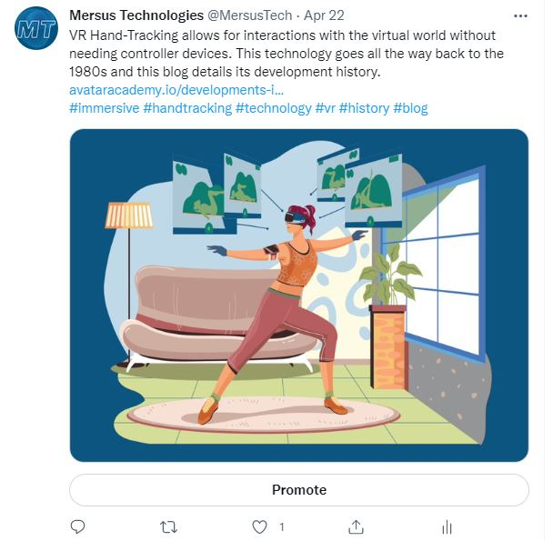
Post 14
The fourteenth post is a link to the fourth blog put up on the Avatar Academy website. Titled Developments in VR Hand Tracking, the blog goes all the way back into the history of the technology as far back as the 1980s. The purpose of this post was to share a link to the website to drive traffic. The post has garnered 1 like, 3 engagements with 44 people reached.

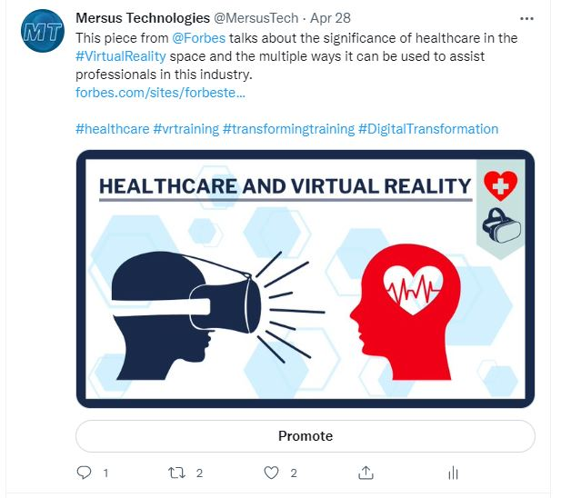
Post 15
The fifteenth post acts as a link to an article about the integration of virtual reality into the healthcare industry. The purpose of this post is to create another image from scratch as well as the relevance of the technology to Mersus and the fact that the company mainly targets those in the likes of biopharma and medtech when it comes to their market. The post links to a Forbes article so that to connect Mersus to a company as significant as Forbes. This is also why Forbes themselves are tag. In the end, the post saw 2 likes, 2 retweets, 1 comment, 18 engagements and 145 users reached.

Retweets/Quote Retweets
Lastly, the collage of images below shows all of the tweets that were retweeted or quote retweeted. This was done to acknowledge other accounts and as a way to show other sides of VR training outside of the Avatar Academy circle. The intent of these were to create recognition as well as the hope that other profiles would connect with and follow Mersus, which did work in some instances. The majority of retweets relate to VR training, Mersus’ victory at the Irish Time awards and interesting VR tidbits like the complete history of headsets and the anniversary of the Oculus Rift. Some of these were Quote Retweeted, meaning we are able to see our own analytics and the performance of these posts.
The first of these was from Tech Data UK from March 21st, which happened because of researchers being on the verge of changing how VR is used thanks to the use of facial recognition technology. The post got 2 likes, a reply from the original tweeter, 8 engagements and 175 impressions.
The second was from Edstutia, talking about how the future of VR corporate training is already here. After the quote retweet, the post got 2 likes, 4 engagements and 78 impressions.
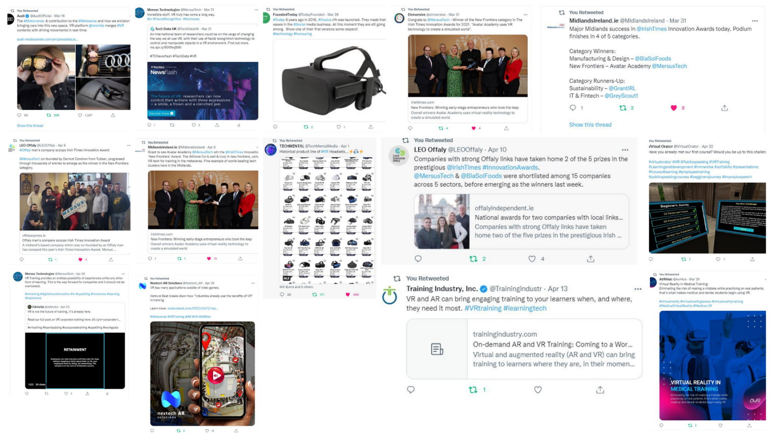
Figure 34 – A collage done through Canva showcasing every retweet and quote retweet on the Twitter platform done during implementation

LinkedIn
LinkedIn is the company’s primary focus when it comes to social media as it is the main avenue for them to create contact with other companies or individuals at a high position within a company. LinkedIn saw by far the most growth when it come to followers. LinkedIn followers saw an 18% growth rate from 455 to 556.
Post 1
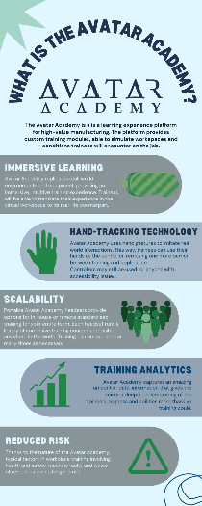
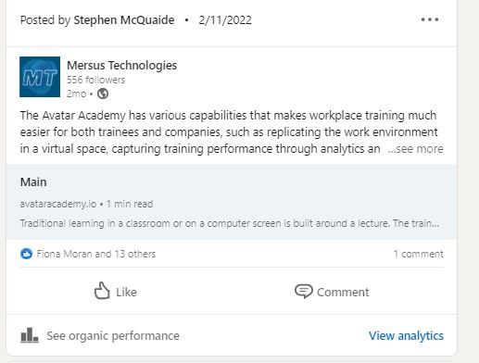
The first post is a link to the Avatar Academy website as it has never been seen on any public platforms prior to this. Because of this, the purpose is to drive initial traffic to the website through first time exposure. The intention was to include the Avatar Academy infographic from Facebook Post 2 and Twitter Post 1 in its original form, shown on the image to the right, but at the time, I was not able to include an image as well as a link to the website. In hindsight, this problem could have been easily solved, but that solution was considered for future posts like this. Despite this, the post managed to receive 14 likes and 1 comment from 42 engagements and a total of 650 impressions.

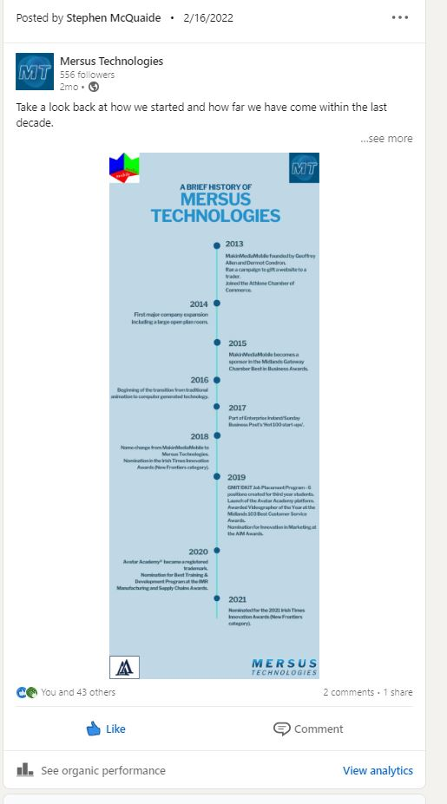
Post 2
The second post showcases a history of Mersus Technologies all the way back to 2013, when they were known as MakinMediaMobile. This post is displayed in the way it was intended, as a timeline in a vertical structure. The purpose of this image is to get people more familiar with Mersus, as a way of opening up to their followers. It is also a way of proving to users that they are a reputable company by detailing their accomplishments throughout the last decase. This is the most successful post throughout all the platforms as it garnered 44 likes as well as 2 comments and 1 share from 162 engagements. The post created a total of 1,595 impressions, all done organically.

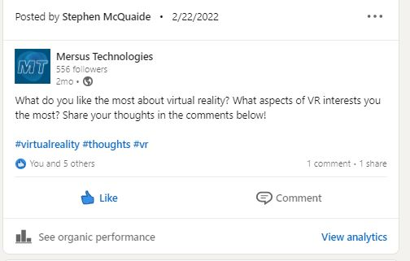
Post 3
The third post was done as an attempt for users to interact and engage with the page, especially after the success of the previous post. The post in question asks the user what they like the most about virtual reality, what interests them about the medium. The post tells the user to share their thoughts in the comments. The post received 6 likes, 1 comment and 1 share out of 24 engagements and a total of 444 impressions.

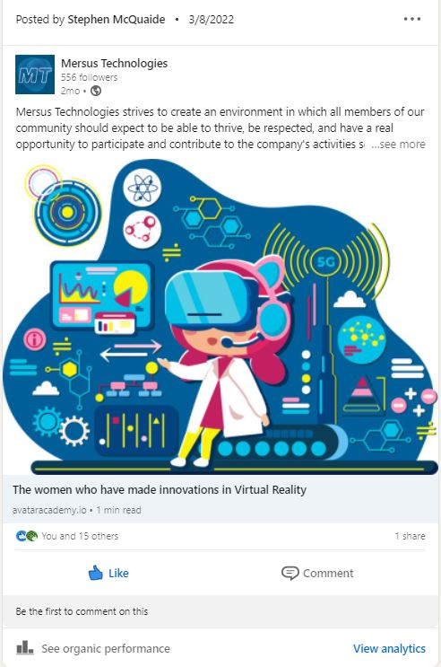
Post 4
The fourth post is a link to the first blog put up on the Avatar Academy website. This post was done to both celebrate International Women’s Day and to promote the blog page that was newly set up. The caption states that the strive for equal opportunities and a future where women are better represented in the Immersive Technology industry. More posts create links to blogs as more content on the website, therefore, an incentive for people to keep visiting. The post has gained 16 likes and 1 share from 27 engagements, with the other 10 acting as clicks. The post itself gained a total of 510 impressions.

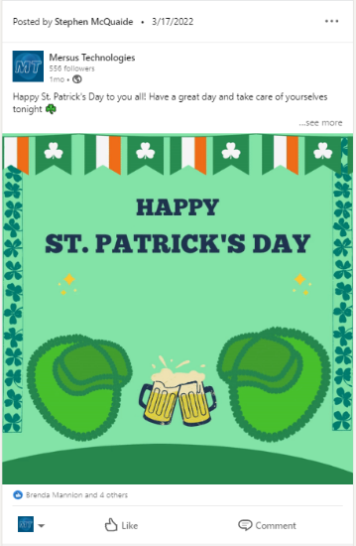
Post 5
The fifth post was created to celebrate St. Patrick’s Day. The image in question is a gif that was made through converting a video made on Canva. Shamrocks were used to cover the entirety of each Mersus icon shown as well as a way to celebrate the occasion. This and the text shown help to maintain the brand identity within the image. The post got a total of 5 likes from 8 impressions and 257 impressions.

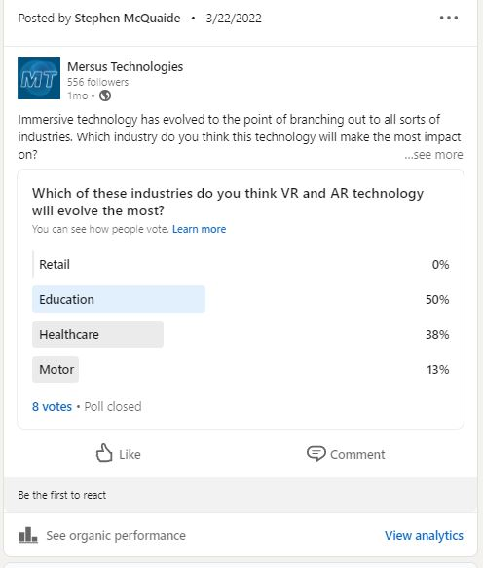
Post 6
The sixth post was created for the sake of user interaction. The poll in question asked which industry did the user think would evolve the most in terms of VR & AR integration. LinkedIn was one of the platforms chosen for this post due to allowing up to four answers for each poll. It lasted for a week to ensure that the users have the most time needed to interact with the post. In the end, 8 people voted with the majority voting for ‘Education’ at 50%, followed by ‘Healthcare’ at 38% and ‘Motor’ at 13%. The post received no likes, but it had 11 engagements and 296 impressions.

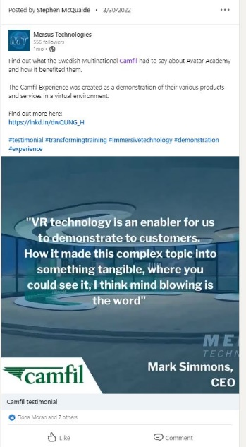
Post 7
The seventh post is a clip taken from Facebook Post 3, involving the testimonials for the Avatar Academy platform. These testimonials are split for the sake of creating a series of short videos dedicated to each company. This video only involves the company FIT and their own VR training programme created by Mersus. The reason for this split was the assumption that shorter videos would perform better compared to long form. On top of that, there were changes to transitions as well as the aspect ratio at the request of the company. The post received 8 likes out of 18 engagements and a total of 272 impressions.

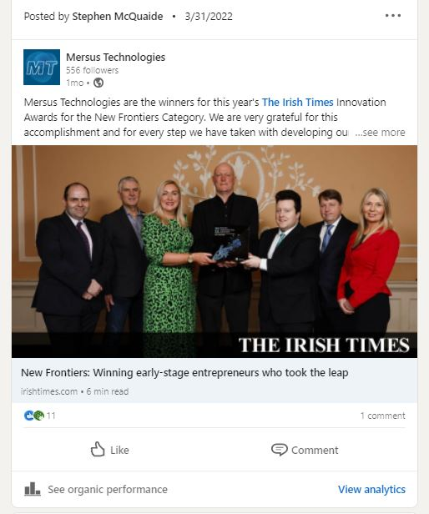
Post 8
The eighth post involves Mersus Technologies victory at the Irish Times Innovation Awards. The purpose of this content was to take advantage of an event that was a big deal and creating a post during that time period when the event would be on peoples’ minds. Because of this as well, the Irish Times and UCD were tagged since they were relevant in this event. The post received 11 likes and 1 comment out of 29 engagements and a total of 404 impressions.

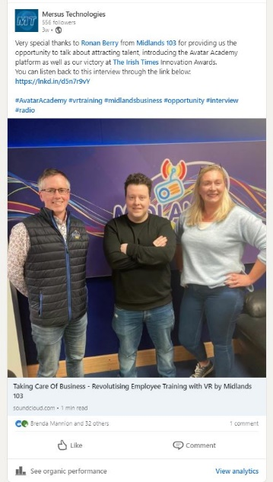
Post 9
The ninth post refers to a link to Midlands 103 as they talked to Mersus about their victory in the Irish Times Awards. This post was created as it is a brand awareness opportunity on the behalf of a relatively known radio station in the country and especially the midlands. This post is also an opportunity to further create brand awareness by tagging the station and including the link to direct users to the audio recording of the discussion. This post saw 32 likes and 1 comment out of 64 engagements and a total of 755 impressions.

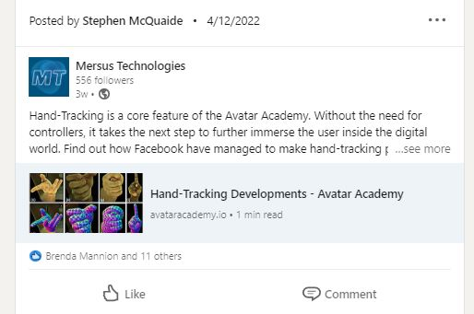
Post 10
The tenth post is a link to the second blog put up on the Avatar Academy website. The blog itself talks about hand-tracking technology since it is a major selling point of the Avatar Academy brand. This post was done to create more traffic to the website through new content. This post saw 13 likes out of 32 engagements and a total of 395 impressions.

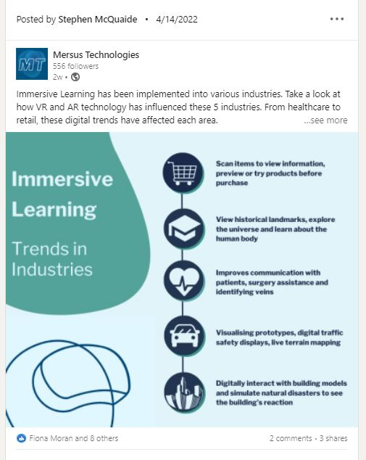
Post 11
The eleventh post, like Facebook Post 12, is a complete remake of Twitter Post 4, highlighting Immersive Learning and the impact it has had on various industries from retail to healthcare to architecture. This version uses the brand colours and creates a more simplified layout while retaining the information found. The purpose was to create a high-quality piece of imagery as well as highlighting interesting uses of VR and AR in other industries. The post saw 9 likes, 2 comments and 3 shares out of 23 engagements. The post got a total of 313 impressions.

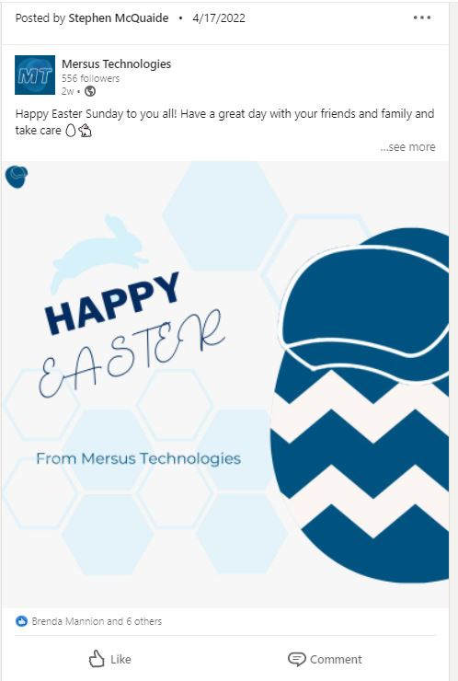
Post 12
The twelfth post is a post wishing the reader a Happy Easter. The purpose of this post was to create a high-quality, creative piece of imagery showcasing an egg wearing a VR headset for creativity while maintaining the brand identity. This is evident in the colours as well as the background and fonts. The post saw 7 likes out of 9 engagements and 271 impressions.

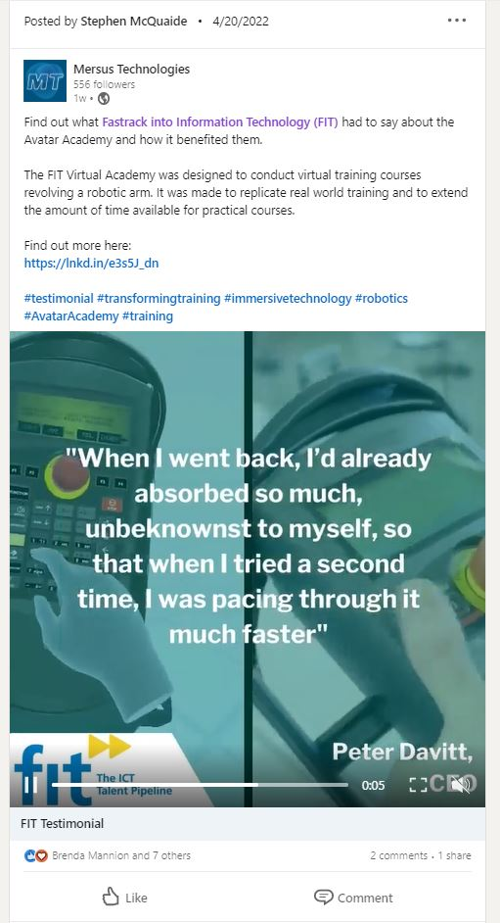
Post 13
The thirteenth post involves another testimonial, this time FIT and the FIT Virtual Academy. The purpose of this post was to get across FIT’s positive experience with the Avatar Academy platform. They were also tagged as the video mentions them and to hope that their followers would notice the video. The post received 8 likes, 2 comments and 1 share out of 24 engagements and a total of 590 impressions.

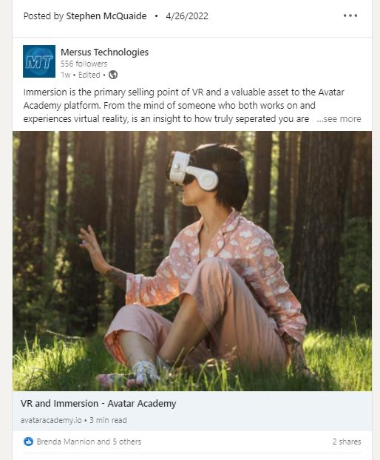
Post 14
The thirteenth post is a link to the third blog put up on the Avatar Academy website. Titled VR & Immersion, the blog goes in depth as to what it really means to be immersed in virtual reality and an insight into how truly separated the user is from the real world once they put on the headset. Once again, the blog was put up to help direct traffic to the website and to increase the numbers as well as create awareness of the technology on top of that. The post has garnered 5 likes and 2 shares out of 16 and 173 impressions.

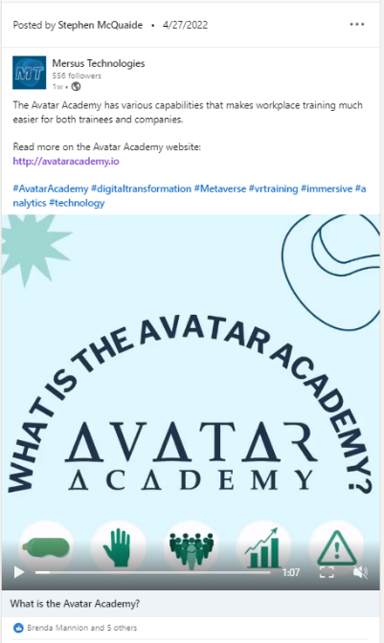
Post 15
The fifteenth post involves the repurposing of ‘What is the Avatar Academy?’ from Facebook Post 1 and Twitter Post 2 into a video format since the post hadn’t been published on LinkedIn at all at this point. Despite this, it still holds the same message, to spread the word on what is the Avatar Academy, what it is for and how it can be beneficial compared to other alternatives. It was also created as a need for more video content. The post got 6 likes out of 10 engagements and a total of 10 engagements

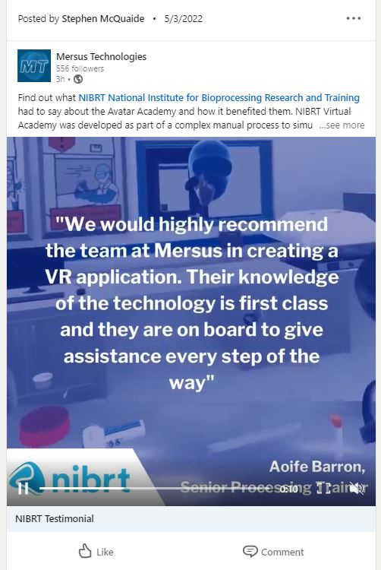
Post 16
The sixteenth post involves another testimonial, this time NIBRT and the NIBRT Virtual Academy. The purpose of this post was to get across NIBRT’s positive experience with the Avatar Academy platform. They were also tagged as the video mentions them and to hope that their followers would notice the video. The post received 6 likes out of 8 engagements and a total of 150 impressions.

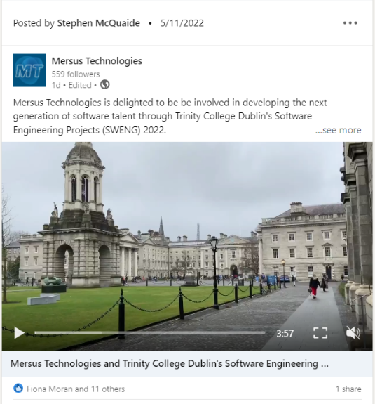
Post 17
The seventeenth post involves a video of students from various Computer Science courses talking about their experiences with the company as part of Trinity College's Software Engineering Projects (SWENG) 2022. Trinity was tagged as the video mentions them and to hope that their followers would notice the video. The post received 12 likes out of 35 engagements and a total of 389 impressions.

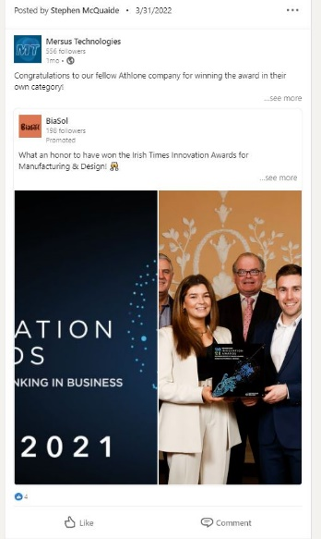
Shared Post 1
This first shared post was done because of its relation to Mersus and the Irish Times Awards. BiaSol is another Athlone company that won their own category at the awards so it’s a matter of acknowledging another company from Athlone and commending them for their efforts. The post garnered 4 likes out of 23 engagements and 230 impressions.

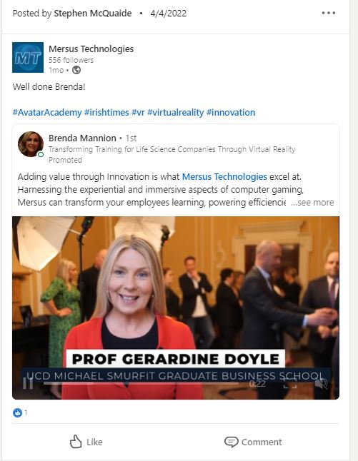
Shared Post 2
This second shared post congratulates one of the heads of Mersus Technologies as it was not only her post that was shared, but she also talked in the video in question. This is a brief promotion of Mersus after their efforts at the Irish Times awards. The post got 1 like out of 3 engagements and a total of 164 impressions.

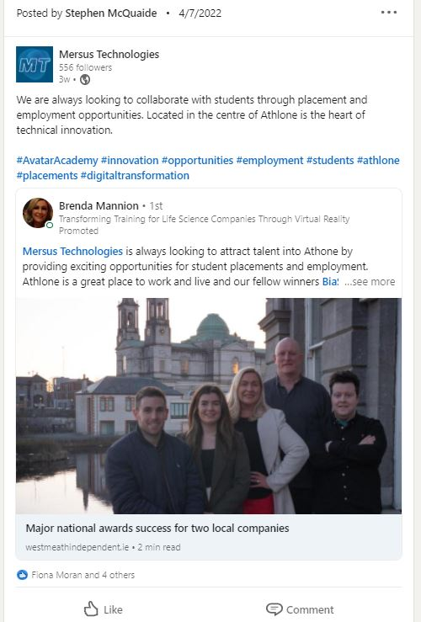
Shared Post 3
This third shared post relates to the fact that Mersus are open to collaborating with students through placements. This was brought up in relation to Athlone and the original post involving BiaSol agreeing with the sentiment that Athlone is a great place to work. The post received 5 likes out of 13 engagements and 266 total impressions.

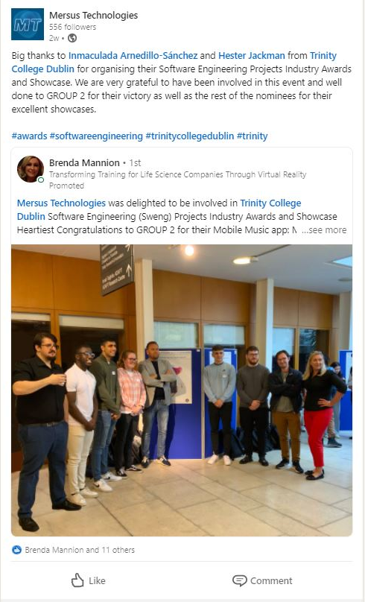
Shared Post 4
The last shared post was in relation to student placements with those from Trinity College. This post was shared as Mersus was one of the judges of the Software Engineering Projects Industry Awards and Showcase. This event created opportunities to tag the college and those representing them. The post received 13 likes out of 35 engagements and a total of 336 impressions.

Monthly Monitoring Insights
The Facebook, Twitter and LinkedIn pages all have their own set of analytics to be regularly monitored so you can monitor the performance of each.
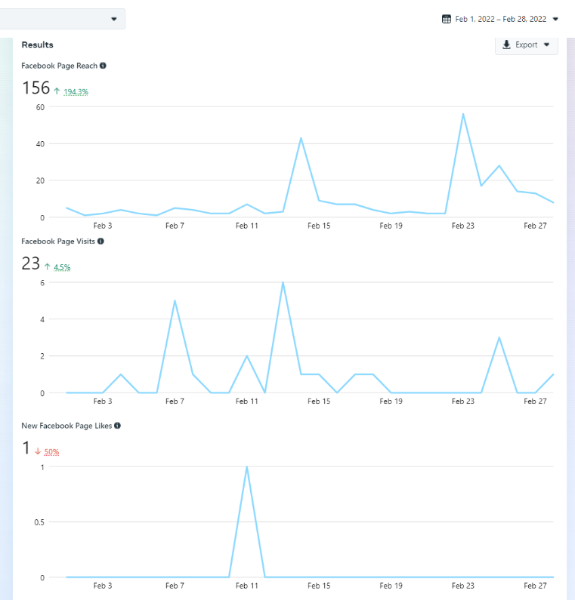
Starting with the Facebook page, February saw a total of 156 reaches, with two major spikes on the 14th and the 23rd with around 40-50 reaches on those days. The page received 23 visits with the 7th and 13th seeing the greatest number of visits. Both saw an increase of 194% and 4.5% respectfully, likely because new posts were starting to be created this month, which gave the users a reason to check out the page. The page saw 1 like this month, which is a 50% decrease compared to January.

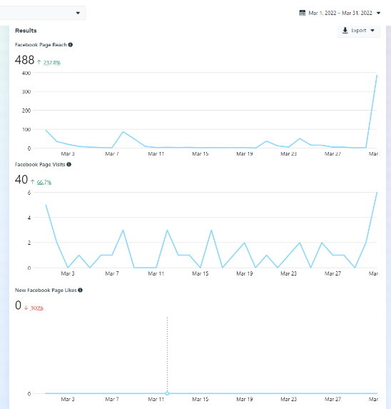
In comparison, March saw a significant increase in both Reach and Visitors. The former increased by double from 156 to 488 while the latter increased from 23 to 40. The post relating to the Irish Times Awards and the success it saw was likely what made these numbers possible right at the very end. The start of the month also saw a larger number of visitors. Unfortunately, the page itself received no likes.

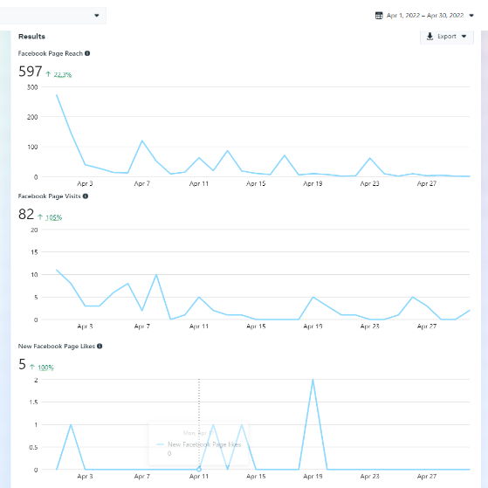
April continued to see this consistent increase in Reach and Visitors. The level of reach increased from 488 to 597, a good portion of which came from the aftermath of the Irish Times Awards from the previous month and the number of visitors increased by just over double from 40 to 82. The most noticeable increase came from page likes, in which the page received 5 likes.

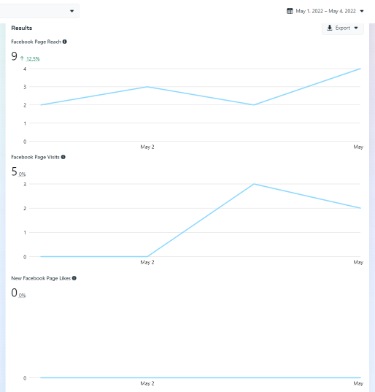
May is currently just calculating the first 4 days of the month, but even compared to the first four days of April, the reach currently is 9, which is a 12.5% increase, meanwhile the number of visitors and likes have not changed.

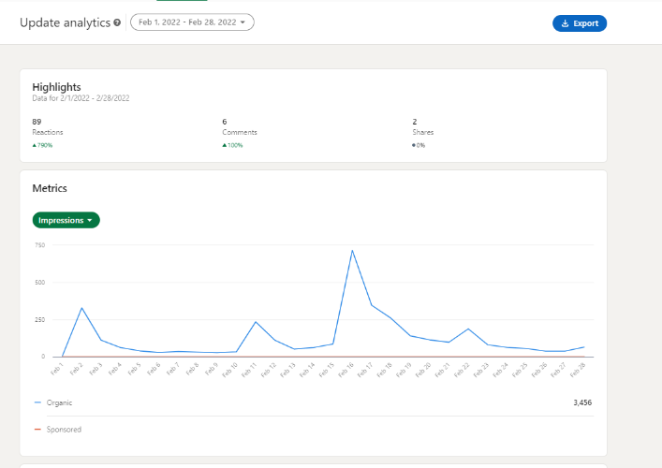
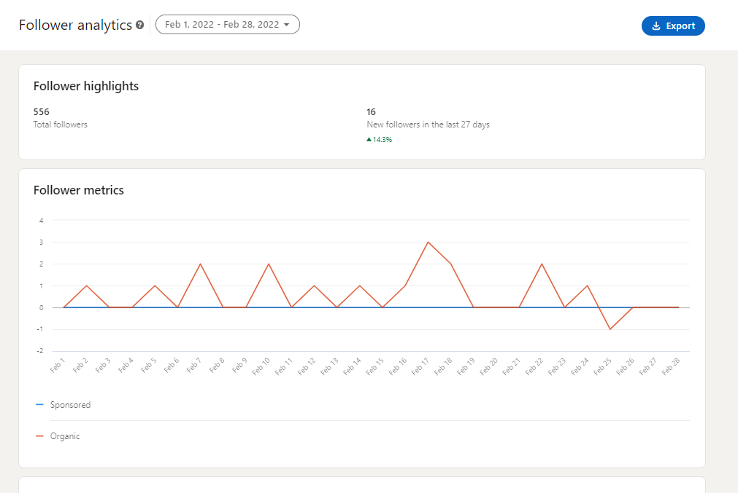
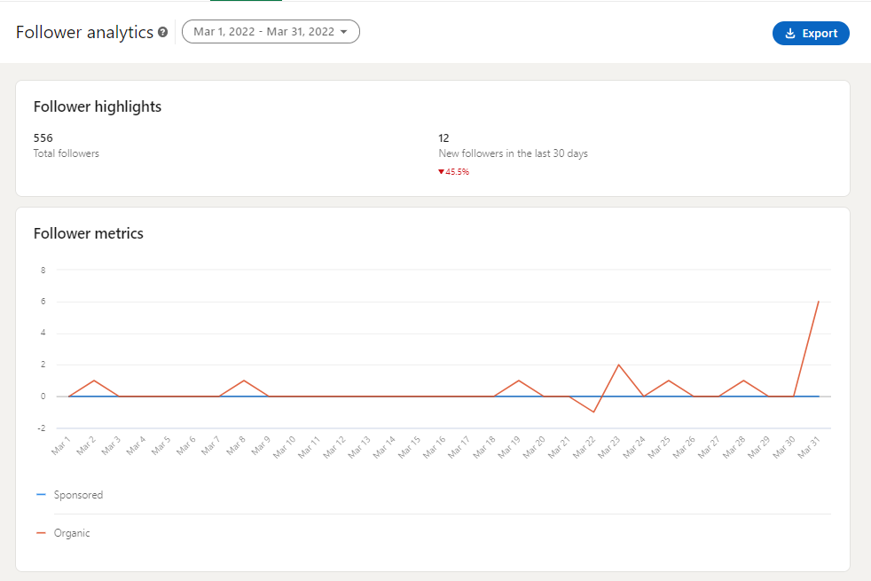
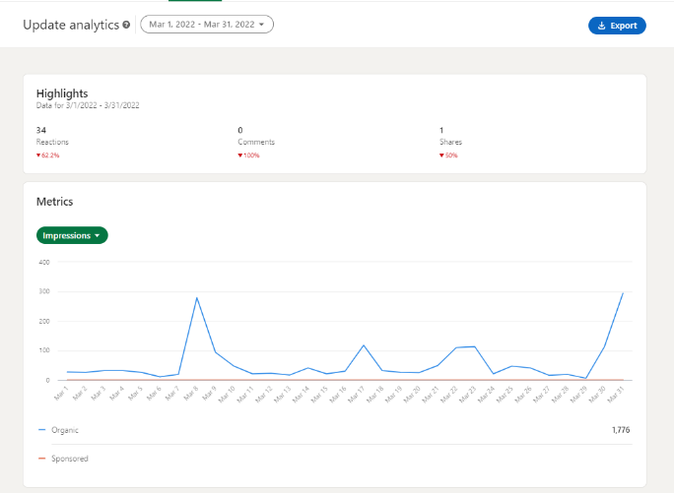
Next up is LinkedIn. Since posts were being published more regularly, it meant there were more opportunities for engagement. Reactions saw a 790% increase to 89 compared to January and Comments saw a 100% increase to 6 as well as 2 Shares The page also saw a total of 3,456 organic impressions overall. As for the visitor demographics, the page received 16 followers during this month.

In March, there was an overall decrease in reactions, comments, shares and follows, likely because there wasn’t as much activity in this time as well as posts not performing as well. Reactions saw a 62% decrease from 89 to 34, there were no comments at all in March and 1 less share compared to February. The overall impressions also decreased from 3,456 to 1,776. As for the visitor demographics, the page received 12 followers this month.

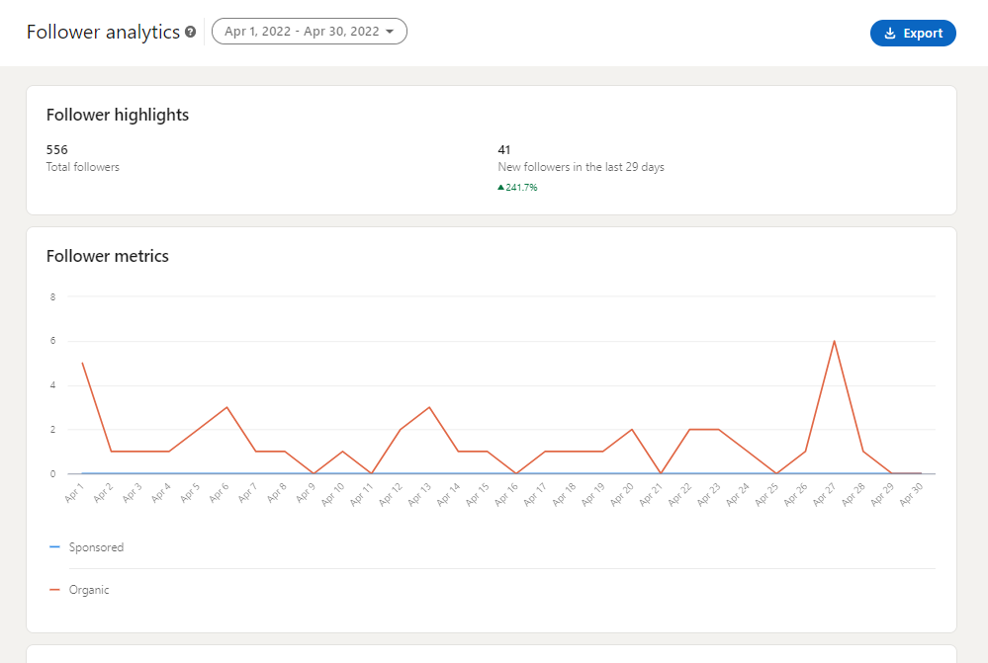
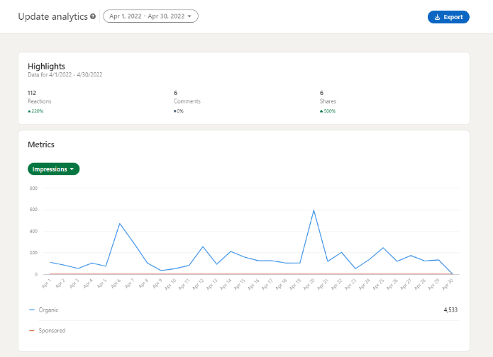
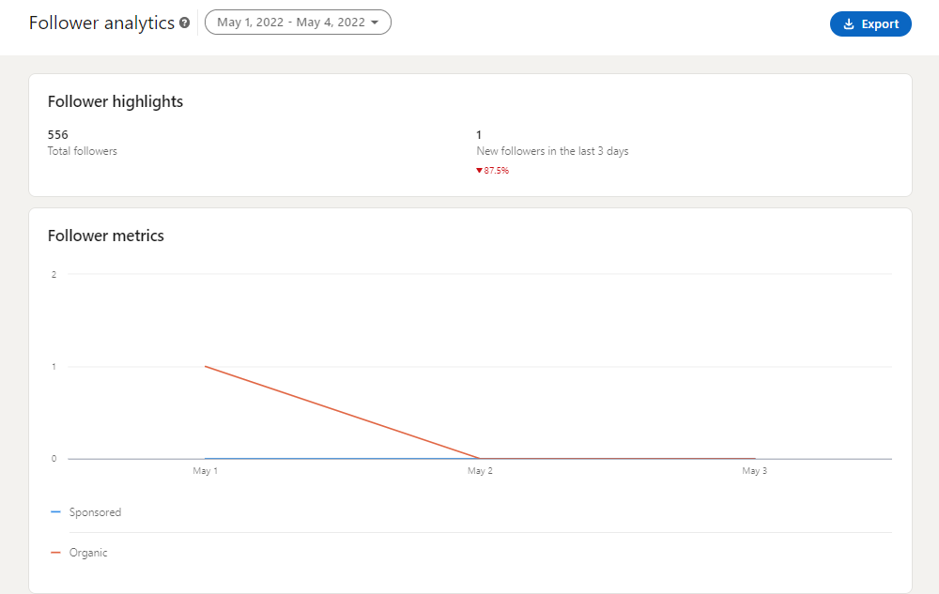
April saw another significant increase in engagement and following. Reactions saw a 220% increase from 34 to 112, there were a total of 6 comments and shares increased from 1 to 6.. The overall impressions also increased significantly from 1,776 to 4,533. As for the visitor demographics, the page received a staggering 41 followers, a 241% increase compared to March.
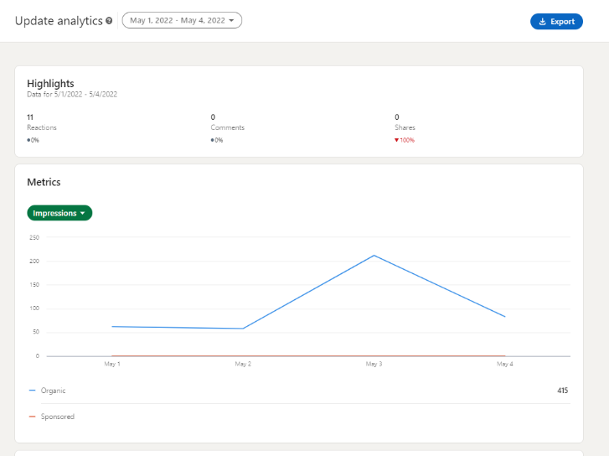
May is only calculating the first 4 days and compared to the first 4 days of April, it currently has 11 reactions, 0 comments, 0 shares and has currently gained 1 follower.

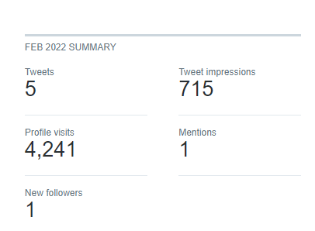
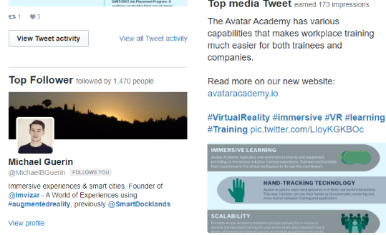
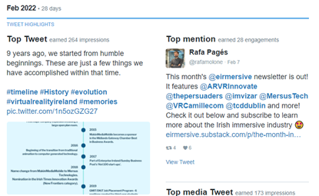
Lastly, there is Twitter, which is an interesting case as it was a struggle to increase the follower count. A huge number of users each month would go out of their way to unfollow the page over the past year, resulting in a reduction of new followers in the double digits. This has been a consistent issue since May 2019 despite posts being made between them and the implementation, so output wasn’t the issue. It is theorised that a number of followers could have been bots or followers were bought at some point and eventually resulted in a constant decline. Throughout the last few months, the number of new followers balancing out those who unfollowed are noticed here. February is the only month that saw an increase of one follower. Aside from that, 5 tweets were created with a total of 715 impressions and 4,241 profile visits.
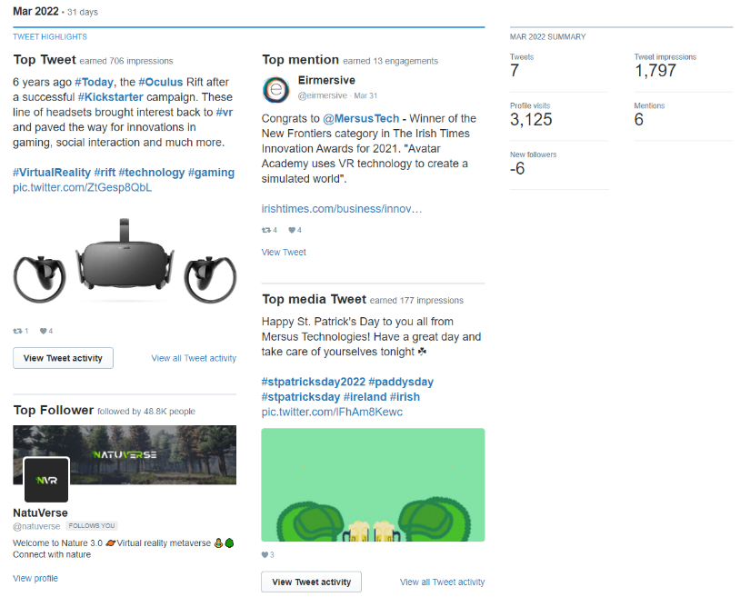
In March, there were a total of 7 tweets made with 1,797 impressions and 3,125 profile visits. The page lost 6 followers which was the largest amount over the course of this project despite the improvement in posting schedule. The company was also tagged 6 times by other profiles. While the number of tweets and impressions saw an increase, the profile visits saw a decrease.

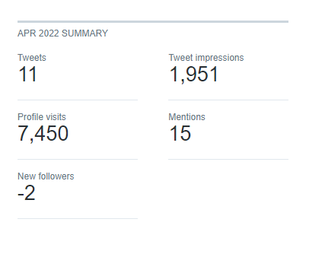
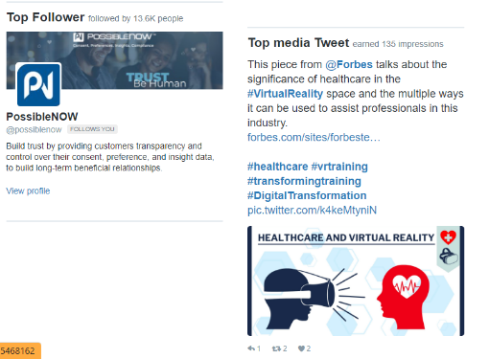
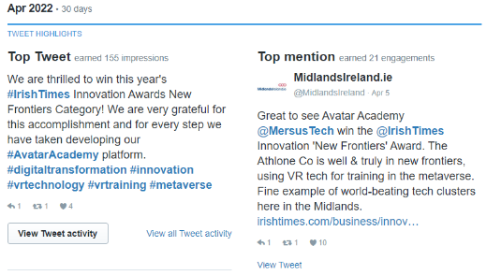
April saw a total of 11 tweets made with 1,951 impressions and 7,450 profile visits. The page lost 2 followers in the process The company was also tagged 15 times by other profiles. The number of tweets, impressions, mentions and profile visits continue to increase, but those unfollowing the page continue to outweigh those who do follow.
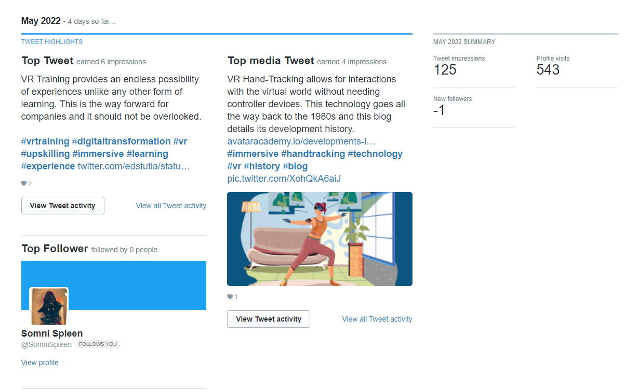

May has only calculated the first four days of the month. This has seen a total of 125 tweet impressions, 543 profile visits and -1 follower.

Design Content Creation

Image Creation
Since this project involves the improvement of social media channels, image content is essential. It is important to use images that catches the eyes of the user while still being able to convey the information presented. Nowadays, people gravitate towards visuals and do so for learning rather than simply reading lines of text on post. With that, a series of images were created. The majority of these images were created using Canva and Adobe Photoshop, with other elements using image assets from the company’s website.
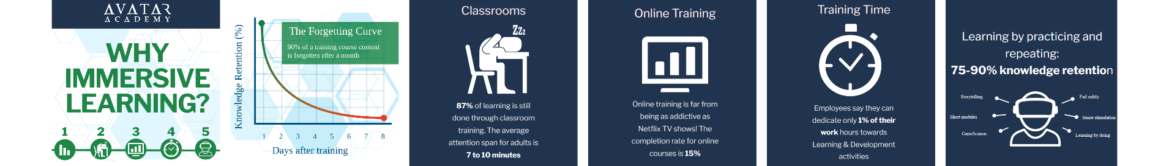

In an effort to promote the Avatar Academy and the idea of immersive learning overall, statistics provided on the website were translated into image form through six images. The five icons, ‘Forgetting Curve’, Avatar Academy logo and the hexagonal backgrounds are all media assets from the website.
Originally, the sections of statistics were just screenshots taken from the website but they resulted in a lower quality, so to rectify that issue, higher quality versions of the icons were taken from the website while the background and text were designed from scratch to replicate what was on the website. The icons on the cover image were used to represent each page. The green colour scheme is one that the company utilises on the site, so this was done for the first image to catch the user’s attention. The format is 1080 x 1080 as they were originally intended for Instagram. Despite the Instagram focus going away, the aspect ratio remained the same.

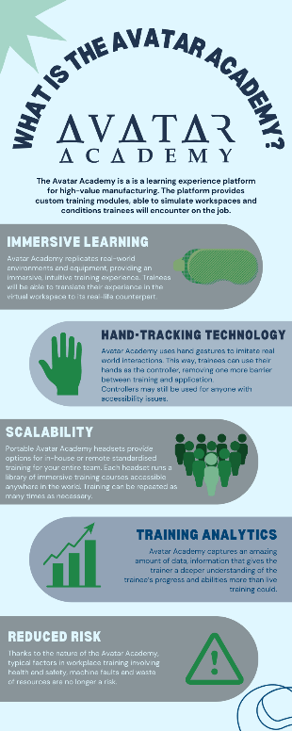

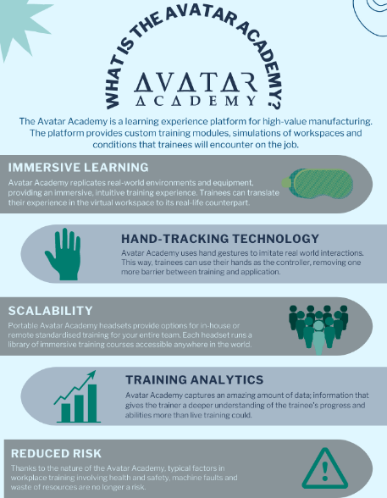

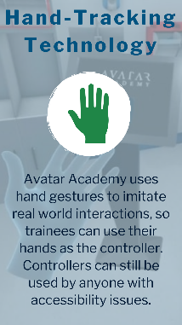
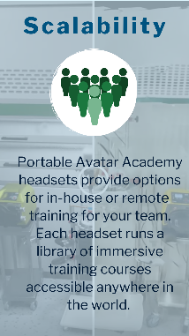
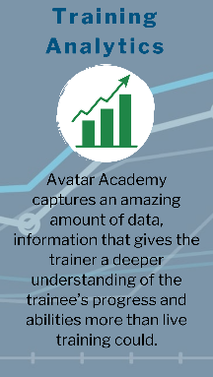
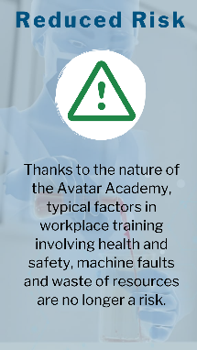
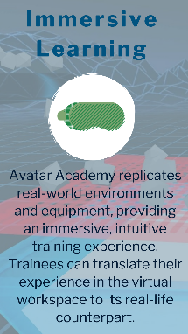
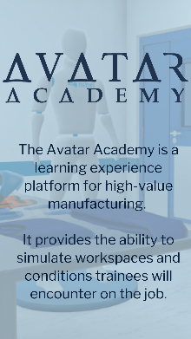
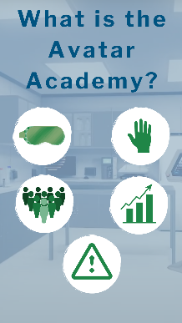

The ‘What is the Avatar Academy?’ post involves the image done in different formats. The first image to the left is the original design. It was planned to be posted universally but since the image got cut off on both Facebook and Twitter, the aspect ratio was changed which meant the size and positioning of different elements had to be changed to fill up space. The portrait images represented the post in a Story format.
The gallery post to the right was done as a way to shake up the image itself and utilise the 940 x 788 aspect ratio recommended for Facebook. The image itself, like the previous set of images was information taken from the website. The font and the colours are consistent with the Avatar Academy brand. Every aspect of the image except for the Avatar Academy logo and the Mersus logo are all taken from Canva and are used to represent each section to give the users a visual hint as to what the text is talking about.



The ‘Happy Valentine’s Day’ posts are done through Canva while the VR headset in the middle was an image taken from another site as other headset images on Canva required Canva Pro. The headset image was edited slightly in Photoshop to look authentic and was then integrated into this image. The Valentine’s theme is present with the colours, softer font and the hearts. To show that it is a post from Mersus, there is also the colour of the couple in blue which represents them in the virtual world as well as the text at the bottom in blue and both the Mersus and Avatar Academy icons at the bottom.

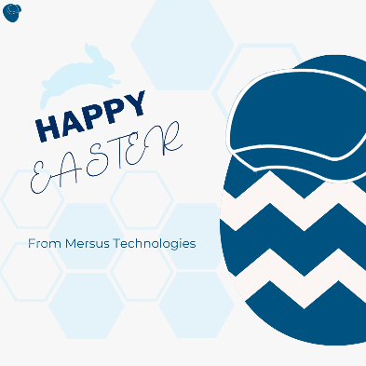
The ‘Happy Easter’ post was done using Canva. The most noticeable thing about the image is the egg, which was done since it looks like the Mersus icon, which is found on the top left-hand corner for context. The hexagonal images in the background are Canva elements but were done to look like the background of the Avatar Academy website. A rabbit is also found in the background to represent the fact that it is an Easter-related post.



The ‘Happy Chinese New Year’ post is one that was not published on any platform as I felt it wasn’t relevant to the company nor its audience. Despite that, the image was created anyway, one for Facebook and another for Instagram. It was created using Canva and it blended the Chinese aesthetic with the brand colours, which was difficult to do considering the contrast. To blend the styles together, a graphic of a tiger was used, and it is wearing an orange headset.
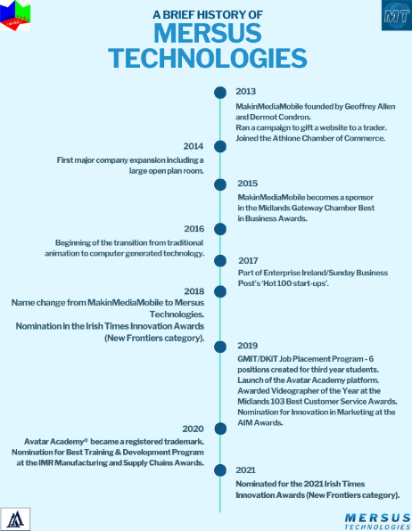
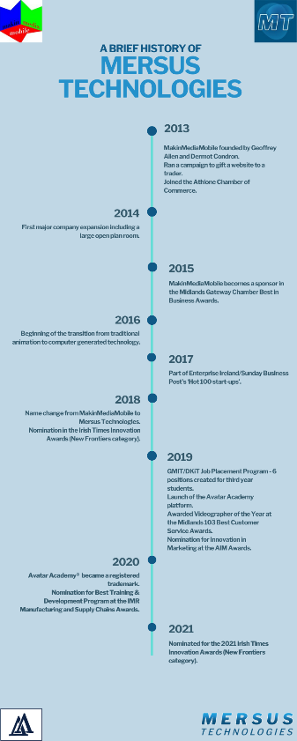


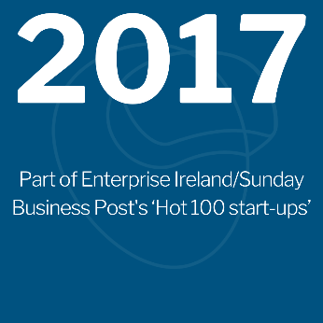
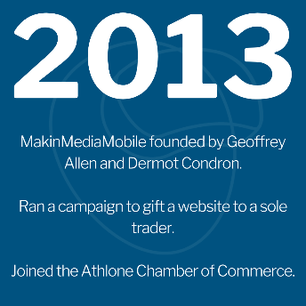

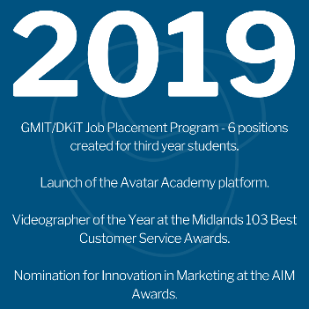


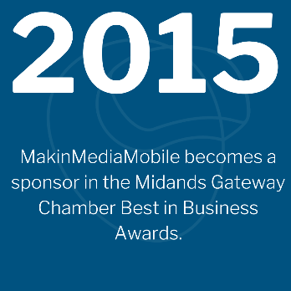
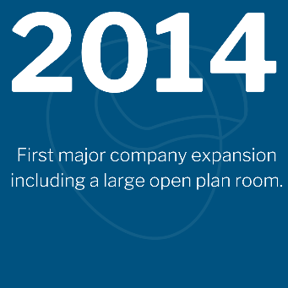

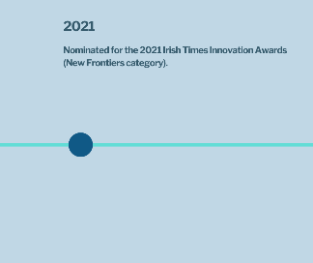
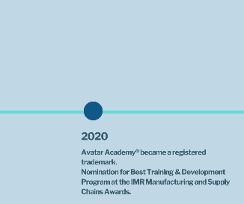
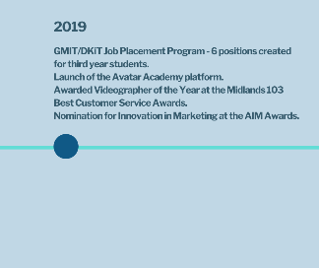
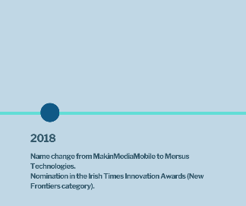
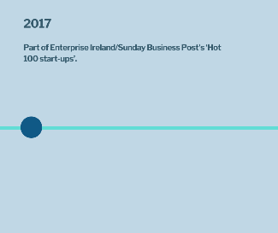
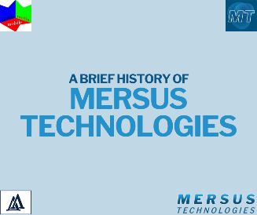
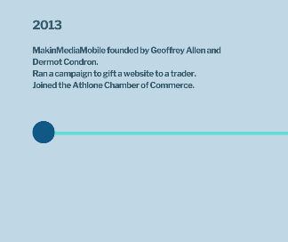
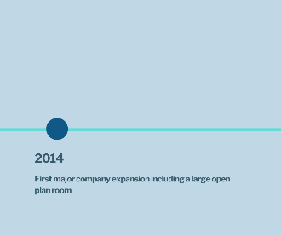
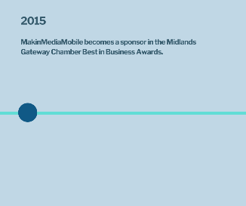
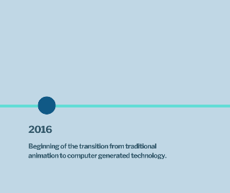
The images above depict a timeline of Mersus Technologies since their inception back in 2013. The image on the previous page is the original image which was intended to be posted on every platform. Unfortunately, only LinkedIn was able to accept this image so for the rest, the image had to be tweaked or repurposed into different formats. The image to the right of it is similar, except it is stretched out to accommodate for Twitter’s image ratio. The Instagram version below it is unique as it is done on a dark blue background, featuring the Mersus icon in the background of each image. The Facebook version splits up the timeline into separate images with the intent of each post connecting, acting like a carousel post without realising that proper carousel posts cannot be done unless it is a part of paid advertising. The main image was created in Canva with the various icons taken elsewhere. Each circle represents each year, and a description is shown under to detail what happened each year in relation to the history of the company. The font and colours reflect the brand also.

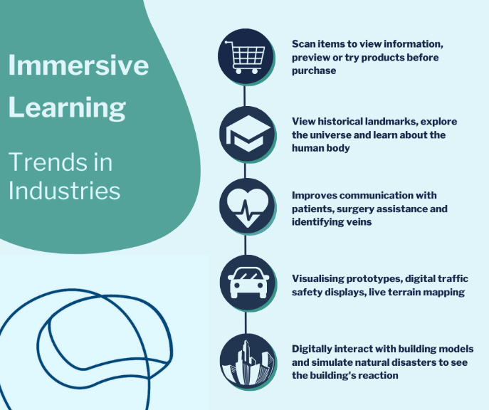
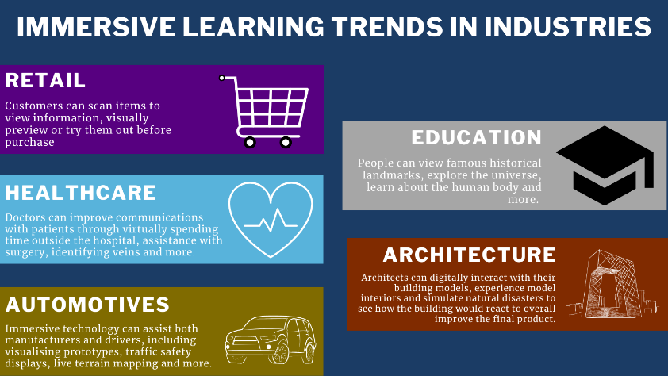

The two images depict two different versions of immersive learning trends in industry. The one to the left was posted onto Twitter and include sections for ‘Retail’, ‘Education’, ‘Healthcare’, ‘Architecture’ and ‘Automotives’. Both images were created in Canva. The left image uses a brand colour in the background while the rest is independent. 5 icons were found through Canva and the information was found from various sources online. Each section uses different colours to make them independent from each other.
The image to the right is a complete remake of the left image. The colours are much more consistent with the brand and the layout is also much more condensed and streamlined. Instead of separating by colour, a line going down featuring the icons are used. The architecture and automotives icons are both changed to make it look more consistent with the rest of the image. A green area is also used to represent the heading of the image.
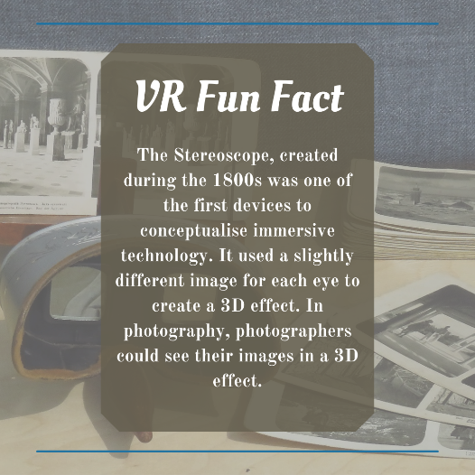
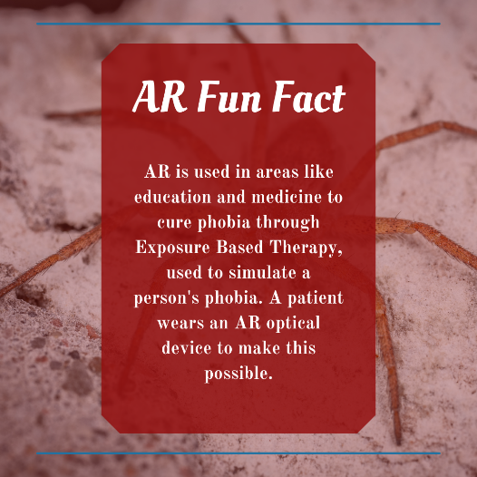
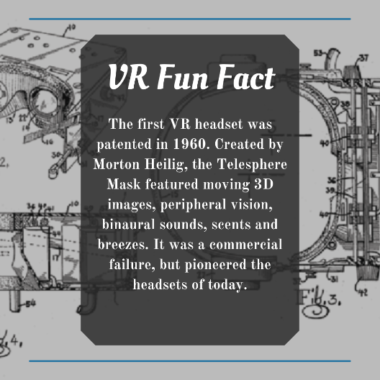
The three posts above were part of a VR/AR Fun Fact series for the Instagram page. Because the focus shifted away from the platform, only one of them got published. The three of them use a similar template which was created through Canva. The font used was to reflect the first image as that talked about an old device from centuries ago. Different colours and backgrounds were planned to be used for each image to differentiate them from each other. The text included a fact about the technology or ways it was used.

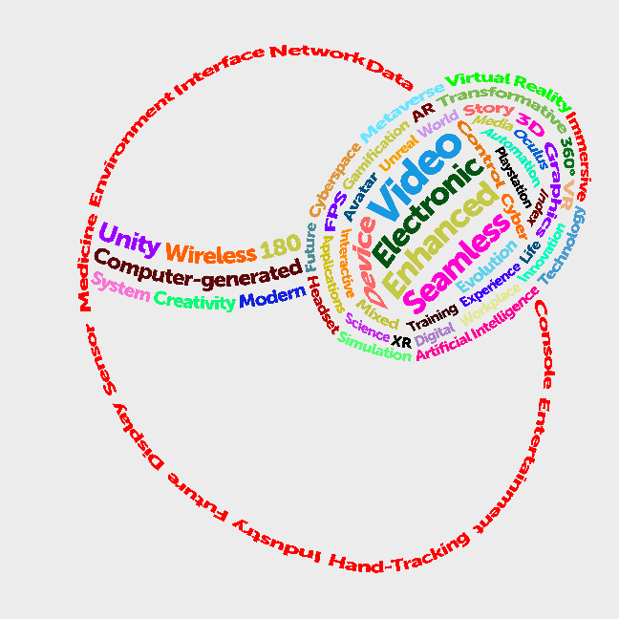
This image depicts a VR Word Cloud, showing the Mersus icon formed through various VR and AR terminology. The image was created using Adobe Photoshop with every word represented as a layer. Nearly all of these letters are warped in the shape of an arc to make up the shape of the icon as well as filling in the headset space. The different colours were used in the headset for variety, meanwhile the words circulating the head are using the same colour to help users to detect the shape of a head.

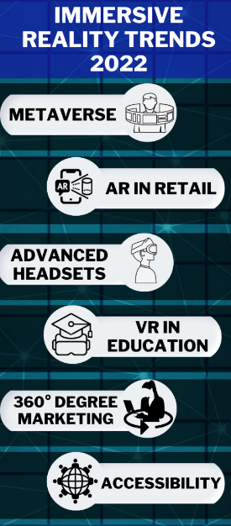
The image to the left very quickly shows the Immersive Reality Trends for 2022 including the ‘Metaverse’, ‘AR in Retail’, ‘Advanced Headsets’, ‘VR in Education’, ‘360 Degree Marketing’ and ‘Accessibility’. This image did not get published because of the feeling that it was too similar to ‘Immersive Learning in Other Industries’, possible overuse of infographics, the fact that it would have to be reformed to accommodate for other platforms and that it doesn’t utilise the brand colours. This image was made in Canva, using icons to represent each section and the background used from either a Canva image or template.


The image is for a Twitter post linking to an article about the use of virtual reality in healthcare. The border uses the brand colours and the hexagons in the background, like the Easter post is created inside Canva. Two heads were used to depict both VR and healthcare. The icons are also displayed on the top right-hand corner to drive the point home.

Video Creation
Video content is just as essential, if not more. Whether it is long form or short form, video is able to convey information in a way that doesn’t requires a user’s full attention, yet it is still possible at the same time. Between that and people’s attention spans reducing as time goes on, quality video content is a way to keep people’s attention rather than simply reading lines of text. The majority of videos were created using Canva and edited through Adobe Premiere Pro.
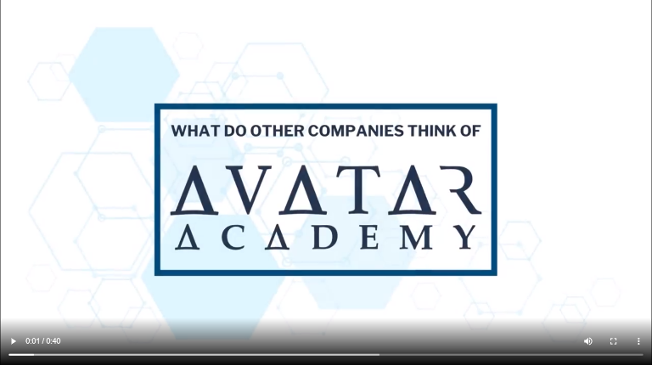
The first video is one that was posted to Facebook, and it is a collection of testimonials for the company that were found on the website. The idea was to use these to tag the companies in question and to tell users that Avatar Academy is a trusted platform. The four companies include Siemens, Camfil, FIT and NIBRT. The video itself features spaces occupied by each company’s logo and the name of the person who gave the testimonial in the bottom-left and bottom-right corners and the testimonial itself in the centre. The background footage seen is video footage of the programme associated with each company. The title card has a border around it as well as the hexagonal pattern and the Avatar Academy logo. The ending footage shows the URL to the Avatar Academy website, which was taken from previous videos done by the company. The video was made in Canva but edited in Adobe Premiere in order to add the music, called ‘Sunrise in Paris’ which was found using YouTube’s free music library to avoid any potential legal situations. The video was created in a 1920 x 1080 ratio.


While not exactly a video, the St. Patrick’s Day post was done as a gif to provide some variety as well as a better chance for engagement from users. In Canva, this was made as a video. The left Mersus icon was replicated using shamrocks for the occasion. The outline, headset and the head itself use various shades of green to easily identify each part. Two pints of beer were animated through two images to make it look like they’re moving with each frame, but in reality, the first image is replaced by the second. The second Mersus icon is a screenshot of the first, since repeating the process would take up time as well as slowing down the application as hundreds of graphics were used to create the first one. This was converted into a gif, so that the footage would constantly loop without user input.

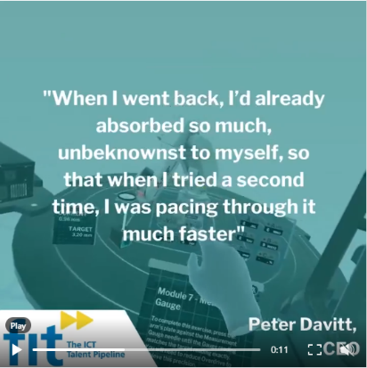
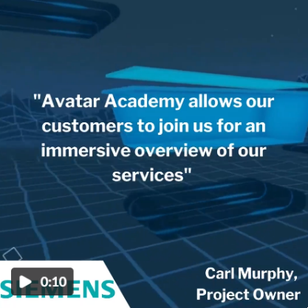
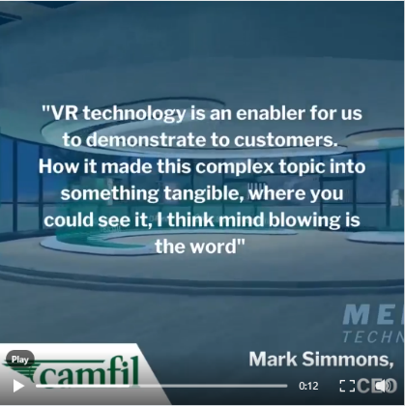
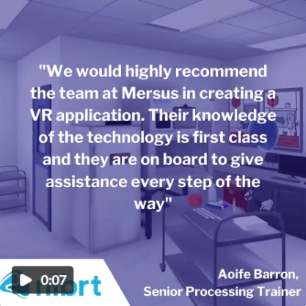
The series of videos to the left are segments of the Facebook testimonial video broken down based on each company. This was done for multiple reasons. Firstly, they are considered as short-form video, which is more likely to keep a user’s attention and since multiple companies are involved, it gives them a bigger chance to be seen by users. It also provides opportunities to tag all four of these companies compared to the Facebook post, where only two were tagged. Since the videos are short form, it provides a chance of better engagement from the user’s end. The videos would primarily be posted on LinkedIn so this would be content that was not seen before on the platform, and it provided an opportunity to tweak the videos and make them more in line with each other rather than using different transitions in one video. The aspect ratio was changed at the request of the company. This meant less empty space, plus the video being more malleable for other platforms if necessary. Like the original video, these were rearranged in Canva, with some finishing touches done on Premiere Pro. The same music was maintained for consistency, but it was edited to include fade outs to accommodate for the shorter video length. After that, the videos were cropped to 1080 x 1080, removing the space occupying the outside areas. The Siemens OEE Testimonial is the only one that is not currently published
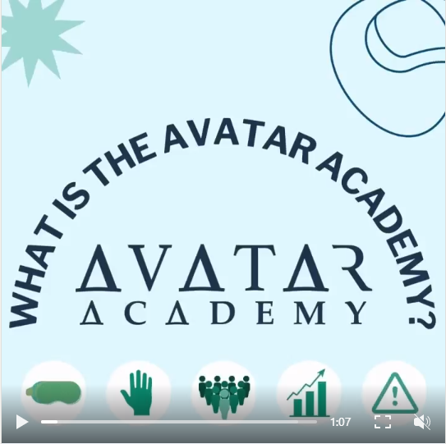
This video is the ‘What is the Avatar Academy?’ sets of image content, but repurposed into a video format. The video was done to create another piece of original video content as well as posting the information to LinkedIn, which had yet to have this information published on the platform. The structure is similar to the Facebook version, where each section and its icon is located at the top and the information takes up the rest of the space. In the background is video footage taken from other Mersus videos in the past that are spliced to represent each section efficiently (Analytics footage for Analytics section/ Footage of hand motions for hand-tracking section).

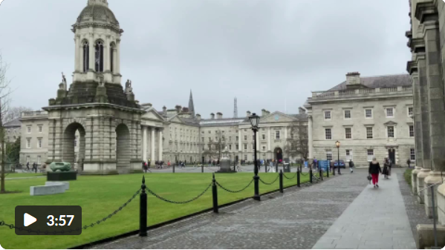
This video was created on the company’s request, involving interviews with students from Trinity College and their experiences with Mersus Technologies. The video is spliced footage of each student answering questions provided by Mersus about their experiences. To give an understanding of the questions, a card shows up displaying the question being asked followed by each student giving their thoughts. This video saw multiple concepts, from individual videos of each student to an attempt of creating captions to give the video a more professional look, this one utilised a majority of the footage sent for the creation process. The video was put together on Adobe Premiere using footage captured by the company of students as well as Trinity College itself, which was used as the introductory shots of this video. The end card showed an animation for Mersus Technologies showing their own website, which was previously used in their other videos. The song that was used was called Advertising, which was found on Canva and it was used for the beginning and the cards showing each question, times when there was no talking in the video.

Other Digital Artifacts
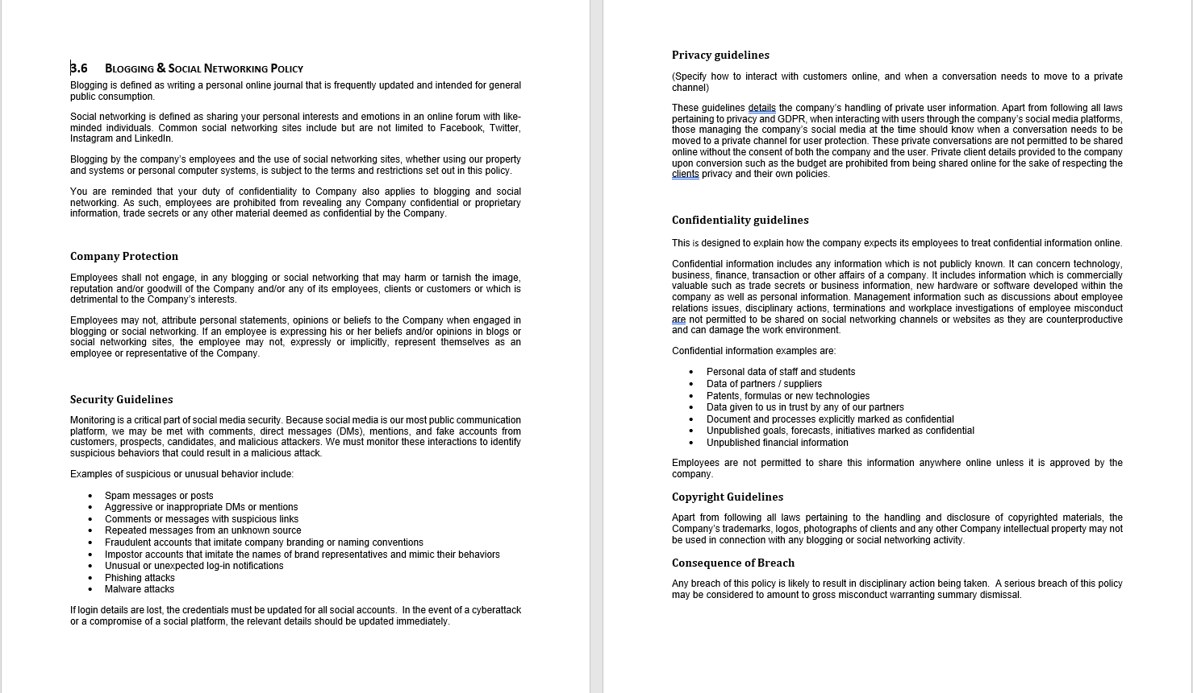
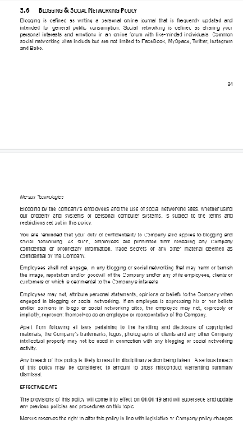
The company requested changes to be made to two of their policies; the Blogging and Social Networking Guidelines that is part of their Company Handbook and the Social Media Handbook.

The image to the left shows the Blogging and Social Networking Guidelines that were found on the Mersus website. The purpose of the policy is to remind employees of what to do and not what to do in relation to information about the company, whether that is expressing beliefs or opinions, handling of certain pieces of information like copyrighted material, trademarking, images involving third-parties and confidentiality as well as displaying the consequences in the event of a breach of the policy. After researching policies of this nature from other entities, it was decided to expand on it and include additional information that is essential. The image to the right displays the updated version, which has seen several additions. These range from headings to categorise each section including ‘Company Protection’, ‘Copyright Guidelines’ and ‘Consequence of Breach’. In addition to these heading, new guidelines were added in order to flesh out the policy and make it look more professional. These include a set of ‘Security Attacks’ in the event of cybercrime on the company’s social platforms. This was added due to the use of digital messaging apps for communication in the company as well as social media accounts being the most accessible way to contact the company. The updated policy also includes ‘Confidentiality Guidelines’, which outlines how the company expects its employees to treat confidential information that is not known to the public, whether that is the technology and software developed or even personal and management information. In short, the information should not be shared unless permitted by the company. Lastly, there is ‘Privacy Guidelines’ which details the handling of customer information and GDPR. Since the Avatar Academy website includes a page where a user can enter their details, this information is to be treated carefully. This also goes for private conversations between company and customer on social media.
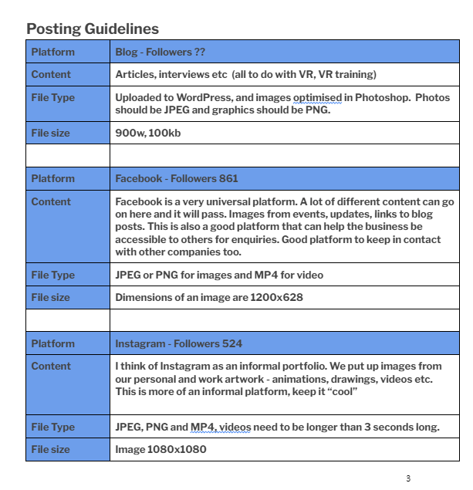
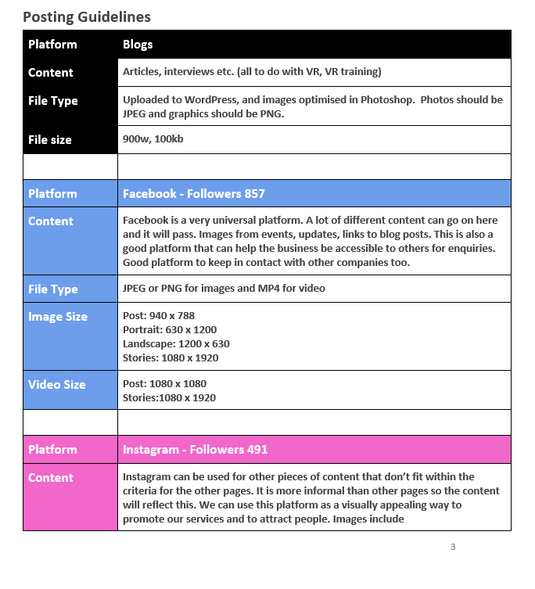

The image to the left shows a part of the Social Media Handbook that was found on the website. The Posting Guidelines show each platform, the follower count and the recommended file size and type that should be published. This version included a section of the table for Pinterest as well as a series of appropriate hashtags for types of posts in areas like ‘VR’, ‘AR’, ‘Animation’, ‘3D Modelling’ and more. A section relating to YouTube ads was also included in the original version of the handbook.
The updated handbook has seen several new additions and changes. This starts with colour-coding each platform as to easily identify them on the table. The follower count was updated as well as the content for Instagram to reflect the company’s transition from animation to immersive technology. Another addition was sections for Image Size and Video Size since each platform have their own maximum file size to work with. File size was also too universal and didn’t always translate to other formats, especially with the additions of Instagram Reels, Facebook Stories and even landscape/portrait/square images. The section on Pinterest was removed since the platform is not relevant to them anymore. In the original version, there was a section dedicated to YouTube ads, so it felt appropriate to do the same thing for other platforms including Facebook and LinkedIn. Both of them allow for various types of ads including Sponsored Content, Text Ads, Dynamic Ads, Boosting posts and more formats as well as guides on how to create ads and different considerations to make when choosing an ad type.
The new versions of the ‘Blogging and Social Networking Guidelines’ and ‘Social Media Handbook’ are found as Word files inside of the folder ‘Updated Guidelines’ which was sent alongside this report.

Other Marketing Efforts

Email Marketing
There was no email marketing implemented into this project.

Brand Image Development
On February 15th, an email was sent to me from one of the heads about the idea of a soft rebrand for Mersus Technologies in order to better relate it back to the Avatar Academy platform. They sent me an image of the conceptual changes made to the logo and wanted to know my thoughts on it. In response, I gave them a rundown of my opinion of the logo and how I felt it could better synergise the online platforms through the use of just one consistent icon rather than using multiple variations with different colour schemes. By removing ‘Technologies’ and replacing that with ‘Digital Transformations’, I figured it would help narrow down what they do since ‘Technologies’ could mean so many different things. The Avatar Academy platform is already in a niche market requiring a simplified explanation, so by having ‘Digital Transformations’, it helps to pin down the company’s purpose.
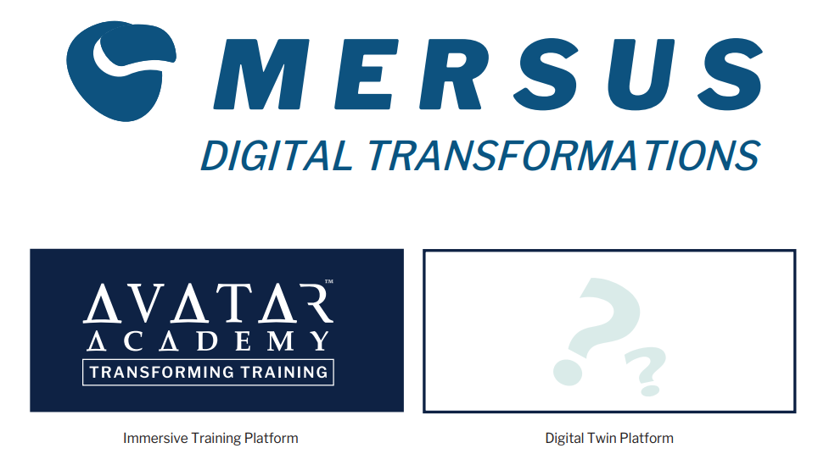

Company Visits
It was agreed upon between myself and the company for me to visit the site on a weekly basis in order to get familiar with the environment and as a convenient means of engagement. I visited the site almost every Thursday from the beginning of March in order to fill in the criteria, getting more comfortable around the company environment and as a means of focusing on working on this project. Whenever I was with the company, I was working on content for social media, changes to the website, working with the Google Search Console, witnessed an Avatar Academy project that was currently in development, taking care of suggestions to make changes to the blogs as well as the Trinity video project discussed on the previous page and being told about posts that should be shared during occasions like the Irish Times Awards.
Every Wednesday, the company themselves would have online meetings through Google Meet, where the company would talk about various project updates, business developments, and other miscellaneous topics; done through screen sharing. During the meeting held on May 4th, I held a presentation for them on camera briefly detailing some of the things I’ve done for the company throughout the last few months; including updates done to the website, blog posts the social media platforms that posts were created for, mentioning the types of posts created and a collage with images of some image/video posts. The presentation was done in Canva and is found in the folder included with this document.
A mentee meeting was held every second Wednesday from the beginning of March as the company had various other mentees in other departments, so it was a matter of checking in on how we were doing during this period and as an outlet for if we required any assistance. The majority are working on the programming and software development side.
Outside of these visits, I’ve kept in contact with a few staff members through the application Slack. This was more accessible than email since everyone within the company was using it for business and casual purposes. Slack was also a convenient method for me to send on any files necessary to the company, whether that was to double-check with them if an image/video was okay to post or if anyone had their own enquiries that needed to be solved.
The folder included with this document includes a section called ‘Evidence of Conversation’, which shows screenshots of conversations with members of the company whether it was through Slack or email.

Website Development
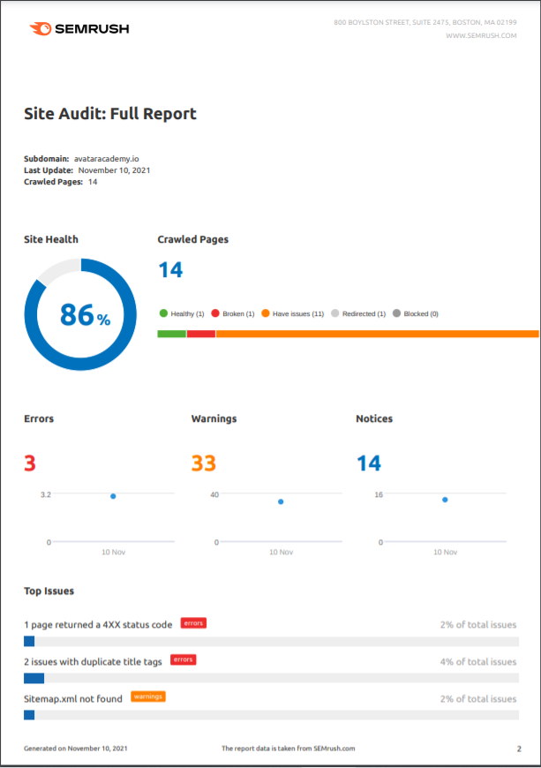
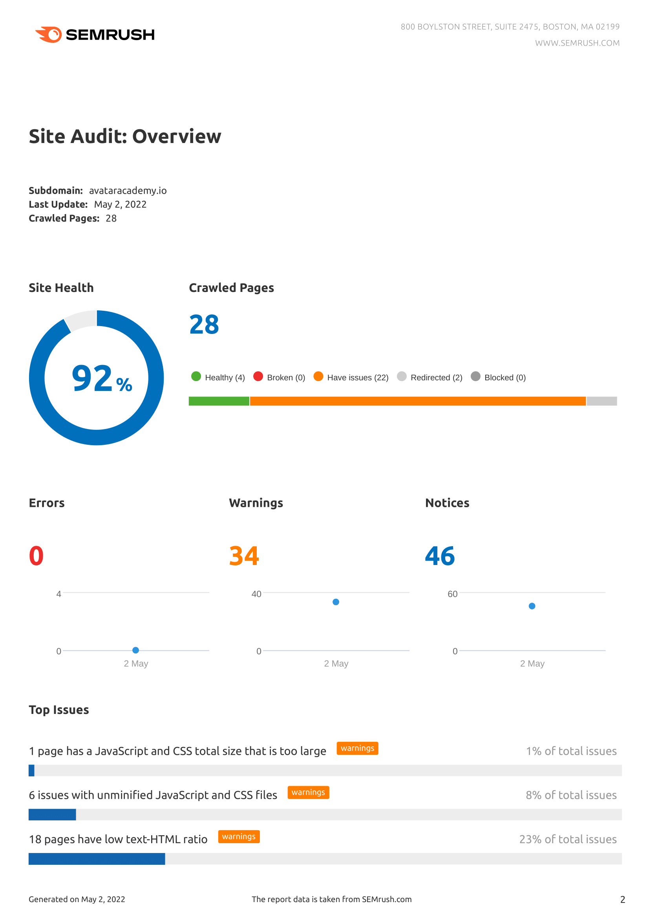
Figure 35 - Before (left) and After (right) images of avataracademy.io’s Site Health and the results of SEO Audits done through SEMrush.

The two SEO audits done on the website showcase the development of the website comparing November 2021 to May 2022. The site health increased from 86% to 92%. This also includes the fact that there are twice as many pages on the website now compared to before. With that, more problems had to be solved.

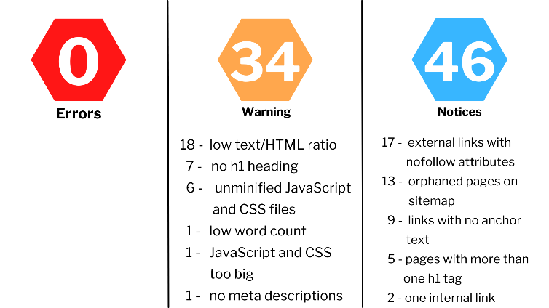
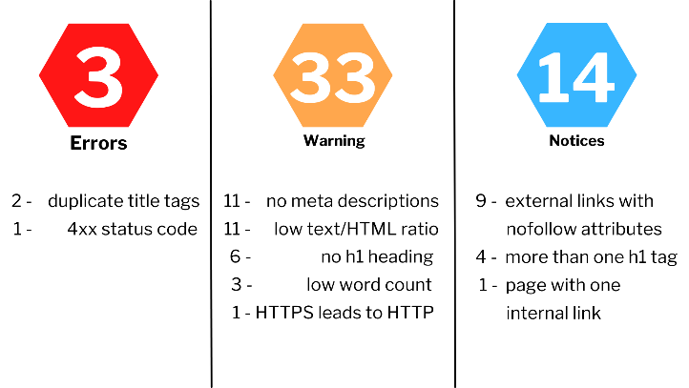

Figure 36 - Before (left) and After (right) images of the Errors, Warnings and Notices found on avataracademy.io, which was audited by SEMrush. The image was created on Canva.

The left image shows the issues that occurred as of November 2021. One task that was set out was to fix as much of these as possible. With the creation of more pages came the potential for more problems to rise up. The errors consisted of duplicate title tags and a 4xx status code. Previously, it was found that the home page and the sitemap were responsible for these problems. In the new report, these have been rectified, meaning that there are no major errors with the website at all. The solution to the 4xx status code is explained in the Sitemap section of this report.
For the warnings, the meta descriptions, h1 heading and low count issues were solved through optimisation through YoastSEO and the Elementor plugin which helps run the website. One page has issues with low word count, large JavaScript and no meta descriptions; nothing could be done about that since that page could not be accessed and edited. This is the ‘Analytics Login’ found on the website, which seems to function separately from the Avatar Academy website. This is the same case for some of the h1 heading warnings. As for low text/HTML and unminified JavaScript files, this is an area that needs to be consulted with those with an expertise for coding.
As for notices, they only increased, especially for links with no anchor text, orphaned pages on the sitemap from the different tags labelled for each blog and external links with nofollow attributes. While not every issue with the website is ironed out, the major ones are no longer a problem and that has caused the site health to increase, which is all the better even with the addition of multiple pages and URLs into the system. Compared to the first audit which only had 1 healthy page, there are now 4 pages that are 100% clean.
It is suggested to clean up most of the pages that are having these issues so that the site has an even greater level of health and a better chance of being found on the search engine. It is also suggested that the company should keep an eye on the audit when they plan to add new content to the website.
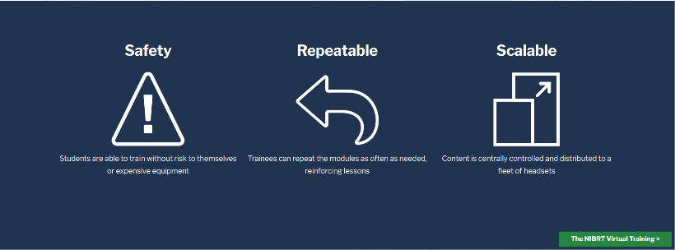
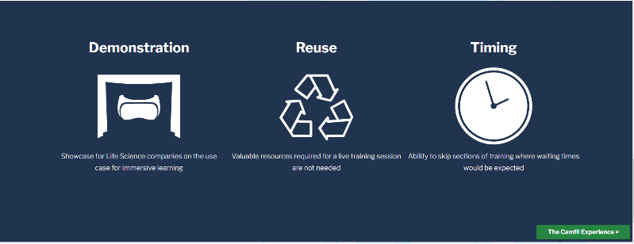

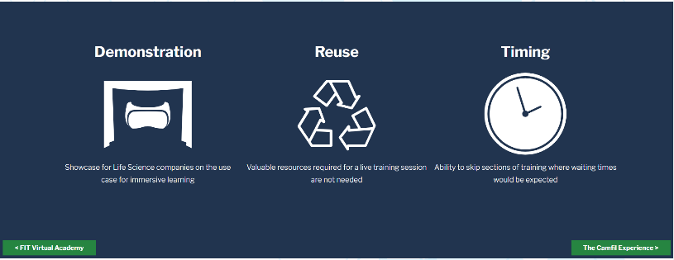
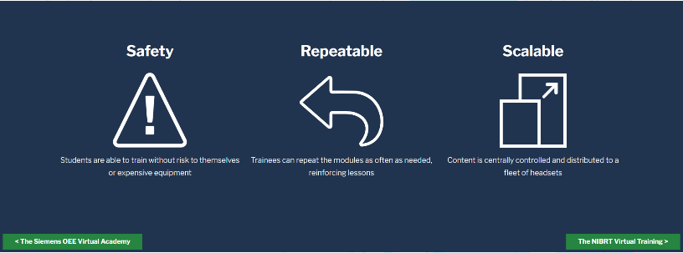
In each project page on the website, there was a button shown on the bottom right-hand corner that directs the user to the next Avatar Academy project. For example, the images to the left uses the FIT Virtual Academy page. The button leads to the NIBRT Virtual Training page. If the user wanted to return to the Siemens OEE page, they would originally have to click the right button every time on each page to get there or they would have to click the Project menu and then return to Siemens that way. To provide easier access, the button to the left was added, which will link directly back to the Siemens page. Not only does it look better, but it makes it so it takes less clicks to return to a given page.
The same thing was applied to the NIBRT page, which not only has a button leading to the Camfil Experience page, but now has a button leading back to the FIT Virtual Academy, which was not there before. The Camfil Experience and Siemens OEE pages now follow suit with these additions.

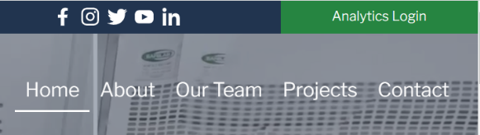

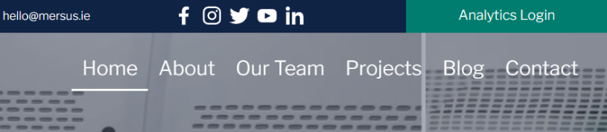

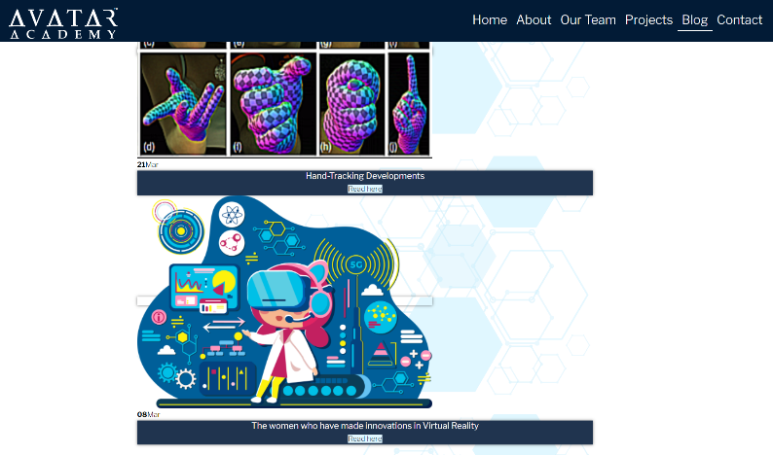
One of the main aims of the website was to add a Blog page as a means of continuous content and a reason to drive traffic. There are currently six blogs published so all of those posts are found in that area.
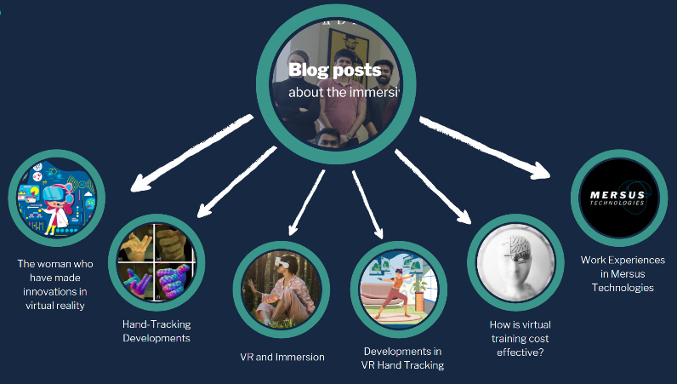
The graphic to the left shows the heading of the Blog page showing each of the blog pages that it links to. Most of these blogs were written by other Mersus staff, except for the ‘The women who have made innovations in virtual reality’, which was written by me. I was responsible for publishing these blogs and making any optimisation changes necessary in order for each one to rank on the search engine. The links to these blogs were also published on social media in order to drive traffic to the website. The blogs would also have some sort of relation to Mersus and the Avatar Academy included within, whether that is to do with Avatar Academy features or any staff members who would factor into this such as students for the ‘Work Experiences in Mersus Technologies’ blog or female staff members in the ‘The women who have made innovations in virtual reality’ blog.

Lastly, the Google Analytics tracking code was embedded into the website using the GA Google Analytics plugin. This enabled the website to be tracked by Google Analytics. This gives an idea of statistics such as the best performing pages, number of users, engagement time, countries where the audience resides and many more. Some of these pieces of information are found in the SEO Monthly Monitoring Insights.
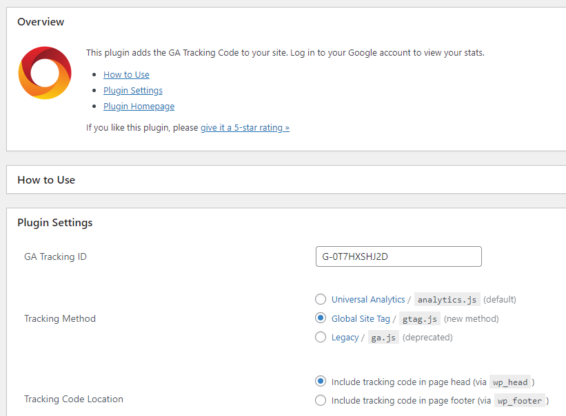

Figure 37 – The installation of GA Google Analytics on WordPress and the tracking code used to connect the site to Google Analytics 4.

Paid Advertising
Despite considerations in creating paid advertising for posts, this did not occur in the end, so there was no paid advertising implemented.

Future Suggestions
Each section details the future suggestions to be made to the company in order to improve their digital presence.
The first of these is on making more aggressive pushes to improve the website’s ranking on the search engine. One of these is the focus on increasing domain authority and the number of backlinks. In the future, the company should continue to incorporate relevant links into the website, mainly through the blogs, so that they can appear in other site’s backlinks. To this end, the company should also continue to post links to the site through social media platforms for more exposure, meaning a better chance of sites using that link in their own pages and in turn; more backlinks and a change in domain authority. It is also no harm for the company to analyse a source’s domain authority to determine whether this is a site they want to link to.
In another effort to push the performance of the website as well as increasing social media reach, the company should delve into Paid Advertising. For the website, there are not many instances of them ranking high on Google despite efforts made to appease Google’s algorithms. The company could perform campaigns to increase presence or bid on keywords to automatically rank in the search engine. For example, it would be an advantage in a situation where the company is involved in any major events, looking to push a specific page or looking to increase traffic in general. As for social media, there are many options including boosting a post to increase the reach, sponsored content or creating ads whether they’re photo or video or multiple other options so that the page can pin down target demographics and locations.
There is a chance that the company can delve into email marketing in various ways. The purpose of email marketing is to a nurture a relationship with users. Through the website Mailchimp, the company could email marketing to generate more leads to connect with other businesses. They could email other companies introducing them through a landing page highlighting the most appealing aspects of the Avatar Academy platform as a step in convincing businesses to open their eyes to digital transformations.
Email marketing could also be used in recruitment efforts, whether that is interns, students or future employees. In this instance, an email could lead them to a landing page highlighting what Mersus can do and the experiences provided by working there. It could also include references to those who previously or currently work at the company as a relatable outlet.
The biggest advantage of email marketing is its remarkably high return on investment, with $38 generated for every dollar spent. Best of all, just under half of the world's population uses email daily, so it’s a low risk, high reward scenario.

Professional Development Skills

Problem Solving
There were minor issues with pieces of content created but were never uploaded. In these instances, the content may not have been uploaded, but they are acknowledged in the report through the Design Content Creation as well as Trello under the ‘Other (including content not uploaded)’ section. This is the same for any draft videos created that had to be changed around to fit the company’s desires. The content that was in their draft stages before needing a change or were finished but never published are included on Trello as well as the folder attached to this document.
Another minor issue came about from the creation of the blogs. This came about after I was sent the documents containing the blogs. After the blogs have already been published on the website and social media, there was a change in preference as the company wanted each blog to link back to the Avatar Academy or Mersus to some capacity. To help create relevance to them, Avatar Academy and/or Mersus were mentioned on social media posts. Eg. posts about hand tracking makes sure to point out that hand tracking is a major selling point of the Avatar Academy. The Women’s Day post includes a statement from Mersus about how they strive to create an equal opportunity environment. In the blogs themselves, an attempt was made to link back to Avatar Academy and Mersus by having lines talking about how the content is relevant in relation to them. Though these aren’t implemented into every blog, a piece was written based on my interpretation on a blog and how I saw the connection between it and the brand.
At the beginning, there were attempts to gather feedback from the company through Trello by tagging those in the group under the comments section, which caused delays in some posts, despite some images being created prior to the start of implementation as there were no replies for an extensive time. Once access to Slack was provided, it was a solution to the issue as it was the company’s means of communication to its employees.

Initiative
The ability to use your own initiative is a valuable skill as it will show that you are able to make your own judgement in what is a good idea and what isn’t. During the implementation, there were scenarios where this occurred. While I was working with the company and while I did seek permission on most pieces of content, the call was ultimately made in terms of when to post it and what to use as captions.
In the middle of the implementation, the old SEO Audit was sent to the company to let them know of the technical issues of the website in full detail. Due to their expertise in programming and coding, the assumption was that issues relating to JavaScript and HTML would be in their control. After realising no changes were made, I took it upon myself to fix whatever issues were possible. The broken sitemap links were one such example. After performing research online, a method was found online involving a line of code that is used for redirecting. The code was provided with the only required changes being the domain name and the subdirectory where the sitemap name is found. The code was implemented into the .htaccess area and the issue was solved. Another example was a page with a ‘http’ link instead of a ‘https’ link. This was discovered on the Elementor plugin where the website pages are developed. In the section where text is edited, there was a hyperlink that had a link to another Avatar Academy page as ‘http’. By adding an ‘s’ in front of it, the issue was solved, by using initiative.
While this version of the video was not published, the Trinity video needed to look and feel professional. One idea that came from using initiative was the inclusion of closed captions so that users could follow what the student was saying during the interview. It did not get published because of time constraints and the company’s desire to edit the video into a different format.

Relationship Building & Engagement
As mentioned in the Company Visits section, visits would occur on Thursdays each week, which made it easier to adapt to the environment the company works in. Early in the implementation stage, email was used frequently as a means of communication with some company staff to share various documents, files, or any other queries such as the rebranding from the Brand Image Development section. Over time, there was access to another means of communication. An app called Slack was used as an efficient and clean way of communicating with Mersus staff. This app was used as an outlet to seek permission or double-check with the company relating to a piece of content before it would be published on social media. The app would also be used some instances where the company would want a task taken care of. One conversation consisted of a task where an image needs to be edited through Adobe Photoshop to darken spots in images to make them clearer. Another includes needing to compile clips for the Trinity video. On top of that, there were also the weekly meeting as a company every Wednesday to discuss business and other miscellaneous topics. There was also the mentee catch-up that occurred every fortnight, which a staff member went to every mentee to see how they were progressing.
In summary, communication as a company was very frequent between visiting the site and listening to meetings every week through Google Meet as well as the mentee meetings and communication through Slack ensured that there were many options. Because of this, I felt like I got a better understanding of the company and their values.

Project Management
It was essential to link what was being done for the implementation back to the objectives. This is where Trello is involved. It is a site that allows for easier management of organized work, with every task maintained, tracked and shared with others. In this case, it was shared with two lecturers, one of which is a supervisor and four members of Mersus. Early on, Trello was used to upload imagery in advance so that it was saved in a card as an attachment. Throughout, checkmarks were utilised to mark each task as an indication of whether it was completed or not. It was used as a reminder of website work that needed to be done as well as social media posts that needed to be published, with each card representing a week along with a few checkmarks to keep track. In the beginning, it was more difficult to accomplish as I didn’t have access to Slack for easier communication, content that didn’t gravitate in hindsight and time constraints with other affairs.
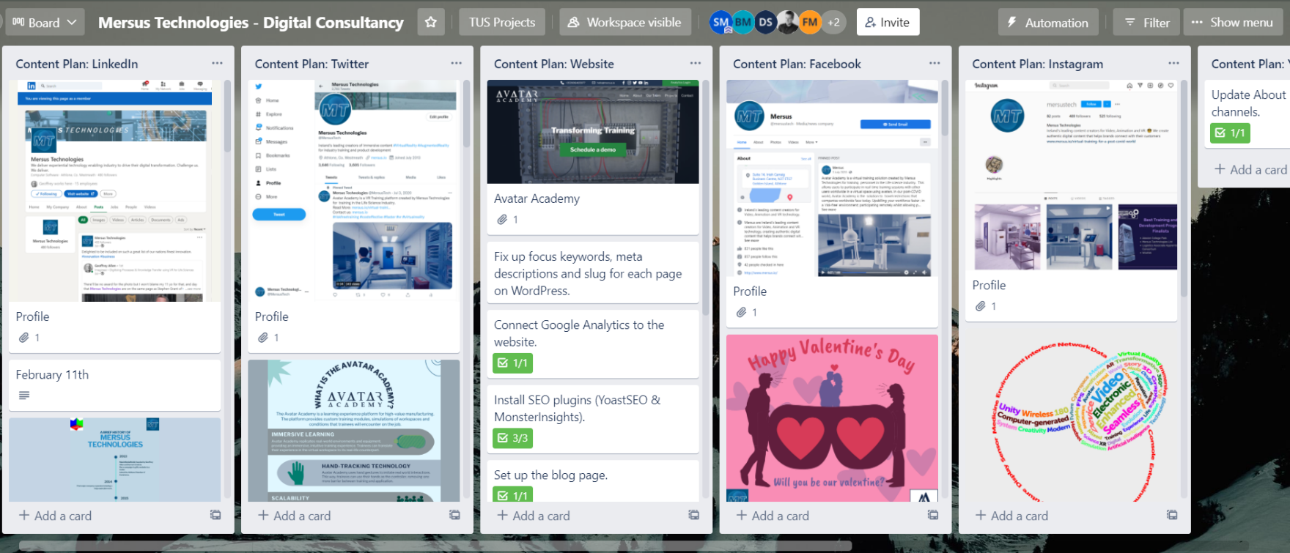
Figure 38 – Trello page for the Mersus Technologies workspace

Conclusion
In conclusion, the report showcases the efforts that have been made to improve Mersus Technologies digital presence. The results from this report can improve further if the company continues to maintain their consistency online and continue to support their digital platforms. Mersus can use these as a metric to determine various things like factors for engagement, the type of content they want to push out and areas they feel need improvement. This report doesn’t just aim discuss what has been done to help them grow online, but also as a personal record for the accomplishments made and the influence that has been made on an establish company’s digital presence. It is a documented report on the trials and tribulations throughout this period and the moments that made this project pay off. This report goes into other developments outside of the website and social media platforms, the tasks that were given and other experiences that were gained by working with Mersus Technologies. This report is a record of everything that was done and gained over the last few months.

